Case Title | Pediatric Sepsis
Scenario Name | Child Health BC

Learning Objectives – This is what we want to accomplish
Technical Skills:
- Recognition of sepsis and illness severity
- Demonstrate basic management of sepsis
- Demonstrate use of Child Health BC sepsis guidelines
- Demonstrate resuscitation skills (including correct use of Broselow tape, IO insertion, fluid bolus, and starting an epinephrine infusion)
Non-technical Skills:
- Demonstrate team skills
- Demonstrate situational awareness
- Demonstrate calling for help early
Scenario Environment
Location | ED Resuscitation area
Monitors | Standard Rural ED
Props/Equipment | Airway intervention equipment, Broselow tape, Pediatric resuscitation cart, Personal protective Equipment, Medications,  Normal saline, IV line, 3-way stop cock, syringes, pressure bag, IO equipment, IO trainers
Make-up/Moulage/Image | Purpura/Petechiae
Confederates/Actors | Parent(s)

Facilitator Notes IMPORTANT TO FOLLOW
BEFORE THE SIMULATION:
- Pre-brief the group:
  - Introduction – Welcome, introductions, sign-in
  - Review overall format – Approximate time for simulation and debrief. Remind that debrief often takes longer than scenario, but is the most important part
  - Confidentiality – What happens in SIM stays in SIM
  - Engagement – Recognize this is a simulated environment but try to buy-in, the more you put into it and the more you’ll get out of it
- Provide Orientation (failing to give proper orientation may set participants up for failure):
  - Manikin, monitors, code cart, meds & fluids, diagnostics, calling for help
  - Child Health BC Sepsis Guidelines
  - Equipment/Procedures in the case as needed – do a needs assessment (i.e. How to use Browselow tape and cart, IO insertion, pediatric fluid bolus with 3-way stop cock)
- Scenario briefing:
  - Learning Objectives (written in the case)
  - Roles – discuss roles, assign as needed
AFTER THE SIMULATION:
Follow the Debrief Guide near the end of this booklet

Simulation Design Notes:
Manikin
- Case written for 3 y.o. sized manikin
- If using different sized manikin (1 month-16.99 years old only – NOT for use with 0-28 days old)
  - Broselow their size and change the age and weight of the child in the case to be consistent with the manikin

Case Introduction:
Called to treatment room to assess child. Triage concerned about decreased LOC.
Parents present with 3 year old unwell for 48 hours with concerns of fever, decreased intake, and sleepy.
Petechial rash on torso and legs and decreased GCS.

History:
Chief Complaint - 48 hours unwell
Immunizations - Non-immunized, use herbal supplements instead
Allergies - No known allergies
Medications - Tylenol 3hrs prior to arrival
Past Medical History - Normally healthy
Exposure - Goes to day care, two siblings. Lives with both parents.
Diet/Diapers- Decreased intake. Last meal – drank small amount of juice this morning. Vomiting x 4 in past 18 hrs. Decreased voiding. Last bowel movement last night.
Signs &Symptoms - Alert yesterday with decreased intake. Occasional cough. Fever x 48 hours. Vomiting but no diarrhea.

Patient Parameters | Effective Management | Notes
Phase 1: Initial Presentation  *Time: 0-10 mins  Condition: Looks unwell, somnolent.  - Monitor: Sinus tachycardia  - HR: 160  - BP: 70/30  - RR: 30  - SP02: 94%  - T: 39.7  - CNS: Irritable when handled: drowsy when left alone. GCS 14  - CVS: cap refill 3-4 seconds, pulses weak peripherally, mottled  - Resp: chest clear  - Glucose: 2.8  - Integ: Rash  - Weight: 16 kg  *Time can be accelerated for the sim, but are listed as the algorithm times | Take a focused history while resuscitating - See History above  Primary Survey  - Isolation – Directs team to apply PPE  - Identifies sepsis (see notes column)  Airway  - Talk to the patient  - Open airway  - Head tilt, chin lift, jaw thrust  Breathing  - Continuous oxygen saturation  - Apply oxygen by mask 10-15L via NRB – sats drop if no oxygen  - Auscultate chest  Circulation  - Continuous cardiorespiratory monitors on  - Check pulses, cap refill, BP  - Identify hypotension  - Attempts to insert IV x 2 – unsuccessful  - Inserts IO  - Gives NS bolus 20 mL/kg over 5-10 mins (using rapid infuser or 3-way stop cock) - if delayed drop BP  Disability:  - Pupils equal and reactive  - Bedside glucometer 2.8 – gives dextrose  Exposure:  - Pluperic rash with petechiae  Medical Management  - Consult local pediatrician  - Orders lab work (see notes column)  - Orders antibiotics (see notes column)  - CXR, EKG  - Considers urinary catheter | Identifies sepsis  - Critical HR: 3 y.o. with HR of >145 bpm  - Temperature: Fever >38  - Respiratory: Resp distress  - Gastrointestinal: vomiting, reduced intake  - Genitourinary: reduced urine output  - Integumentary: rash  - High Risk Factors: Caregiver concern, not immunized  - Further signs of septic shock:  - Cap refill time >2 secs  - Mottled skin, weak pulses  - Decreased urine output  - Metal status changes  Labwork:  CBC, blood culture, Electrolytes, VBG, Urea, Creat, Glucose, Lactate, Calcium, Magnesium, Phosphate, ALT, AST, total bili, PT, PTT, fibrinogen, Blood type and screen, urine C&S, CRP  Antibiotics:  Ceftriaxone (100mg/kg/dose, max 2g) IV/IOq24h  OR  Cefotaxime (75mg/kg/dose Max 2g) IV/IO q6h AND  Vancomycin (15mg/kg/dose, Max 1 g) IV/IO q6h  Antiviral for suspected Meningitis:  Acyclovir (20 mg/kg/dose) IV/IO q8h  Consequences of ineffective management:  Continue to drop blood pressure
Phase 2: No response to fluids,  Decreasing LOC  Time: 10-20 mins  Condition: Drowsy but able to arouse  - Monitor: Sinus tachycardia  - HR: 156  - BP: 72/35  - RR: 42  - SP02: 95% with oxygen  - T: 39.7  - CNS: drowsy but able to arouse, GCS 13 (E-4,M5,V4)  - CVS: cap refill 4 secs, pulses weak  - Resp: chest clear  - Glucose: 4.5  - Integ: Rash  - Rest of exam normal | Patient Reassessment  Airway  - Maintains the airway: jaw thrust, chin lift, head tilt  - Has suction nearby  - Prepares airway adjuncts  - Assigns someone to attend to the airway  Breathing  - Reassesses SPO2 and RR and effectiveness of respirations  - Auscultates chest for signs of crackles from bolus  - Prepares bag mask ventilation  Circulation  - Reassesses HR, BP, CRT  - Identifies hypotension and decompensated shock  - Assesses for hepatomegaly from bolus  - Continues to give NS fluid bolus 20 mL/kg over 5-10 mins (second bolus), consider third bolus in rapid succession  Disability  - Reassess GCS  - Takes another bedside glucometer – 4.5  - Starts D5W NS IV/O maintenance fluids (4,2,1 rule)  Medical Management  - Call PTN for consultation (PTN 1 866 233 2337)  - Obtain further fluid resuscitation and inotrope strategy from physician or consultation | Consider use of Tele PICU for consultation if available  If acting as PICU consultant:  - Ask for status of child  - Indicate need to give 3rd bolus  - Advise to prepare Epinephrine infusion (to start at 0.05 mcg/kg/min; titrate up by 0.02 mcg/kg/min) IV/IO  - Advise if symptoms of shock remain after 3rd bolus to start Epi infusion  Consequences of ineffective management:  Continue to drop blood pressure
Phase 3: No response to fluids,  Further declining LOC  Time: 20-30 mins  Condition: Drowsy but able to arouse  - Monitor: Sinus tachycardia  - HR: 158  - BP: 71/33  - RR: 40  - SP02: 95% with oxygen  - CNS: drowsy but able to arouse, GCS 12(E-3,M5,V4)  - CVS: cap refill 4 secs, pulses weak  - Resp: chest clear  - Glucose: 5.5  - Integ: Rash | Patient Reassessment  Airway  - Maintains the airway, has suction nearby  - Airway adjuncts prepared if not yet done  Breathing  - Reassesses SPO2 and RR and effectiveness of respirations  - Auscultates chest for signs of crackles from bolus  - Bag mask ventilation ready  Circulation  - Reassesses HR, BP, CRT  - Identifies hypotension and decompensated shock  - Assesses for hepatomegaly from bolus  - Gives NS fluid bolus 20 mL/kg over 5-10 mins (third bolus)  Medical Management  - Prepares Epinephrine infusion (see notes column)  - Obtain further fluid resuscitation and inotrope strategy from physician or consultation | Do not intubate until epinephrine infusion started  Epinephrine Infusion  Epinephrine 0.05mcg/kg/min IV/IO  (Can titrate up by 0.02mcg/kg/min)
Phase 4: No response to fluids,  Decreased LOC  Time: 30-40 mins  Condition: Drowsy but able to arouse  - Monitor: Sinus tachycardia  - HR: 158  - BP: 71/33  - RR: 40  - SP02: 95% with oxygen  - CNS: drowsy but able to arouse, GCS 12(E-3,M5,V4)  - CVS: cap refill 4 secs, pulses weak  - Resp: chest clear  - Glucose: 5.5  - Rest of exam normal | Patient Reassessment  Airway  - Maintains the airway, has suction nearby  - Airway adjuncts prepared if not yet done  Breathing  - Reassesses SPO2 and RR and effectiveness of respirations  - Auscultates chest for signs of crackles from bolus  - Bag mask ventilation ready  Circulation  - Reassesses HR, BP, CRT  - Identifies hypotension and decompensated shock  - Assesses for hepatomegaly from bolus  - Starts Epinephrine infusion at 0.5 mcg/kg/min IV/O | Do not intubate until epinephrine infusion started  Epinephrine Infusion  Epinephrine 0.05mcg/kg/min IV/IO  (Can titrate up by 0.02mcg/kg/min)
Phase 4: Improving Condition (Epinephrine Infusion @ 0.07 mcg/kg/min)  Time: 40-50 mins  Condition: Becoming more a little more alert  - Monitor: Sinus tachycardia  - HR: 158  - BP: 84/45  - RR: 34  - SP02: 97% with oxygen  - CNS: becoming a little more alert, GCS 14(E-4,M6,V4)  - CVS: cap refill 3 secs, pulses a little stronger  - Resp: chest clear  - Glucose: 6.5  - Rest of exam normal | Patient Reassessment  Airway  - Maintains the airway, has suction nearby  - Airway adjuncts prepared if not yet done  Breathing  - Reassesses SPO2 and RR and effectiveness of respirations  - Auscultates chest for signs of crackles from bolus  - Bag mask ventilation ready  Circulation  - Reassesses HR, BP, CRT  - Identifies improvements in circulation  Medical Management  - Discusses with Intensivist considerations of:  - Intubation (anticipate clinical deterioration with procedure)  - Addition of second inotrope  - Use of steroid (refractory hypotension for select populations)  - PRBC transfusion  - Transfer to higher level of care – end case | Do not intubate until epinephrine infusion compete
DEBRIEF GUIDE – For Facilitator use following the simulation
Learning Objectives – Did we accomplish these?
Technical Skills:
- Recognition of sepsis and illness severity
- Demonstrate basic management of sepsis
- Demonstrate use of Child Health BC sepsis guidelines
- Demonstrate resuscitation skills (including correct use of Broselow tape, IO insertion, fluid bolus, and starting an epinephrine infusion)
Non-technical Skills:
- Demonstrate team skills
- Demonstrate situational awareness
- Demonstrate calling for help early

Facilitator Guide IMPORTANT TO FOLLOW
- REACTIONS – Gives the group an opportunity to release emotions
  - Example Question: “How did that feel?”
- GATHER – Get a clear understanding of what took place
  - Example Question: “Can someone summarize the case?”
- ANALYZE – Why the participants did what they did, how it affected the outcome (consider technical, non-technical, and system factors)
  - Example Question: “What did you think you did well?” “What would you change next time?”
- SUMMARIZE – What have they learned and how it can be applied
  - Example Question: “In closing, can everyone state a take-away that will help you in the future?”
KEY DEBRIEF POINTS:
- Early identification and initial management of pediatric sepsis is crucial
  - Rapid delivery of basic interventions (i.e. first hour antibiotics and IV fluids) increases survival rates by up to 50%
- Do not delay antibiotics
  - Ideal to obtain blood samples before antibiotic admin, but antibiotics must not be delayed due to difficulties obtaining venous access
  - Recommended: Rapid administration of antibiotics within the first 10 minutes
- Rapidly administer IV fluids
  - Recommended: First bolus within first 10 minutes
- Reassessment after each fluid bolus is key
  - This includes full set of vital signs + signs of fluid overload (i.e. palpate for hepatomegaly and auscultate for crackles)
  - Normalization of vital signs include: cap refill <2 secs, normalized peripheral pulse strength, warm extremities, urine output >1 mL/kg/h, normal mental status, normal BP for age, and normal glucose concentration
- Inotrope infusion should be discussed
  - MRP should discuss with BCCH PICU consideration of epinephrine infusion including dosing
- Maintenance fluids should have dextrose
  - Children >28 days should have 5% dextrose solution at maintenance IV rate to prevent hypoglycemia

Images
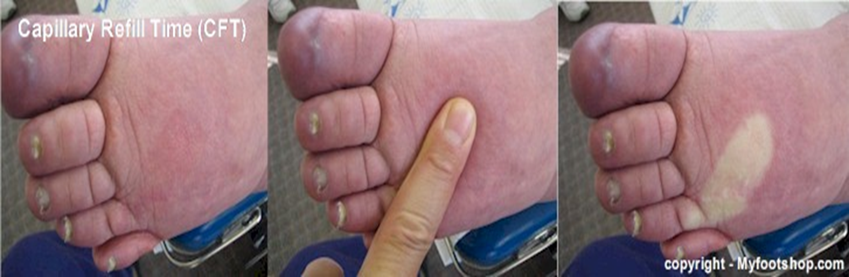

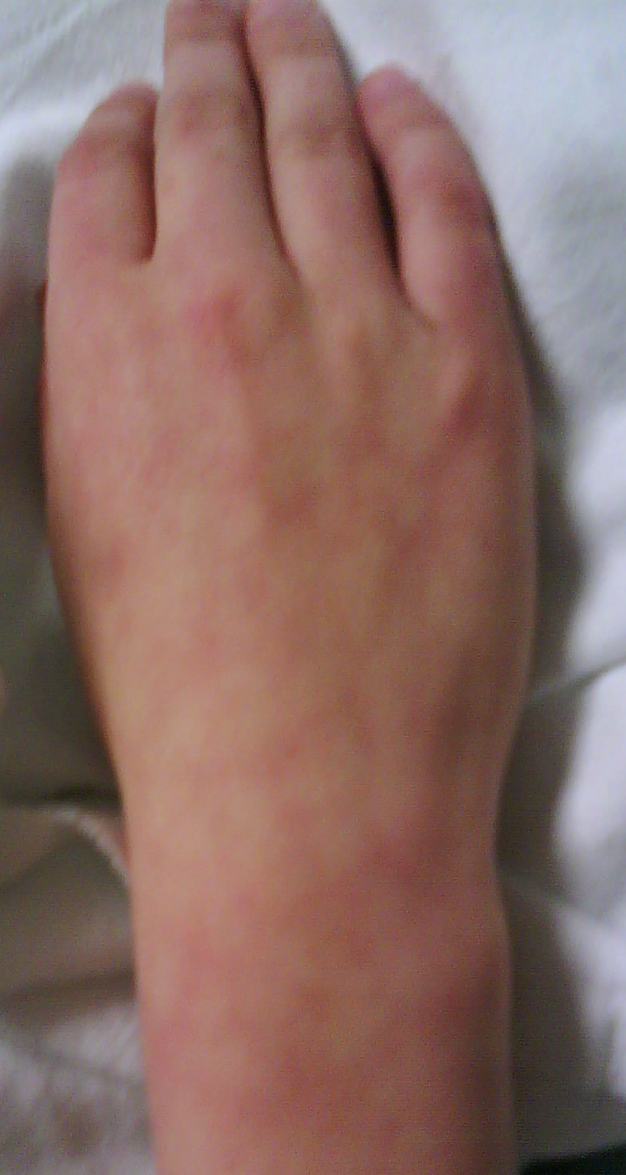

RADIOMETER ABL 700 SERIES  ABL725 PEDS ward 08:25 2015-03-13  PATIENT REPORT Syringe – S 195uL Sample # 189522  Identifications  Patient ID 000000000  Patient Last Name SMITH  Patient First Name J.  Sample type Cap  temp 37.0 ˚C  FO₂(I) 00.0%  Operator XXX,x  Note  Blood Gas Values  ↑ pH 7.28 [ 7.350 – 7.450 ]  pCO₂ 34.0 mmHg [ 35.0 – 45.0 ]  pO₂ 89.3 mmHg [ 80.0 – 100 ]  Acid Base Status  cBase(Ecf)_{c} 3.6 mmol/L  cHCO₃⁻(P.st)_{c} 20.0 mmol/L  Oximetry Values  cHb 130 g/L [ 135 - 175 ]  Hct_{c} 30.8 %  sO₂ 96.1 % [ ]  FO₂Hb 93.6 % [ ]  FCOHb 1.5 % [ ]  FHHb 3.8 % [ ]  FMetHb 1.1 % [ ]  Electrolyte Values  cNa⁺ 136 mmol/L [ 133 - 146 ]  cK⁺ 4.8 mmol/L [ 3.5 - 5.0 ]  cCa²⁺ 1.26 mmol/L [ 1.09 - 1.25 ]  cCa²⁺ (7.4)_{c} 1.22 mmol/L  cCl⁻ 99 mmol/L [ 96 - 107 ]  ctCO₂(B)_{c} 27.3 mmol/L  Anion Gap_{c} 7.2 mmol/L  cGlu 5.4 mmol/L [ 3.3 - 11.1 ]  cLac 3.0 mmol/L [ 0.5 - 2.2 ]  Notes  ↑ Value(s) above reference range  ↓ Value(s) below reference range  c Calculated value(s)  Printed 08:30 2015-03-13 | RADIOMETER ABL 700 SERIES  ABL725 PEDS ward 08:25 2015-03-13  PATIENT REPORT Syringe – S 195uL Sample # 189522  Identifications  Patient ID 000000000  Patient Last Name SMITH  Patient First Name J.  Sample type Cap  temp 37.0 ˚C  FO₂(I) 00.0%  Operator XXX,x  Note  Blood Gas Values  ↑ pH 7.28 [ 7.350 – 7.450 ]  pCO₂ 34.0 mmHg [ 35.0 – 45.0 ]  pO₂ 89.3 mmHg [ 80.0 – 100 ]  Acid Base Status  cBase(Ecf)_{c} 3.6 mmol/L  cHCO₃⁻(P.st)_{c} 20.0 mmol/L  Oximetry Values  cHb 130 g/L [ 135 - 175 ]  Hct_{c} 30.8 %  sO₂ 96.1 % [ ]  FO₂Hb 93.6 % [ ]  FCOHb 1.5 % [ ]  FHHb 3.8 % [ ]  FMetHb 1.1 % [ ]  Electrolyte Values  cNa⁺ 136 mmol/L [ 133 - 146 ]  cK⁺ 4.8 mmol/L [ 3.5 - 5.0 ]  cCa²⁺ 1.26 mmol/L [ 1.09 - 1.25 ]  cCa²⁺ (7.4)_{c} 1.22 mmol/L  cCl⁻ 99 mmol/L [ 96 - 107 ]  ctCO₂(B)_{c} 27.3 mmol/L  Anion Gap_{c} 7.2 mmol/L  cGlu 2.8 mmol/L [ 3.3 - 11.1 ]  cLac 3.0 mmol/L [ 0.5 - 2.2 ]  Notes  ↑ Value(s) above reference range  ↓ Value(s) below reference range  c Calculated value(s)

