Case Title | Pediatric Sepsis/Meningitis
Scenario Name | Hot Head

Learning Objectives - Use action words
Knowledge:
- Understand the pathophysiology of SIRS/Sepsis in a young child
- Understand the pathophysiology and clinical implications of meningitis and status seizures in a young child

Skills:
- Initiate Contact and Respiratory precautions/isolation
- Recognize sepsis and illness severity and treat immediately
- Manage status seizures in a toddler
- Resuscitation of septic child
- Intubation of septic/meningitic seizing child
Attitude/Behaviours:
- Demonstrate Team skills
- Demonstrate Situational awareness
- Demonstrate Graded Assertiveness
Scenario Environment
Location | ED Resuscitation area
Monitors | Standard ED
Props/Equipment | Airway intervention equipment, Broselow tape, Pediatric resuscitation cart, Personal protective Equipment, Medications
Make-up/Moulage | Purpura/Petechiae
Potential Distractors | Parents?

Case Introduction:
Called to T3 stat. RN carries 3 year old child in from triage.
Parents present with 3 year old unwell for 24 hours with fever. Awoke this am to find child in bed lethargic and listless.
Petechial rash on torso and legs, decreased GCS.

Patient Parameters | Effective Management | Notes
Phase 1: Initial Presentation  Condition: Septic/Altered Mental Status  Initial Assessment  - Heart Rhythm: SR  - HR: 160  - BP: 80/40  - RR: 30  - SP02: 94%  - T: 39.7  - Glucose: 4.5  - CNS: Localizes, Moans, Eyes open to voice  - Chest: Clear  - CVS: HS normal  - GI: Normal  - GU: Normal  - Integ: Rash as above  - Weight: 15kg | - Take a focused history (see Notes column)  - Medical Management  - Oxygen  - PPE – isolate  - VS, Monitor, IV – consider IV as IO takes time.  - Call for back up – Pediatrics, 2nd ED physician  - Initiate Fluids – 20cc/kg boluses with syringe  - Prepare for intubation  - Initiate Cultures and Septic Panel of lab work including lactate and ABG/VBG, coags…  - Order CXR  - Order CT head  - IV antibiotics – broad spectrum  Consequences of ineffective management  - Failure to isolate--- all staff gets meningitis and dies!!!  - Drop in BP, elevate HR (SBP <76 indicates hypotensive shock)  - Drop in Sats  - PEA arrest | - Focused history  - Healthy 3 year old.  - As above – 24 hour febrile illness with no focus of infection  - Alert, eating and drinking yesterday  - Some vomiting yesterday  - Found in bed today in current condition  PMHx  - None  - Unimmunized  Meds  - None  Allergies  - None
Phase 2: Seizures  Condition: Status Seizures  Physical Examination  - Status Seizures (not, simulator CANNOT seize, so will need to verbalize this to participants, while dropping sats & increasing HR etc.)  - CNS: eyes closed | - Patient Reassessment (see Notes column)  - Medical Management  - IV Benzodiazepines  - Consider Dilantin/Propofol  - Manage airway now  Consequences of ineffective management  - PEA Arrest | - Patient Reassessment  Airway  - Not difficult  Breathing  - Stopped  Circulation  - Unchanged  Will likely do brief PEA arrest unless all aspects are managed in timely manner.  Then ROSC and stabilization
Phase 3: Stabilization  Condition: Improving BP and HR after multiple boluses. Improved sats with ventilation  - HR: 120  - BP: 100/60  - RR: 30  - SP02: 96% | - Patient Reassessment (see Notes column)  - Medical Management  - Seizures stop  - Reassess VS  - More fluids  - Set up ventilator  - Call Peds ICU  - Recall Peds and Adult ICU in Kelowna  - Ensure isolation in effect  - Catheter  - OG/NG | - Patient Reassessment  Airway  - Not difficult  Breathing  - RR 30  Circulation  - Improving

Insert more lines if more phases required.

Expected Patient Management | Debriefing Points
- Student

- R1

- Senior IM resident

References:

X-RAYS

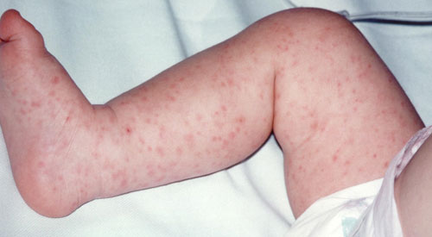

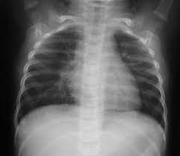

LABS – click here OR fill out below
LABORATORY *LIVE* Lab Summary Report

Test | DATE/TIME here | Flag (H or L) | Reference
CBC
WBC | 20.1 | H | 3.5 – 10.8 10^9/L
RBC |  |  | 4.3 – 5.7 10^12/L
Hgb | 143 |  | 130 – 170 g/L
HCT |  |  | 0.37 – 0.47 L/L
Platelets | 612 | H | 150 – 400 10^9/L
D-Dimer |  |  | <250 mcg/L
Chemistry
Na | 140 |  | 137 – 145 mmol/L
K | 4 |  | 3.5 – 5.0 mmol/L
Cl | 100 |  | 98 – 107 mmol/L
HCO3 | 10 | L | 22-26 mmol/L
Urea |  |  | 2.5 – 6.1 mmol/L
Creat | 100 |  | 62 – 106 umol/L
GFR Est |  |  | > 60 ml/min
Glucose - Random | 4.4 |  | 3.0 – 11.0 mmol/L
Lactate | 6 | H | 0.9 – 1.8 mmol/L
CK |  |  | 5 – 130 U/L
Troponin |  |  | <0.03 mcg/L
Coags
INR | 1.6 | H | 0.9 – 1.2
PTT | 50 | H | 28 – 38 s
ABGs
Arterial
pH | 7.24 | L | 7.35- 7.45
pCO2 | 50 | H | 35 – 45 mmHg
PO2 |  |  | 80-100 mmHg
BE |  |  | -2.0 to +2.0 mmol/L
HCO3 | 10 | L | 22 – 26 mmol/L
O2 Sat |  |  | 95 – 100%

