Section 1: Case Summary

Scenario Title: | FPIES/Hypovolemic Shock
Keywords: | Hypovolemia, lethargy, vomiting, shock, shocky, pediatric
Brief Description of Case: | A 6 month old infant will present with lethargy and profuse vomiting. The infant will then have profuse, uncontrollable diarrhea. The infant will become bradycardic, require chest compressions/ventilation, aggressive fluid replacement, & blood glucose correction. The infant will respond favourably, and recover

Goals and Objectives
Simulation Session Goal: | Management of hypovolemic shock
Objectives:  (Medical and CRM) | - Identify hypovolemic shock  - Calculate and administer NS bolus  - Correct blood glucose  - Manage pediatric bradycardic arrest

Learners, Setting and Personnel
Target Learners: | ☐ Junior Learners |  | ☐ Senior Learners |  |  | ☐ Staff
Target Learners: | ☒ Physicians | ☒ Nurses |  | ☒ RTs | ☐ Inter-professional
Target Learners: | ☐ Other Learners:
Location: | ☐ Sim Lab |  | ☒ In Situ |  |  | ☐ Other:
Recommended Number of Facilitators: | Instructor/Facilitator: 1
Recommended Number of Facilitators: | Confederates:
Recommended Number of Facilitators: | Sim Techs: 1

Scenario Development
Date of Development: | May 4 2021
Scenario Developer(s): | Dr. Navid Deghani
Affiliations/Institutions(s): | Fraserhealth
Contact E-mail: | simulation@fraserhealth.ca
Last Revision Date: | May 4 2021
Revised By: | Zoe Schuler
Version Number: | 2

Section 2A: Initial Patient Information

- Patient Chart
Patient Name: Jess Smith | Age: 6 months | Gender : F | Weight: 8 kg
Presenting complaint: Vomiting and diarrhea
Jess was brought in by her parents for sudden onset vomiting and diarrhea about an hour after introducing sweet potatoes to her diet. The diarrhea has been uncontrollable, and and mom is worried because she seems really lethargic.

Allergies: none
Past Medical History:  Normal pregnancy  Normal birth  Vaccinations up to date  No known health issues | Current Medications:  none
Family/Social History:
Lives with both parents, has an older sibling (age 3)

Section 2B: Confederate
Confederate and Standardized Patient Roles and Scripts
Role | Description of role, expected behavior, and key moments to intervene/prompt learners. Include any script required (including conveying patient information if patient is unable)

Section 3: Technical Requirements/Room Vision

A. Patient
☒ Mannequin – 6 month size infant manikin
☐ Standardized Patient
☐ Task Trainer
☐ Hybrid
B. Special Equipment Required
Cardiac Leads
BP cuff
SpO2 probe
Mock IV set up
Normal saline
IV tubing
Equipment for administering infant boluses (syringes, stopcocks)
Infant BVM
Infant O2 facemask, NP, NRBM
Syringes/needles for drawing up dextrose
Green Syringe transfer device

Broselow tape
Pediatric resuscitation drug reference (specific to the site)

C. Required Medications
NS
D50W prefilled syringe
D10W 500mL bag
Epinephrine 1:10000 PFS

D. Initial Patient Set-up & Moulage
☒ IV drainage bag with attached tubing
☐ IV setup of ________ and infusing @________

Infant diaper with diarrhea (optional)
Sunken fontanelle
Set manikin movements to reduced arm and leg movements
E. Monitors at Case Onset
☐ Patient on monitor with vitals displayed
☒ Patient not yet on monitor
F. Patient Reactions and Exam
Include any relevant physical exam findings that require mannequin programming or cues from patient
(e.g. – abnormal breath sounds, moaning when RUQ palpated, etc.) May be helpful to frame in ABCDE format.

Vital signs as per phase 1 start
Weak cry, mottled skin
Increased respiratory rate, with no increased effort
Normal pupils

Section 4: Scenario Progression

Scenario States, Modifiers and Triggers
Patient State/Vitals | Patient Status | Learner Actions, Modifiers & Triggers to Move to Next State |  | Facilitator Notes
Phase 1  Baseline State  Rhythm: SR  HR: 178  BP:62/38 (46)  RR: 32  O₂SAT:98% r/a  T: 35.2 C rectal  Blood Sugar- 2.9  Set manikin to sunken fontanelle, & reduced arm/leg movements | A – no obstructions  B – ↑rate, no ↑ effort, clear breath sounds  C – cap refill 4 sec; mottled; sunken fontanelle  D – weak cry,  E – mottled, no rashes, wounds, or bruising | Expected Learner Actions  Undress patient  Assess airway  Auscultate chest  Check Cap refill  Start IV  Check glucometer  Administer bolus by weight  Correct blood glucose | Modifiers  -  -  Triggers  - When bolus initiated, move to phase 2 | Bolus of 160mL (8 kg x 20 ml/kg)  Dextrose administration per Broselow Resuscitation table:  - D10W (42.5mL)  - D25W (8ml D50W diluted with 8ml of SWFI)
Phase 2 -- Deterioration  Rhythm: SR  HR: 178 ↓ to 52 over 1 min  BP: 42/18 (26)  RR: 32 ↓ to 8 over 1 min  O2SAT: 98% ↓ 84% over 1 min  T: 35.1  Blood glucose: 4.2  Set manikin to limp | A – no obstructions  B – rate decreases, poor effort  C – cap refill 4 sec; mottled; sunken fontanelle  D – unresponsive  E – mottled, no rashes, wounds, or bruising | Expected Learner Actions  Identify bradycardia  Support ventilations with BVM  Begin chest compressions  Continue IV boluses  May consider Epinephrine IV  May get further history from parents | Modifiers  - If glucose not corrected in phase one, glucose to remain 2.9  - If glucose corrected = 4.2  -  Triggers  - chest compressions x 2 minutes, move to phase 3  - | May consider other interventions prior to chest compressions (ventilation, blood glucose correction, volume replacement)  May consider Epinephrine 1:10000 (0.08mg or 0.8 mL IV) or team may elect to attempt other interventions (ventilation, fluids replacement, glucose correction)
Phase 3. Recovery  Rhythm: SR  HR: 52 ↑100 over 20 sec  BP: 70/50 (57)  RR: 8 ↑32 over 1 min  O2SAT: 84% ↑98% over 20sec  T: 35.2  Set fontanelle to flat  Change movements to reduced arm/let movements | A – no obstructions  B – rate & effort increases  C – cap refill 3 sec; fontanelle flat  D – crying  E – pink | Expected Learner Actions  Discontinue chest compressions  Reassess ABC’s  Support ventilations until RR improves  Reassess fluid volume status  Consider more bolues  Consider maintenance fluids  Warm patient  Discuss disposition | Modifiers  - When HR reaches 100, set manikin to cry  -  -  Triggers  -  -  Scenario ENDS when baby starts to cry. Further discussion regarding patient disposition

Appendix A: ECGs, X-rays, Ultrasounds and Pictures

Paste in any auxiliary files required for running the session. Don’t forget to include their source so you can find them later!

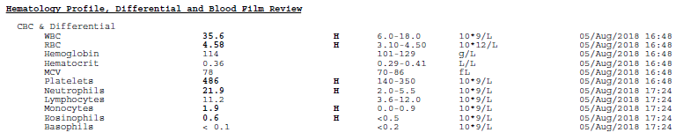

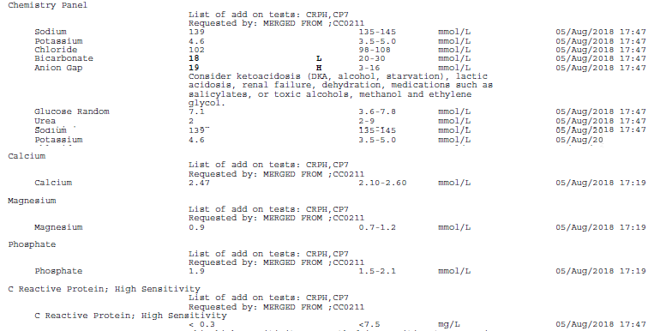

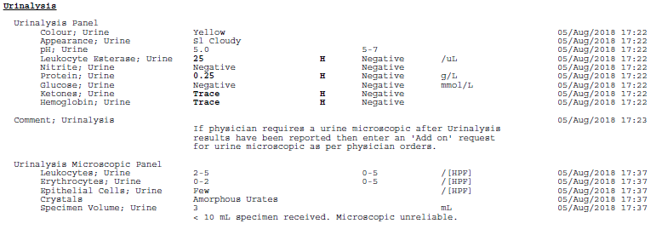

Appendix B: Facilitator Cheat Sheet & Debriefing Tips

Include key errors to watch for and common challenges with the case. List issues expected to be part of the debriefing discussion. Supplemental information regarding any relevant pathophysiology, guidelines, or management information that may be reviewed during debriefing should be provided for facilitators to have as a reference.

FPIES (Food Protein-Induced Enterocolitis Syndrome)

- Severe non-IgE mediated food allergy presenting with GI symptoms and altered mentation
- Most commonly seen with milk and soy but can be seen with other foods such as grains, rice, meats, poultry, seafood, fruits, and vegetables
- Suspect it when an infant presents shocky and altered around time of food introduction e.g. 5 or 6 month of age
- Associated with profuse vomiting and diarrhea and altered mentation
- Leukocytosis, neutrophilia, and thrombocytosis are common
- Rapidly responds to fluid resuscitation
- Need to rule-out sepsis, trauma, intoxication, inborn errors, etc.
- Tolerance acquisition to offending agents can be seen at 12 to 18 months

References

1. Barasche, Judith; Stollar, Fabiola; Bergmann, Marcel M. Severely-Altered Consciousness and Profuse Vomiting in Infants. Pediatric Emergency Care. October 06, 2016

