Case Title | Hyperleukocytosis associated with Acute Myelogenous Leukemia
Scenario Name | Hyperleukocytosis associated with Acute Myelogenous Leukemia

Learning Objectives - Use action words
Knowledge:
- Review the presentation and initial management of hyperleukocytosis in malignant conditions.
- Review of types of blood products.
Skills:
- Demonstrate management of hyperleukoctysis in malignant conditions.
- Demonstrate understanding of initial management of associated coagulopathy.
- Provide definitive therapy while arriving at diagnosis of underlying malignancy (for oncology fellow)
Attitude/Behaviours:
- Demonstrate Team skills
- Demonstrate Situational awareness
- Demonstrate Graded Assertiveness
Scenario Environment
Location | ED
Monitors | Bedside monitor
Props/Equipment | IV set-up  Central line kit
Make-up/Moulage
Potential Distractors

Case Introduction:
6 year old girl who has a fever x3 days at home. General malaise. Tonight has progressing tiredness and headache. Crying and irritable. Sleeping on couch and not wanting to play. Red spots beginning to appear on legs, arms, face and trunk since afternoon. Nosebleed for 30 minutes before presentation.

Patient Parameters | Effective Management | Notes
Phase 1: Presentation  Condition: Tired. Whimpering. Holding head.  Initial Assessment  - Heart Rhythm: ST  - HR: 160  - BP: 110/52  - RR: 30  - SP02: 90% RA  - T: 39.5  - CNS: GCS 13 (E = 3, V = 4, M = 6). Tired. PERL @4. No focal deficits. Reflexes 2/4.  - CVS: hyper dynamic precordium, Grade III/VI systolic ejection murmur. Gallop rhythm. Cap refill <2 sec  - Chest: Mild distress. Mildly decr a/e, crackles.  - GI: soft. Liver just under costal margin. No splenomegaly. No splenomegaly.  - Integ: Nodules (leukemia cutis) and petechiae/purpura  - Weight: 25 kg | - Take a focused history (see notes column)  - Medical Management  - Apply oxygen by mask  - Apply monitors  - How is the patient positioned: on back vs. side  - Pressure to nose to stop bleeding.  - Auscultate chest  - Check pulse, cap refill, BP  - Insert IV x 2 – Start IVF bolus (without K)  - Orders stat bloodwork: CBC, Diff, Group and Screen, BC, CRP, Lytes, Ca, Mg, PO4, Urea, Creatinine, Liver Enzymes and Bili’s, PTT, INR, Fibrinogen, D-Dimer, Uric Acid, LDH, Venous Gas and Lactate.  - Orders Stat CXR.  - Starts Cefotaxime/Vancomycin or other broad spectrum antibiotics.  - Makes NPO.  - DOES NOT DO LUMBAR PUNCTURE. | - Focused history  PMHx  - Healthy  - Fully Immunized including meningococcal  Meds  - Nil  Allergies  - NKA  Other  - Assigns person for A&B  - Suction mouth and nose if required
Phase 2: Continuous Bleeding  Condition: Nose bleed stops with pressure. Now bleeding from IV sites  Physical Examination  - Heart Rhythm: ST  - HR: 160  - BP: 108/50  - RR: 30  - SP02: 92% on O2 by face mask  - CNS: GCS 13  - CVS: bleeding from IV sites | - Patient Reassessment (see Notes column)  - Medical Management  - Orders another fluid bolus (20cc/kg) of NS over 15 minutes then runs D5W1/2NS plus 50 mEq NaHCO₃/L without KCL at 2-4x maintenance requirements (around 130 – 260 cc / hour).  - Calls oncology for immediate advice on how to manage.  - Calls bloodbank stat (see notes column)  - Establishes a 3rd IV if needed for fluid and blood products.  - Inserts folley catheter.  - Recognize and treat Hyperkalemia.  - 12-lead EKG (no changes of hyperkalemia).  - Kayexalate 1g/kg orally.  - Changes antibiotics to f/n guidelines (Pip/Tazo and Gent or Meropenum) | - Patient Reassessment  Airway  - Nose bleed stops with pressure  Breathing  - No changes  Circulation  - Bleeding from IV sites  Request from Blood Bank  - 5 Units CMV neg Irradiated Platelets – run over 15-30 minutes.  - 10 cc/kg CMV neg Irradiated prbc’s – run over 3-4 hours. Not to exceed this volume because of concerns about hyperviscosity.  - 10 cc/kg fresh plasma IV over 30 minutes – 1 hour.  - 5 units (1 unit per 5 kg) cryoprecipitate IV push.
Phase 3: Condition Deteriorates  Condition: Depressed LOC  Physical Examination  - Heart Rhythm: ST  - HR: 140  - BP: 122/60  - RR: 30  - SP02: 100% on 5L FM  - T: 39.5  - Chest: poor a/e bilaterally. Loud crackles.  - CNS: GCS 9. (E=2, V=2, M=5 - but localizes to painful stimuli but only on left side). PERL. Reflexis equivicol.  - CVS: hyperdynamic precodium, GR III/VI SEM. CRT<2secs  - GU: u/o < 25 cc since presentation to ED | - Patient Reassessment (see Notes column)  - Medical Management  - Calls ICU stat.  - Ensures fluids are OK and urine output is maintained at least 3 cc/kg/hour. Gives 1 mg/kg furosemide or mannitol 0.5g/kg over 15 minutes.  - Aims urine pH 7.0-7.5.  - Starts urate oxidase 0.2mg/kg IV stat. Stops NaHCO in IV fluid.  - Reviews peripheral smear.  - Calls hematopathology to call in techs for emergent bone marrow aspirate and biopsy that evening. Reviews if flow-cytometry can be done on peripheral blood drawn already.  - CT Scan Head with ICU support.  - Calls for pheresis team. Femoral line needed for leukapheresis.  - Starts Prednisone or Dexamethasone and initiates tumor lysis precautions.  - Transfuses more platelets ASAP and asks for another stat set of coags and CBC/Diff when CT Scan is done. | - Patient Reassessment  - Attention paid to quick neuro  Airway  - No changes  Breathing  - No changes  Circulation  - Minimal u/o

Insert more lines if more phases required.

Expected Patient Management | Debriefing Points
- Student

- R1

- Senior IM resident

References:

X-RAYS – Click here

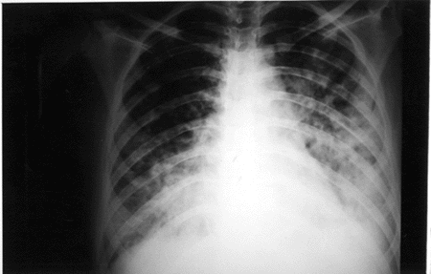

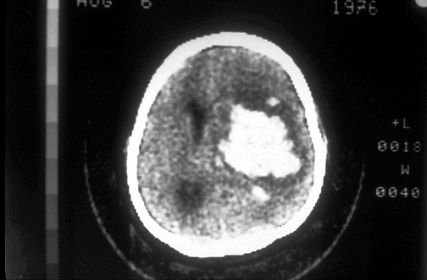

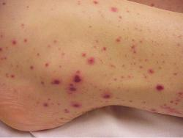

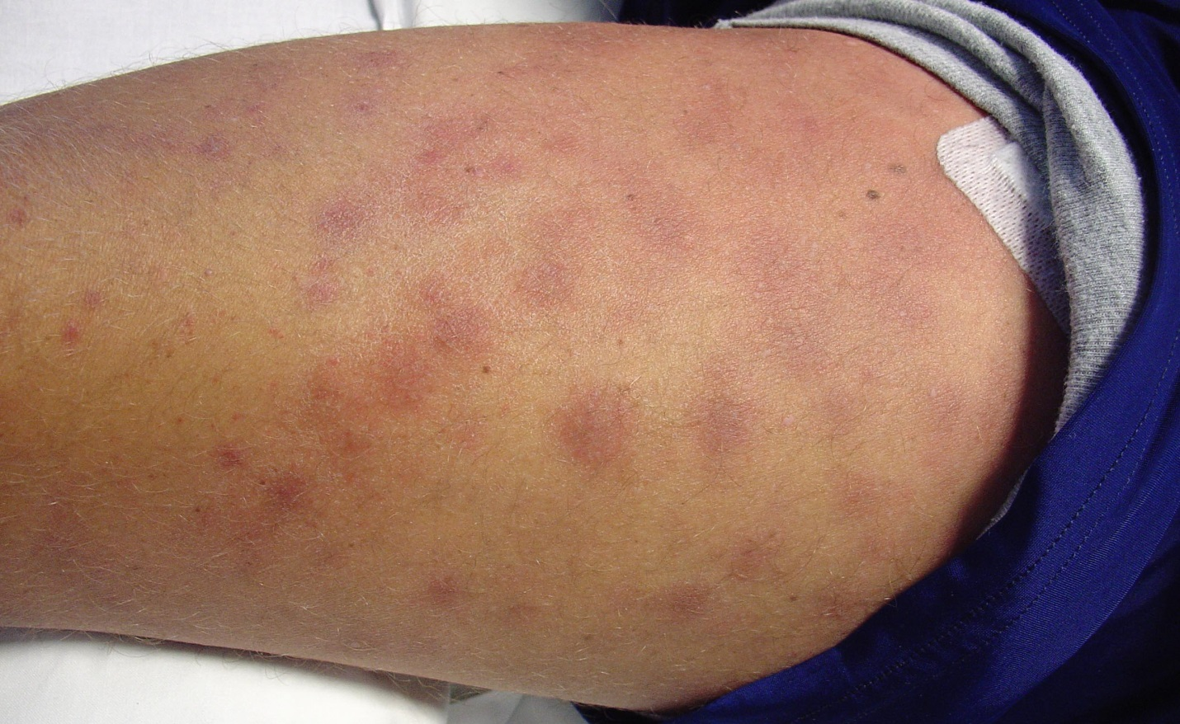

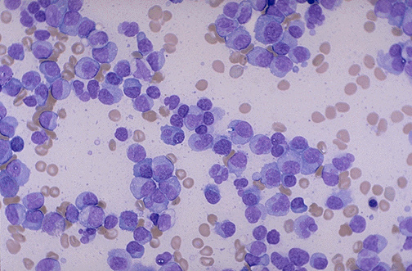

LABS – click here OR fill out below

LABORATORY *LIVE* Lab Summary Report
Test | DATE/TIME here |  | Flag (H or L) | Reference
CBC
WBC | 480 |  |  | 3.5 – 10.8 10^9/L
Neutrophils | 0.2 x 10⁹/L
Lymphocytes | 2.6 x 10⁹/L
Other cells | 475 x 10⁹/L
 | Toxic changes seen
Hgb | 46 |  | L | 130 – 170 g/L
Platelets | <5 |  | L | 150 – 400 10^9/L
Fibrinogen | 0.8 |  |  | g/L
D-Dimer | 2.5 |  |  | <250 mcg/L
Chemistry
Na | 130 |  |  | 137 – 145 mmol/L
K | 6.7 |  |  | 3.5 – 5.0 mmol/L
HCO3 | 14 |  |  | 22-26 mmol/L
Lactate | 4.0 |  |  | 0.9 – 1.8 mmol/L
Urea | 14.8 |  |  | 2.5 – 6.1 mmol/L
Creat | 65 |  |  | 62 – 106 umol/L
Ca | 2.25
PO4 | 1.95
Bilirubin Conujugated |  | 8
Bilirubin Unconjugated |  | 22
Uric Acid | 1247 |  |  | mmol/L
AST | 120
LDH | >20,000
ALT | 145
CRP | 85
Coags
INR | 3.6 |  | H | 0.9 – 1.2
PTT | 96 |  | H | 28 – 38 s
ABGs
Arterial
pH | 7.25 |  | L | 7.35- 7.45
pCO2 | 48 |  |  | 35 – 45 mmHg
PO2 |  |  |  | 80-100 mmHg
BE |  |  |  | -2.0 to +2.0 mmol/L
HCO3 | 14 |  |  | 22 – 26 mmol/L
O2 Sat |  |  |  | 95 – 100%

