|  |  |
| --- | --- |
| **Case Title** | Thyroid Storm |
| **Scenario Name** | Thyroid Storm |

|  |  |
| --- | --- |
| **Learning Objectives -** [**Use action words**](http://ubccpd.ca/sites/ubccpd.ca/files/Accreditation_Learning%20Objectives_%20Verbs.pdf) | |
| **Knowledge:**   1. Recognize the possibility of thyrotoxicosis in an emergency patient 2. Recognize the signs and symptoms of thyroid storm 3. Consider the possibility of induced arrhythmias related to thyroid storm | |
| **Skills:**   1. Demonstrate management of hypertension, tachycardia associated with thyroid storm | |
| **Attitude/Behaviours:**   1. Demonstrate Team skills 2. Demonstrate Situational awareness 3. Demonstrate Graded Assertiveness | |
| **Scenario Environment** | |
| **Location** | ED |
| **Monitors** | Bedside monitor |
| **Props/Equipment** | Medications  Intubation Equipment  ECG |
| **Make-up/Moulage** |  |
| **Potential Distractors** |  |

|  |
| --- |
| **Case Introduction:** |
| 11 year old girl with fever x 9 days was seen by family doctor 3 days ago and started on penicillin for suspected strep throat and cervical adenitis. Today she is quite agitated and confused at times. Parents very concerned and brought her to the emergency. |

| **Patient Parameters** | **Effective Management** | **Notes** |
| --- | --- | --- |
| **Phase 1: Presentation**  **Condition:** Looks very unwell. Toxic.  **Initial Assessment**   * **Heart Rhythm:** ST * **HR:** 210 * **BP:** 160/70 * **SP02:** 95% RA * **T:** 41 * **CNS:** GCS 14. Drowsy and confused at times. * **Chest:** Clear * **CVS:** gallop rhythm, soft murmur, capillary refill 2 secs * **Weight:** 25 kg | 1. **Take a focused history** (see Notes column) 2. **Medical Management**  * Apply monitors * Order bloodwork: CBC, electrolytes, blood gas, lactate, renal function, coagulation labs, blood culture, toxicology, extra serum/plasma on hold * Thyroid function tests – T3, T4, TSH * U/A, UC&S plus sample on hold * Antipyretic for fever   **B**   * Apply O2 by mask * Order CXR   **C**   * Insert IV x 2 * IV fluid bolus 20cc/kg | 1. **Focused history**  * Unwell for 10-14 days * Fevers, excessive sweating at night * Emotionally labile/sensitive x1 week * Swollen glands in throat area – swelling noted * Decreased attention span at school * Headaches and jitteriness * No chance of intoxication or overdose   **PMHx**   * Previously healthy   **Meds**   * Penicillin   **Allergies**   * NKA |
| **Phase 2: Slight Improvement**  **Condition:** Some improvement, but still looks unwell  **Physical Examination**   * **Heart Rhythm:** ST * **HR:** 190 * **BP:** 160/70 * **RR:** 32 * **SP02:** 99% on O2 * **T:** 38.9 * **CNS:** drowsy and confused – seems disoriented * **CVS:** gallop rhythm, soft murmur, capillary refill 2 secs | 1. **Patient Reassessment** (see Notes column) 2. **Medical Management**  * Provide IV fluid – D5NS – dextrose solutions are preferred IV fluids to cope with high metabolic demands * Control hyperthermia by applying ice packs and cooling blankets * Give tylenol or advil for fever * Give antibiotics * Consult endocrinology : Administer propanolol or esmolol to control sympathomimetic symptoms – control autonomic effects of thyroid hormone, and block conversion of T4 to T3.   A   * Prepare equipment for intubation * Have suction nearby   B   * Continue O2 * Prepare BVM   C   * Repeat IV fluid boluses * Identify ECG changes | 1. **Patient Reassessment**   **Airway**   * Patent   **Breathing**   * Tachypneic   **Circulation**   * Hypertension |
| **Phase 3: Deteriorating GCS**  **Condition:** Progressively confused, disoriented with deteriorating GCS  **Physical Examination**   * **Heart Rhythm:** ST * **HR:** 180 * **BP:** 160/70 * **RR:** 32 * **SP02:** 99% on O2 * **T:** 38.9 * **CNS:** GCS 11. Drowsy and confused – seems disoriented, eyes closed. * **Chest:** Clear. * **CVS:** gallop rhythm, soft murmur, capillary refill 2 secs | 1. **Patient Reassessment** (see Notes column) 2. **Medical Management**  * Review bloodwork * Consult with endocrinology re use of methimazole or Propylthiouracil (see notes) * Administer glucocorticoids : block conversion of T4 to T3 and associated with improved survival, give hydrocortisone 5mg/kg IV q6-8 h * Consult ICU for admission to hospital   **A**   * jaw thrust/head tilt prn * Intubate patient with RSI due to deteriorating GCS   **C**   * Give D5NS at maintenance and boluses as needed for poor perfusion | 1. **Patient Reassessment**   **Airway**   * Risk maintaining due to decreasing GCS   **Breathing**   * Tachypneic   **Circulation**   * Present   **Other**   * PTU : inhibits synthesis of thyroid hormone by inhibiting conversion of T4 to T3 – can be given po or ng (in comatose patients) – preferred due to early onset of action * Methimazole : inhibits synthesis of thyroid hormone. Comatose patients may require administration via NG tube because agent is available solely as PO preparation * Potassium Iodide : use in childhood thyroid storm is untested. Inhibits release of thyroid hormone from the thyroid gland. Must be given po/ng |

**Insert more lines if more phases required.**

|  |  |
| --- | --- |
| **Expected Patient Management** | **Debriefing Points** |
| 1. **Student** 2. **R1** 3. **Senior IM resident** |  |

**References:**

**X-RAYS – Click** [here](https://extranet.interiorhealth.ca/IHUBCFaculty/Diagnostics/Forms/AllItems.aspx?RootFolder=%25252FIHUBCFaculty%25252FDiagnostics%25252FX%25252Drays&View=%25257bFD97E2FE-FD01-433F-B9CB-D75A4195924E%25257d)

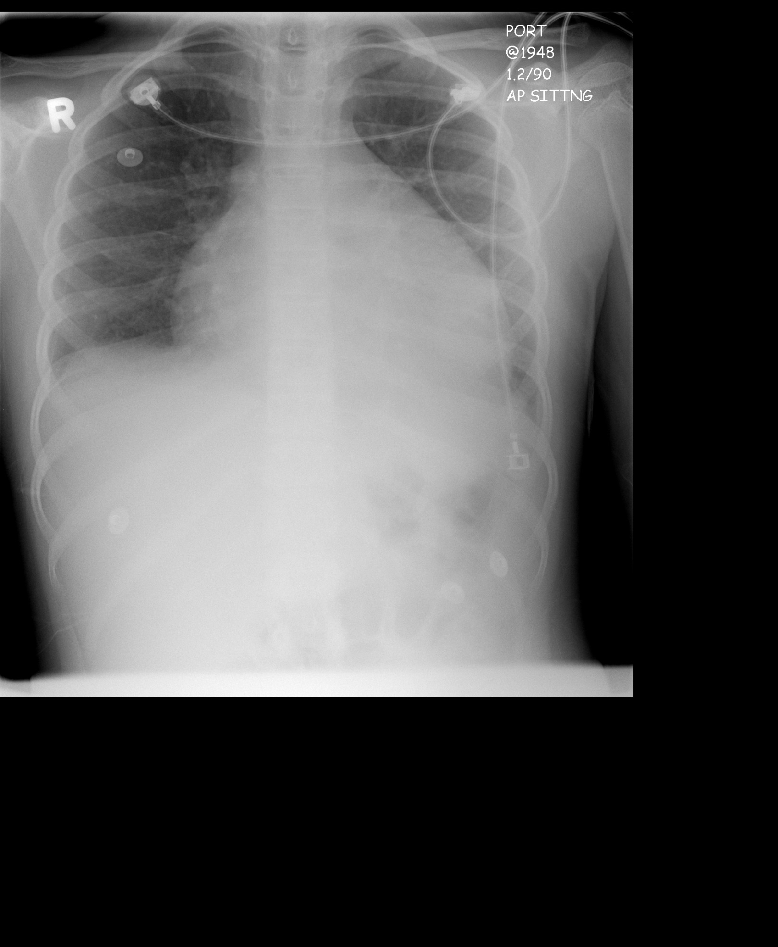

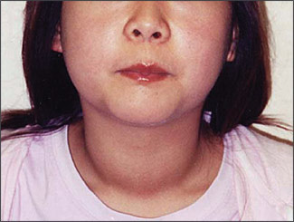

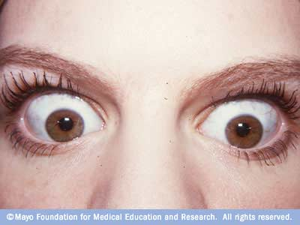

**LABS – click** [here](https://extranet.interiorhealth.ca/IHUBCFaculty/Diagnostics/Forms/AllItems.aspx?RootFolder=%25252FIHUBCFaculty%25252FDiagnostics%25252FLabs&View=%25257bFD97E2FE-FD01-433F-B9CB-D75A4195924E%25257d) **OR fill out below**

LABORATORY *LIVE* Lab Summary Report

|  |  |  |  |
| --- | --- | --- | --- |
| **Test** | **DATE/TIME here** | **Flag** (H or L) | **Reference** |
| **CBC** | | | |
| WBC |  |  | 3.5 – 10.8 10^9/L |
| RBC |  |  | 4.3 – 5.7 10^12/L |
| Hgb |  |  | 130 – 170 g/L |
| HCT |  |  | 0.37 – 0.47 L/L |
| MCV |  |  | 84.0 – 98.0 fL |
| MCH |  |  | 28.3 – 33.5 pg |
| MCHC |  |  | 329 – 352 g/L |
| RDW |  |  | 12.0/15.0 % |
| Platelets |  |  | 150 – 400 10^9/L |
| D-Dimer |  |  | <250 mcg/L |
| **Chemistry** | | | |
| Na |  |  | 137 – 145 mmol/L |
| K |  |  | 3.5 – 5.0 mmol/L |
| Cl |  |  | 98 – 107 mmol/L |
| HCO3 |  |  | 22-26 mmol/L |
| Urea |  |  | 2.5 – 6.1 mmol/L |
| Creat |  |  | 62 – 106 umol/L |
| GFR Est |  |  | > 60 ml/min |
| Glucose - Random |  |  | 3.0 – 11.0 mmol/L |
| Lactate |  |  | 0.9 – 1.8 mmol/L |
| CK |  |  | 5 – 130 U/L |
| Troponin |  |  | <0.03 mcg/L |
| **Coags** |  |  |  |
| INR |  |  | 0.9 – 1.2 |
| PTT |  |  | 28 – 38 s |
| **ABGs** | | | |
| **Arterial** | | | |
| pH |  |  | 7.35- 7.45 |
| pCO2 |  |  | 35 – 45 mmHg |
| PO2 |  |  | 80-100 mmHg |
| BE |  |  | -2.0 to +2.0 mmol/L |
| HCO3 |  |  | 22 – 26 mmol/L |
| O2 Sat |  |  | 95 – 100% |

**EKGs – click** [here](https://extranet.interiorhealth.ca/IHUBCFaculty/Diagnostics/Forms/AllItems.aspx?RootFolder=%25252FIHUBCFaculty%25252FDiagnostics%25252FECGs&View=%25257bFD97E2FE-FD01-433F-B9CB-D75A4195924E%25257d) **or paste**

