|  |  |
| --- | --- |
| **Case Title** | Hypothermia – Ski Hill |
| **Scenario Name** |  |

|  |  |
| --- | --- |
| **Learning Objectives -** [**Use action words**](http://ubccpd.ca/sites/ubccpd.ca/files/Accreditation_Learning%20Objectives_%20Verbs.pdf) | |
| **Knowledge:**   1. Recognize Severe Hypothermia 2. Understand indications for external active rewarming – 2016 Accidental Hypothermia Clinical Practice Guidelines 3. Understand management of VF in the hypothermic patient | |
| **Skills:**   1. Rapid Sequence Intubation/Airway management 2. Hypothermic Active Rewarming 3. ACLS guidelines for Cardiac Arrest management 4. Use of LUCAS for CPR | |
| **Attitude/Behaviours:**   1. Demonstrate Team skills 2. Demonstrate Situational awareness 3. Demonstrate Graded Assertiveness | |
| **Scenario Environment** | |
| **Location** | Emergency Deparment |
| **Monitors** | Bedside cardiac monitor, Crash Cart, Defibrillator |
| **Props/Equipment** | RSI meds, intubation equipment, core temp thermometer, vascular access supplies, IO supplies, Chest tubes, OG, Foley, LUCAS |
| **Make-up/Moulage** | Nil |
| **Potential Distractors** | None |

|  |
| --- |
| **Case Introduction:** |
| Prehospital Notification:  30-something male, found in tree well by Silver Star ski patrol. Patient did not return from night skiing, at which time patrol was notified and search of hill begun. Collateral by friends: ETOH and cocaine use prior to skiing. Unknown duration of cold exposure but last seen at 6pm, found at 9pm. Minimally responsive/GCS 7 (E1-M4-V2). EHS unable to get a temperature. Bradycardic/hypotensive. Unable to obtain vascular access. |

| **Patient Parameters** | **Effective Management** | **Notes** |
| --- | --- | --- |
| **Phase 1: Severe hypothermia**  **Condition:** Unstable  Minimally responsive with ++ airway secretions  **Initial Assessment**   * **Heart Rhythm:** Sinus bradycardia with J waves * **HR:** 45 * **BP:** 85/45 * **RR:** 14 * **SP02:** unobtainable * **Temp:** 27 C (core) | 1. **Take a focused history** (see Notes column) 2. **Medical Management** 3. **Temp monitoring** – obtain a core temp (rectal or esophageal) and blood glucose 4. **Airway intervention** – Recognize need for intubation/RSI. Etomidate, Ketamine, Succinylcholine and Rocuronium are OK. Recognize the need to minimize jostling. 5. **Hypotension** – Vascular access and initial crystalloid infusion. Peripheral IV access is unsuccessful…will require IO vs central line (caution with SC/IJ and inducing dysrhythmia)   **Active external and minimally invasive warming** –warmed humidified O2 (titrate to 92-98%) and warmed IV fluids (38-42 C). “Hypothermia burrito” – see appendix E Accidental Hypothermia Clinical Practice Guideline for BC:  1.Insulation or heating pad beneath patient  2. Replace wet clothes  3. Forced air/chemical/or electrical heating device above patient  4. Insulation blanket  Consider bladder irrigation, thoracic and/or peritoneal lavage if ECMO not available within 6 hours or not recommended | 1. **Focused history**   Friends report ETOH and cocaine use prior to skiing today.  **PMHx**   * Unknown   **Meds**   * Unknown   **Allergies**   * Unknown |
| **Phase 2: VF Arrest**  **Condition:** Unresponsive  Progress to this phase following intubation.  **Physical Examination**   * **Heart Rhythm:** VF * **HR:** - * **BP:** -/- * **RR:** 12 (vent) * **Temp:** 27 C (core)   **CNS:** nresponsive | 1. **Patient Reassessment**   *Recognizes change in condition to pulseless VF*   1. **Medical Management:**  * CPR * Up to 3 doses of epinephrine and defibrillation with further dosing guided by clinical response (after 3 defibrillation attempts have been unsuccessful, do not pause CPR to analyze the rhythm until core temp has increased by at least 2-4 degrees C) * Order labs (serum K 8.3), portable CXR * Should consider alternative/competing causes for hypothermia (metabolic/infectious/drugs/traumatic/etc) | 1. **Patient Reassessment**   **Airway**  **Breathing**  **Circulation** |
| **Phase 3: Active Internal Rewarming**  **Condition:** Unstable  **Physical Examination**   * **Heart Rhythm:** VF * **HR: -** * **BP: -/-** * **Temp:** 28 C | 1. **Medical Management:**  * Continue CPR and rewarming techniques | Once warmed and multiple defibrillations provided, allow for ROSC |
| **Phase 4: ROSC**  **Condition:** Unstable, unresponsive  **Physical Examination**   * **Heart Rhythm:** Sinus Brady * **HR:** 45 * **BP:** 76/32 * **Temp:** 30 C | 1. **Medical Management:**  * ROSC algorithim * Prepare for transfer to KGH with ECMO team |  |

**X-RAYS**

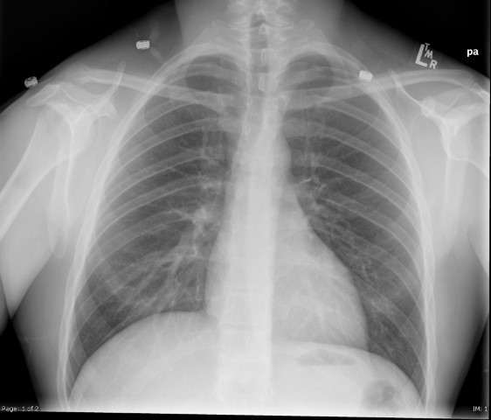

**X-Rays**

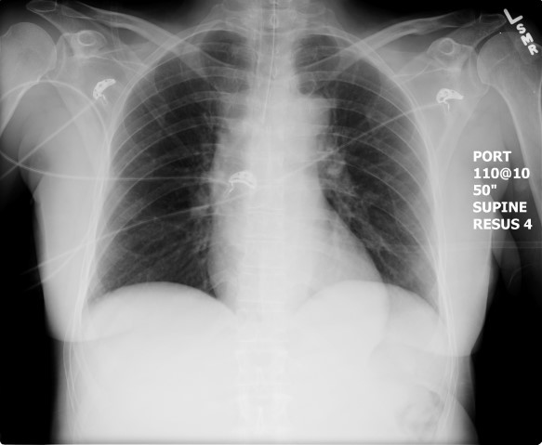

**LABS**

LABORATORY *LIVE* Lab Summary Report

|  |  |  |  |
| --- | --- | --- | --- |
| **Test** | **DATE/TIME here** | **Flag** (H or L) | **Reference** |
| **CBC** | | | |
| WBC | 16.8 |  | 3.5 – 10.8 10^9/L |
| RBC |  |  | 4.3 – 5.7 10^12/L |
| Hgb | 145 |  | 130 – 170 g/L |
| HCT |  |  | 0.37 – 0.47 L/L |
| Platelets |  |  | 150 – 400 10^9/L |
| D-Dimer |  |  | <250 mcg/L |
| **Chemistry** | | | |
| Na | 146 |  | 137 – 145 mmol/L |
| K | 8.3 |  | 3.5 – 5.0 mmol/L |
| Cl |  |  | 98 – 107 mmol/L |
| HCO3 |  |  | 22-26 mmol/L |
| Urea |  |  | 2.5 – 6.1 mmol/L |
| Creat |  |  | 62 – 106 umol/L |
| GFR Est |  |  | > 60 ml/min |
| Glucose - Random |  |  | 3.0 – 11.0 mmol/L |
| Lactate | 11.3 |  | 0.9 – 1.8 mmol/L |
| CK |  |  | 5 – 130 U/L |
| Troponin |  |  | <0.03 mcg/L |
| **Coags** |  |  |  |
| INR |  |  | 0.9 – 1.2 |
| PTT |  |  | 28 – 38 s |
| **ABGs** | | | |
| **Arterial** | | | |
| pH | 6.98 |  | 7.35- 7.45 |
| pCO2 | 56 |  | 35 – 45 mmHg |
| PO2 | 72 |  | 80-100 mmHg |
| BE |  |  | -2.0 to +2.0 mmol/L |
| HCO3 | 13 |  | 22 – 26 mmol/L |
| O2 Sat |  |  | 95 – 100% |

**EKGs**

