|  |  |
| --- | --- |
| **Case Title** | Thoracic Aortic Dissection |
| **Scenario Name** | “I can’t move my legs” |

|  |  |
| --- | --- |
| **Learning Objectives -** [**Use action words**](http://ubccpd.ca/sites/ubccpd.ca/files/Accreditation_Learning%20Objectives_%20Verbs.pdf) | |
| **Knowledge:**   1. Review differential diagnosis of acute paraplegia 2. Recognition of thoracic dissection types A and B | |
| **Skills:**   1. Demonstrate management of thoracic aortic dissection | |
| **Attitude/Behaviours:**   1. Demonstrate Team skills 2. Demonstrate Situational awareness 3. Demonstrate Graded Assertiveness | |
| **Scenario Environment** | |
| **Location** | ED |
| **Monitors** | Bedside monitor |
| **Props/Equipment** |  |
| **Make-up/Moulage** | None |
| **Potential Distractors** | Family – pressing for “clot buster” |

|  |
| --- |
| **Case Introduction:** |
| 76 yo male brought in with sudden inability to move legs. |

| **Patient Parameters** | **Effective Management** | **Notes** |
| --- | --- | --- |
| **Phase 1: Presentation**  **Condition:** Anxious. Skin cool and clammy  **Initial Assessment**   * **Heart Rhythm:** Sinus * **HR:** 72 * **BP:** 70/40 * **RR:** 20 * **SP02:** 93% * **T:** 37.0 * **Glucose:** 18 * **CNS:** GCS 15. Unable to move legs. * **Chest:** Clear * **Integ:** Cool and clammy | 1. **Take a focused history** (see Notes column) 2. **Medical Management**  * ABC’s * IV, O2, monitor * Thoracic Aorta Dissection Management:   + Type B – Manage medically   + Type A – Recognize must go to OR * Identify differential diagnoses for acute paraplegia * Investigations * Call surgeon   **Consequences of ineffective management**   * Death | 1. **Focused history**  * Sudden onset associated with shoulder pain.     **PMHx**   * Diabetes * Back pain * HTN * CHF with poor EF   **Meds**   * Metoprolol * Ramipril * Lasix * Metformin   **Allergies**   * NKA |
| **Phase 2: Improvement**  **Condition:**  **Physical Exam**   * **Heart Rhythm:** Sinus * **HR:** 80 * **BP:** 180/98 * **RR:** 18-20 * **SP02:** 93% on 3L * **CNS:** GCS 15. No change to paraplegia. | 1. **Patient Reassessment** (see Notes column) 2. **Medical Management**  * Continue managing ABCs * Surgeon calls back – OR ready | 1. **Patient Reassessment**   **Airway**   * Patent   **Breathing**   * Improved   **Circulation**   * Improved |

**Insert more lines if more phases required.**

|  |  |
| --- | --- |
| **Expected Patient Management** | **Debriefing Points** |
| 1. **Student** 2. **Junior Resident** 3. **Senior Resident** | * Discussion on Aortic dissection, spinal shock, and epidural hematoma |

**References:**

**X-RAYS**

[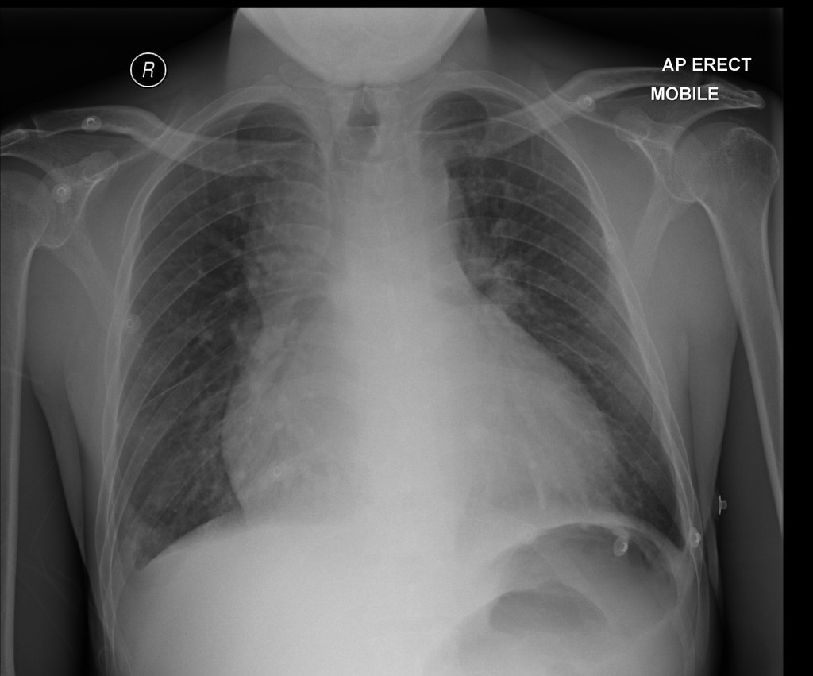](https://www.google.ca/url?sa=i&rct=j&q=&esrc=s&source=images&cd=&cad=rja&uact=8&ved=0ahUKEwil0aOz67jRAhWnj1QKHUl-DWUQjRwIBw&url=https://radiopaedia.org/cases/aortic-dissection-on-ctpa&bvm=bv.143423383,d.cGw&psig=AFQjCNH4yDWh5gnpPmr_2VVAE1CaQxuNVg&ust=1484181023010221)

[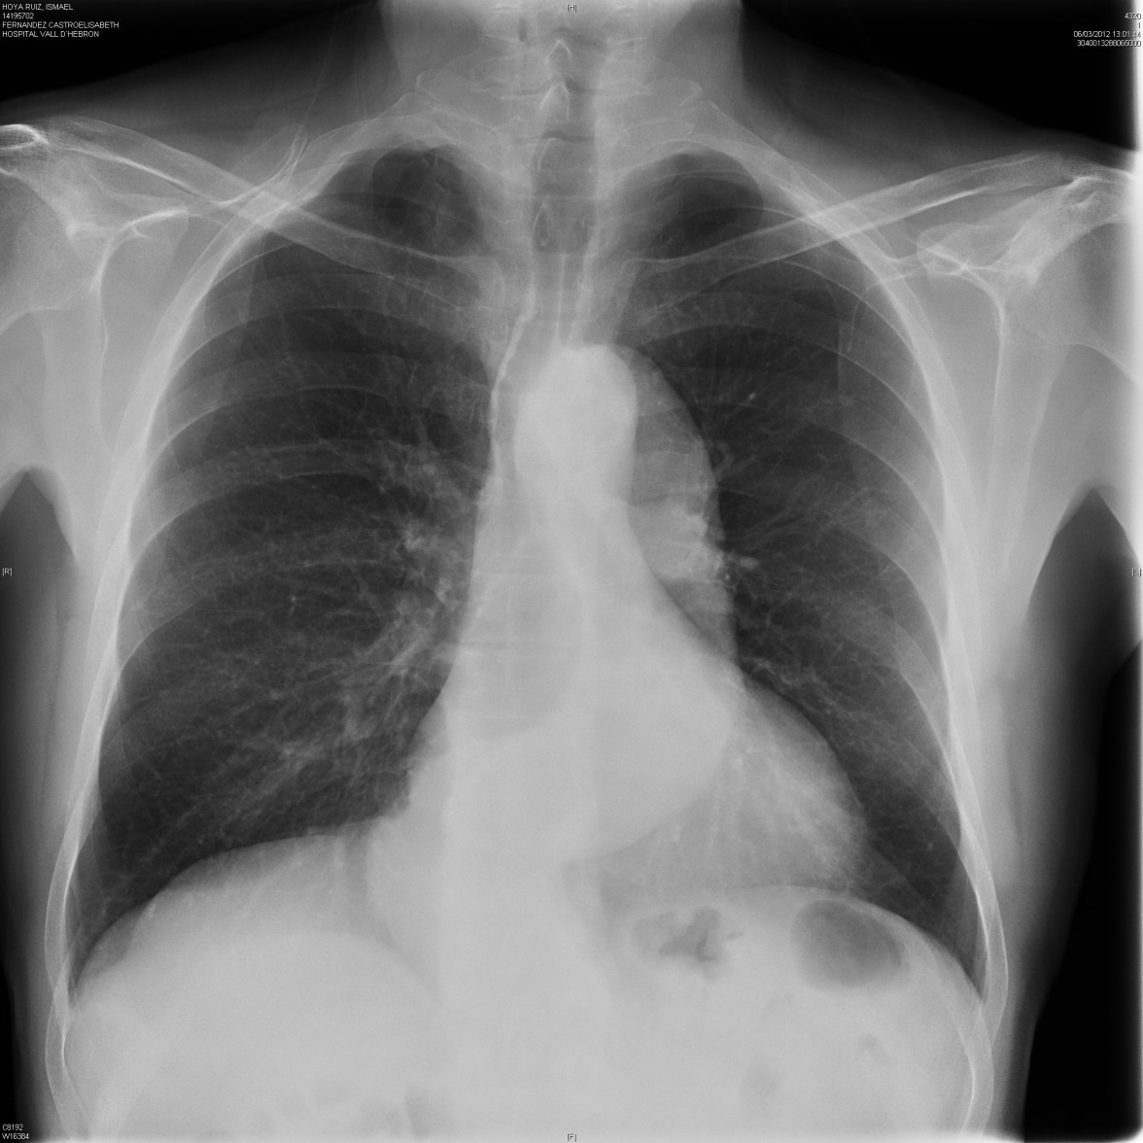](https://www.google.ca/url?sa=i&rct=j&q=&esrc=s&source=images&cd=&cad=rja&uact=8&ved=0ahUKEwjo667n6rjRAhXkjVQKHb6CB98QjRwIBw&url=https://coreem.net/core/aortic-dissection/&bvm=bv.143423383,d.cGw&psig=AFQjCNHW3Ea432cZYIiuYZlOpDCnM5wKCA&ust=1484180882077746)

**LABS – click** [here](https://extranet.interiorhealth.ca/IHUBCFaculty/Diagnostics/Forms/AllItems.aspx?RootFolder=%25252FIHUBCFaculty%25252FDiagnostics%25252FLabs&View=%25257bFD97E2FE-FD01-433F-B9CB-D75A4195924E%25257d) **OR fill out below**

LABORATORY *LIVE* Lab Summary Report

|  |  |  |  |
| --- | --- | --- | --- |
| **Test** | **DATE/TIME here** | **Flag** (H or L) | **Reference** |
| **CBC** | | | |
| WBC | **12.9** | **H** | 3.5 – 10.8 10^9/L |
| RBC | 5.0 |  | 4.3 – 5.7 10^12/L |
| Hgb | 141 |  | 130 – 170 g/L |
| HCT | 0.40 |  | 0.37 – 0.47 L/L |
| Platelets | 330 |  | 150 – 400 10^9/L |
| D- Dimer | **7000** | **H** | <250 mcg/L |
| **Chemistry** | | | |
| Na | 140 |  | 137 – 145 mmol/L |
| K | 3.8 |  | 3.5 – 5.0 mmol/L |
| Cl | 102 |  | 98 – 107 mmol/L |
| HCO3 | **16** | **L** | 22-26 mmol/L |
| Urea | **18.1** | **H** | 2.5 – 6.1 mmol/L |
| Creat | **300** | **H** | 62 – 106 umol/L |
| GFR Est | **23** | **L** | > 60 ml/min |
| Glucose - Random | **18** | **H** | 3.0 – 11.0 mmol/L |
| Lactate | **3.0** | **H** | 0.9 – 1.8 mmol/L |
| CK | **150** | **H** | 5 – 130 U/L |
| Troponin | **0.03** | **H** | <0.03 mcg/L |
| **Coags** |  |  |  |
| INR | 1.0 |  | 0.9 – 1.2 |
| PTT | 30 |  | 28 – 38 s |
| **ABGs** | | | |
| **Arterial** | | | |
| pH | 7.36 |  | 7.35- 7.45 |
| pCO2 | 36 |  | 35 – 45 mmHg |
| PO2 | 93 |  | 80-100 mmHg |
| BE | 1.0 |  | -2.0 to +2.0 mmol/L |
| HCO3 | 22 |  | 22 – 26 mmol/L |
| O2 Sat | 93 |  | 95 – 100% |

**EKGs**

[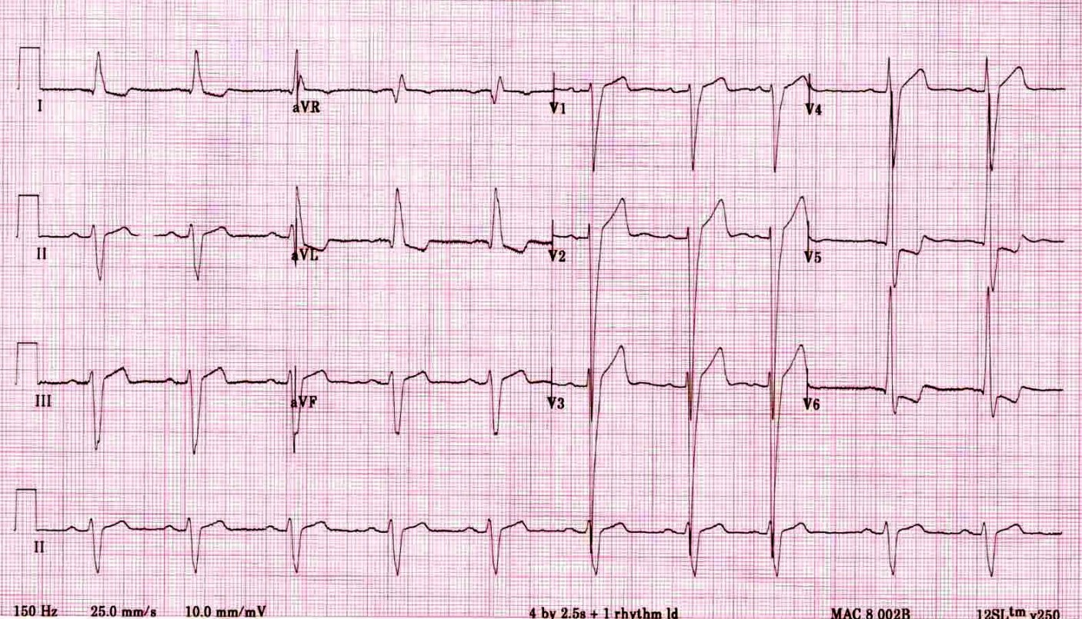](https://i0.wp.com/lifeinthefastlane.com/wp-content/uploads/2011/02/LVH2.jpg)