|  |  |
| --- | --- |
| **Case Title** | Methanol Intoxication |
| **Scenario Name** | Methanol Intoxication |

|  |  |
| --- | --- |
| **Learning Objectives -** [**Use action words**](http://ubccpd.ca/sites/ubccpd.ca/files/Accreditation_Learning%20Objectives_%20Verbs.pdf) | |
| **Knowledge:**   1. Identify symptoms and signs of Methanol intoxication 2. Describe how to utilize Anion gap and osmolar gap in regard to time of ingestion. 3. Discuss indications of Antidote and hemodialysis. | |
| **Skills:**   1. Utilize the resources & anticipate complication. 2. Manage methanol intoxication. | |
| **Attitude/Behaviours:**   1. Demonstrate Team skills 2. Demonstrate Situational awareness 3. Demonstrate Graded Assertiveness | |
| **Scenario Environment** | |
| **Location** | Emergency Department |
| **Monitors** | Cardiac, BP, pulse oximeter |
| **Props/Equipment** | ECG: Sinus tachycardia  CXR: post intubation  Lab results |
| **Make-up/Moulage** | Yes |
| **Potential Distractors** | None |

|  |
| --- |
| **Case Introduction:** |
| 10 y.o. boy who accidently ingested around 30ml of a windshield-washer fluid which was kept in a Gatorade bottle. It took 1hr to arrive to the ER. |

| **Patient Parameters** | **Effective Management** | **Notes** |
| --- | --- | --- |
| **Phase 1: Confused and vomiting**  **Condition:** Vomiting and seems confused  **Initial Assessment**   * **Heart Rhythm:** Sinus Tachycardia * **HR:** 140 * **BP:** 102/60 * **RR:** 34 * **SP02:** 98% RA * **T:** 35.5 C * **CNS:** GCS 13 (spont eye opening, delirious but seems to answer some questions, localizes pain). Answers some questions, asking for mom, confused at times * **Chest:** clear * **CVS:** cap refill 2 secs, pulses palpable * **GI:**  Abd soft * **H/N:** complain of blurry vision. Like walking in a snowstorm * **MSK:** normal * **Weight:** 20 kg | 1. **Take a focused history** (see Notes column) 2. **Medical Management**   **Airway**   * Assesses airway and talks to the patient * Clears / suctions the airway as needed   **Breathing**   * Check oxygen saturation * Apply monitors * Auscultate chest * Checks for adequacy of chest rise * Applies oxygen by simple mask   **Circulation**   * Monitors (if not done yet) * Check pulse, cap refill, BP * Identify the rhythm : sinus tachycardia * Asks for 2 large bore IV * Asks for bolus 20cc/kg NS * Orders blood work including: glucocheck,VBG, Serum lyte, serum osmolality, Alcohol level, LFT.   **Other**   * Contact poison center * Applies warm blankets | 1. **Focused history**  * Initially delirious, screaming, GCS 13/15 * No IV * Time of ingestion 3:30pm   **PMHx**   * Healthy * Immunization up to date   **Meds**   * None   **Allergies**   * NKDA |
| **Phase 2: Condition Worsens**  **Condition:** the patient’s condition has worsened, GCS fluctuation 8 - 10/15  **Physical Examination**   * **Heart Rhythm:** Sinus Tachycardia * **HR:** 170 * **BP:** 92/50 * **RR:** 40 * **SP02:** 100% with oxygen by mask * **T:** 36.0 * **CNS:** 10 (eye opening to verbal, delirious but seems to answer some questions, localizes pain). Confused at times. PERL * **Chest:** clear * **CVS –** tachycardic, pulses palpable and cap refill 3 secs * **Abdomen – soft, BS +ve** * **H/N –** PERL, normal * **MSK –** normal | 1. **Patient Reassessment** (see Notes column) 2. **Medical Management**   Airway   * Repositions airway * Assesses LOC   **Breathing**   * Auscultates chest * Continues to give oxygen and monitor sats   **Circulation**   * Reassess HR, pulses, BP, Cap refill * Asks for second bolus of 20 cc/kg of NS through second IV * Orders blood (not arrived yet)   **Secondary Survey**   * Assesses: H/N, Chest, CVS, Abdomen, MSK   **Further Interventions**   * Fomipazole 15 mg/kg I.V * Correct acidosis * Stat consultation : Nephrology& ICU for hemodialysis. * Orders repeat blood test with alcohol level ,AG, OG ,VBG, serum lytes & LFT. * Consider co-factor (Folic acid…) * Consider securing airway. * Inserts foley and monitor U.O.P | 1. **Patient Reassessment**   **Airway**   * Drowsy with gradual decrease in LOC * Continues to protect his airway spontaneously, but occasionally needs repositioning. * Intubated   **Breathing**   * Maintaining sats with O2   **Circulation**   * Tachycardic |
| **Phase 3: Decreased LOC**  **Condition:** Decreased LOC GCS < 8/15; eyes closed now  **Physical Examination**   * **Heart Rhythm:** Sinus Tachycardia * **HR:** 160 * **BP:** 91/48 * **RR:** 40 * **SP02:** 92% with oxygen by mask * **T:** 36.0 C * **CNS:** GCS 7; eyes closed 1, no response to painful stimuli 3, withdraws to pain 4 * **Chest:** clear * **CVS:** cap refill 3 secs, pulses palpable | 1. **Patient Reassessment** (see Notes column) 2. **Medical Management**   Airway   * Prepare for intubation due to decreasing LOC   + Orders drugs for RSI   + Pre -oxygenates   + Prepares equipment and ET CO2   + Atropine 0.02 mg/kg   + Etomidate 0.3 mg/kg   + Succs 1.5 – 2 mg/kg * Checks tube placement post intubation, orders CXR   **Breathing**   * Assesses chest pre/post intubation * Monitors oxygen saturation   **Circulation**   * BP remained stable.   **Imaging:**   * CXR – normal   **Further Interventions**   * ICU staff & Nephrologist arrive – will take patient to PICU * Consider Folinic acid & folic acid if not given. * Discuss need for Fomepizole during dialysis. | 1. **Patient Reassessment**   **Airway**   * Not protected d/t decreased LOC, must intubate   **Breathing**   * Sats dropping, must intubate   **Circulation**   * Tachycardic |

**Insert more lines if more phases required.**

|  |  |
| --- | --- |
| **Expected Patient Management** | **Debriefing Points** |
| 1. **Student** 2. **R1** 3. **Senior IM resident** |  |

**References:**

**X-RAYS - click** [here](https://extranet.interiorhealth.ca/IHUBCFaculty/Diagnostics/Forms/AllItems.aspx?RootFolder=%25252FIHUBCFaculty%25252FDiagnostics%25252FLabs&View=%25257bFD97E2FE-FD01-433F-B9CB-D75A4195924E%25257d) **OR fill out below**

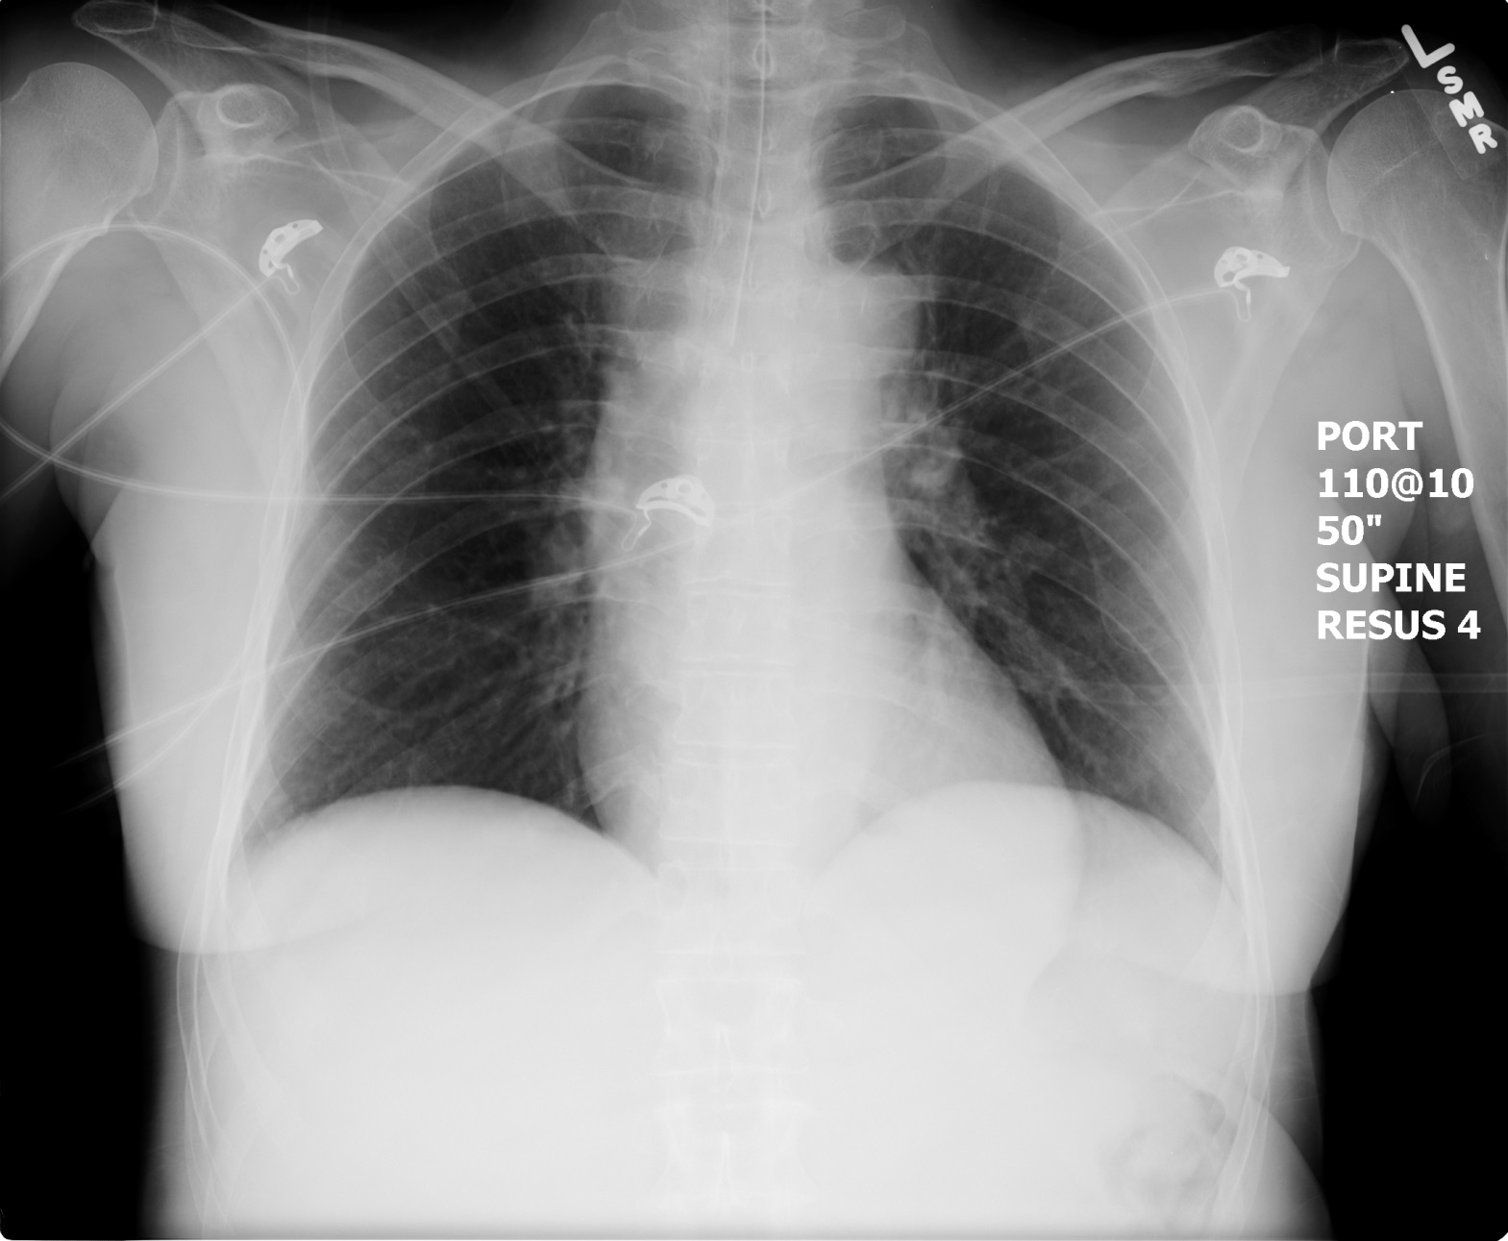

**LABS – click** [here](https://extranet.interiorhealth.ca/IHUBCFaculty/Diagnostics/Forms/AllItems.aspx?RootFolder=%25252FIHUBCFaculty%25252FDiagnostics%25252FLabs&View=%25257bFD97E2FE-FD01-433F-B9CB-D75A4195924E%25257d) **OR fill out below**

LABORATORY *LIVE* Lab Summary Report

|  |  |  |  |
| --- | --- | --- | --- |
| **Test** | **DATE/TIME here** | **Flag** (H or L) | **Reference** |
| **CBC** | | | |
| WBC | **12.5** | **H** | 3.5 – 10.8 10^9/L |
| RBC |  |  | 4.3 – 5.7 10^12/L |
| Hgb | **100** | **L** | 130 – 170 g/L |
| HCT |  |  | 0.37 – 0.47 L/L |
| Platelets | **400** |  | 150 – 400 10^9/L |
| **Chemistry** | | | |
| Na | 140 |  | 137 – 145 mmol/L |
| K | 5.0 |  | 3.5 – 5.0 mmol/L |
| Cl |  |  | 98 – 107 mmol/L |
| HCO3 |  |  | 22-26 mmol/L |
| Urea | **6.2** | **H** | 2.5 – 6.1 mmol/L |
| Creat | **46** | **L** | 62 – 106 umol/L |
| GFR Est |  |  | > 60 ml/min |
| Glucose - Random | 7.5 |  | 3.0 – 11.0 mmol/L |
| Lactate |  |  | 0.9 – 1.8 mmol/L |
| Serum Osmo | 302 | **H** |  |
| Osmo Gap | 8.3 | **H** |  |
| **Coags** |  |  |  |
| INR | 1.2 |  | 0.9 – 1.2 |
| PTT | **39** | **H** | 28 – 38 s |
| **ABGs** | | | |
| **Arterial** | | | |
| pH | **7.24** | **L** | 7.35- 7.45 |
| pCO2 | 40 |  | 35 – 45 mmHg |
| PO2 | **56** | **L** | 80-100 mmHg |
| BE | **-10** | **L** | -2.0 to +2.0 mmol/L |
| HCO3 | **15** | **L** | 22 – 26 mmol/L |
| O2 Sat |  |  | 95 – 100% |

**EKGs – click** [here](https://extranet.interiorhealth.ca/IHUBCFaculty/Diagnostics/Forms/AllItems.aspx?RootFolder=%25252FIHUBCFaculty%25252FDiagnostics%25252FECGs&View=%25257bFD97E2FE-FD01-433F-B9CB-D75A4195924E%25257d) **or paste**

