|  |  |
| --- | --- |
| **Case Title** | Decompensated Congestive Heart Failure |
| **Scenario Name** |  |

|  |  |
| --- | --- |
| **Learning Objectives -** [**Use action words**](http://ubccpd.ca/sites/ubccpd.ca/files/Accreditation_Learning%20Objectives_%20Verbs.pdf) | |
| **Knowledge:**   1. Recognize the presentation of decompensated CHF 2. Describe the management of decompensated CHF | |
| **Skills:**   1. Interpret ECG 2. Interpret CXR | |
| **Attitude/Behaviours**   1. Demonstrate Team skills 2. Demonstrate Situational awareness 3. Demonstrate Graded Assertiveness | |
| **Scenario Environment** | |
| **Location** | ER, ICU |
| **Monitors** | Telemetry, crash cart |
| **Props/Equipment** | BiPAP |
| **Make-up/Moulage** | Diaphoresis |
| **Potential Distractors** | None |

|  |
| --- |
| **Case Introduction:** |
| 71 yo male presents by ambulance due to shortness of breath. Triaged CTAS 1 to Trauma 3. |

| **Patient Parameters** | **Effective Management** | **Notes** |
| --- | --- | --- |
| **Phase 1: Severe Respiratory Distress**  **Condition:** Unstable  Sitting up, severe resp distress, 2-3 word sentences  **Initial Assessment**   * **Heart Rhythm:** Sinus Tachycardia * **HR:** 112 * **BP:** 190/105 * **RR:** 42 * **SP02:** 85% on NRB @ 15L * **T:** 36.4 C * **Glucose:** 6.2 * **Chest:** Bilateral coarse crackles * **CNS:** GCS 15 * **CVS:** S1/S2 with S4, cap refill 3 secs * **GI:** Normal * **Integ:** Diaphoretic * **Weight:** 82 kg * **Height:** 175 cm | 1. **Take a focused history** (see Notes column) 2. **Medical Management**  * Monitor * IV access * NTG SL/IV * RT to start BiPAP * EP, Troponin,BNP   **Consequences of ineffective management**   * Progress to Phase 2 (Impending Respiratory Failure) if NTG and BiPAP not started * Progress to Phase 3 (Condition Improvement) if NTG and BiPAP started | 1. **Focused history**   Sleeping in chair for 2 nights, awoke 5am with severe dyspnea. Denies chest pain.  **PMHx**   * MI with subsequent CABG x4 (7 years ago) * DM2 * HTN * Dyslipidemia * Never smoked   **Meds**   * ASA * Ramipril * Bisoprolol * Atorvastatin * Metformin   **Allergies**   * None |
| **Phase 2: Impending Respiratory Failure**  **Condition:** Unstable  Patients RR and BP drops and HR increases. GCS falls. Eyes closed.  **Physical Examination**   * **Heart Rhythm:** Sinus Tachycardia * **HR:** 132 * **BP:** 105/60 * **RR:** 28 * **SP02:** 80% on NRB @ 15L * **CNS:** GCS 7 (E-1, V-2, M-4) * **Chest:** Bilateral coarse crackles with decreased A/E throughout | 1. **Patient Reassessment** (see Notes column)-*Recognizes change in condition* 2. **Medical Management:**  * RSI and intubation | 1. **Patient Reassessment**   **Airway**   * Anticipates need to protect airway, begins set-up for intubation   **Breathing**   * Shallow, ineffective resps   **Circulation**   * Peripheral pulses weaker |
| **Phase 3: Condition Improvement**  **Condition:** Stable  (progress to this **ONLY** if NTG and BIPAP started)  Breathing improves, able to speak in full sentences.  **Physical Examination**   * **Heart Rhythm:** Sinus Rhythm * **HR:** 90 * **BP:** 150/84 * **CNS:** GCS 15 * **Chest:** Bilat fine crackles | 1. **Patient Reassessment** (see Notes column)-*Recognizes change in condition* 2. **Medical Management:**  * May wean NTG when BP improves and resp status improves * Furosemide IV * Foley to urometer * Consult Cardiology, CCU admit | 1. **Patient Reassessment**   **Airway**   * Protecting own   **Breathing**   * Deeper respirations, less WOB noted   **Circulation**   * Strong peripheral pulses |

|  |  |
| --- | --- |
| **Expected Patient Management** | **Debriefing Points** |
| 1. **Student** 2. **R1** 3. **Senior IM resident** |  |

**References:**

**X-RAYS – Click** [here](https://extranet.interiorhealth.ca/IHUBCFaculty/Diagnostics/Forms/AllItems.aspx?RootFolder=%25252FIHUBCFaculty%25252FDiagnostics%25252FX%25252Drays&View=%25257bFD97E2FE-FD01-433F-B9CB-D75A4195924E%25257d)

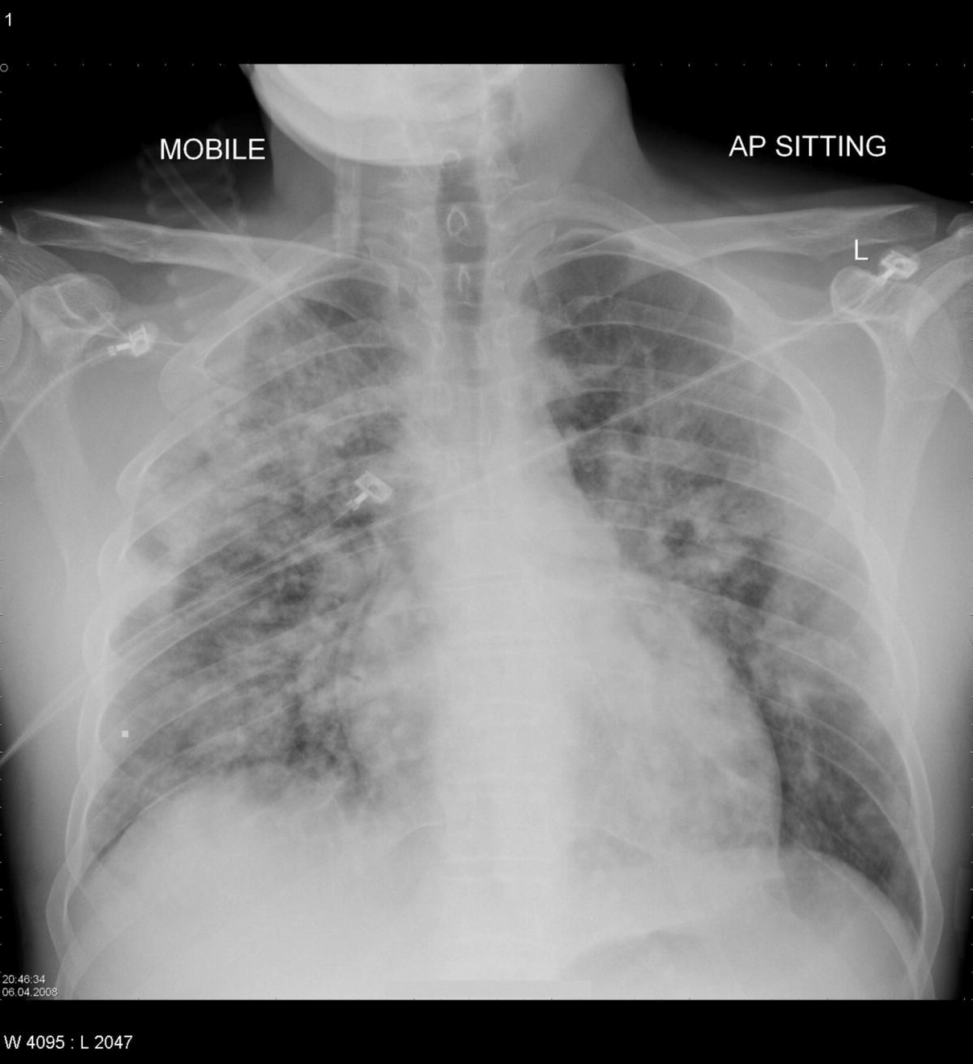

**LABS – click** [here](https://extranet.interiorhealth.ca/IHUBCFaculty/Diagnostics/Forms/AllItems.aspx?RootFolder=%25252FIHUBCFaculty%25252FDiagnostics%25252FLabs&View=%25257bFD97E2FE-FD01-433F-B9CB-D75A4195924E%25257d) **OR fill out below**

|  |  |  |  |
| --- | --- | --- | --- |
| **Test** | **DATE/TIME here** | **Flag** (H or L) | **Reference** |
| **CBC** | | | |
| WBC | 11 | **H** | 3.5 – 10.8 10^9/L |
| RBC |  |  | 4.3 – 5.7 10^12/L |
| Hgb | 145 |  | 130 – 170 g/L |
| HCT |  |  | 0.37 – 0.47 L/L |
| Platelets | 550 | **H** | 150 – 400 10^9/L |
| D-Dimer |  |  | <250 mcg/L |
| MCV | 90 | **H** | 0.37-0.47 L/L |
| **Chemistry** | | | |
| Na | 138 |  | 137 – 145 mmol/L |
| K | 4.2 |  | 3.5 – 5.0 mmol/L |
| Cl | 102 |  | 98 – 107 mmol/L |
| HCO3 | 24 |  | 22-26 mmol/L |
| Urea | 5.5 |  | 2.5 – 6.1 mmol/L |
| Creat | 97 |  | 62 – 106 umol/L |
| GFR Est | 66 |  | > 60 ml/min |
| Glucose - Random | 6.0 |  | 3.0 – 11.0 mmol/L |
| Lactate |  |  | 0.9 – 1.8 mmol/L |
| CK |  |  | 5 – 130 U/L |
| Troponin |  |  | <0.03 mcg/L |
| BNP | 980 | **H** | 0 – 99 mg/L |
| Lactic Acid | 3.7 | **H** | <2.0 mmol/L |
| **Coags** |  |  |  |
| INR | 1.0 |  | 0.9 – 1.2 |
| PTT | 32 |  | 28 – 38 s |
| **ABGs** | | | |
| **Arterial** | | | |
| pH |  |  | 7.35- 7.45 |
| pCO2 |  |  | 35 – 45 mmHg |
| PO2 |  |  | 80-100 mmHg |
| BE |  |  | -2.0 to +2.0 mmol/L |
| HCO3 |  |  | 22 – 26 mmol/L |
| O2 Sat |  |  | 95 – 100% |

**EKGs – click** [here](https://extranet.interiorhealth.ca/IHUBCFaculty/Diagnostics/Forms/AllItems.aspx?RootFolder=%25252FIHUBCFaculty%25252FDiagnostics%25252FECGs&View=%25257bFD97E2FE-FD01-433F-B9CB-D75A4195924E%25257d) **or paste**

