|  |  |
| --- | --- |
| **Case Title** | Obstructive Shock: Cardiac Tamponade |
| **Scenario Name** | Calvin Tam |

|  |  |
| --- | --- |
| **Learning Objectives -** [**Use action words**](http://ubccpd.ca/sites/ubccpd.ca/files/Accreditation_Learning%20Objectives_%20Verbs.pdf) | |
| **Knowledge:**   1. Identify the approach to Cardiogenic Shock 2. Describe the management of Cardiac Tamponade | |
| **Skills:**   1. Demonstrate resuscitation skills occurring simultaneous with assessment skills 2. Discuss Bedside Echo – Approach to Shock 3. Demonstrate insertion of a Central Line 4. Demonstrate Pericardiocentesis | |
| **Attitude/Behaviours**   1. Demonstrate Team skills 2. Demonstrate Situational awareness 3. Demonstrate Graded Assertiveness | |
| **Scenario Environment** | |
| **Location** | ER, ICU |
| **Monitors** | Regular monitor |
| **Props/Equipment** |  |
| **Make-up/Moulage** |  |
| **Potential Distractors** |  |

|  |
| --- |
| **Case Introduction:** |
| 42 yr Male, healthy active, cough, cold, nausea, vomiting, mild diarrhea, aches x 1 wk. Early this am, got up out of bed and collapses  EMS vitals: BP- 86/60, HR- 92, RR- 24, 02 Sat- 94% |

| **Patient Parameters** | **Effective Management** | **Notes** |
| --- | --- | --- |
| **Phase 1: Pericardial Effusion**  **Condition:** Stable.  Awake, BP soft, Tamp volume 250.  Looks well, tired, slightly dry.  **Initial Assessment**   * **Heart Rhythm:** Sinus Rhythm * **HR:** 92 * **BP:** 90/60 * **RR:** 24 * **SP02:** 98% on 10L NRB * **T:** 37.7 * **Glucose:** 6.7 * **Chest:** A/E clear * **CNS:** GCS 15 * **CVS:** Distant HS, JVP 4-5 * **GI:** Abd soft | 1. **Take a focused history** (see Notes column) 2. **Medical Management**  * Ask paramedic for focused hx, and vitals at the scene * Ask for further VS – glucose 6.7 and Temp 37.7 * Performs focused exam * ABCs – commenting on findings * Simultaneously having patient hooked up to monitor, IVs started * Orders investigations, EKG, CXR, labs | 1. **Focused history**   **PMHx**   * Healthy, appendectomy     **Meds**   * Recent OTC cough medicine   **Allergies**   * None |
| **Phase 2: Mild Cardiac Tamponade**  **Condition:** Unstable  Patients BP drops and HR increases, complaining of  nausea. Looks unwell. Tamp volume 300.  **Physical Examination**   * **Heart Rhythm:** Sinus Tachycardia * **HR:** 110 * **BP:** 82/58 * **RR:** 26 | 1. **Patient Reassessment** (see Notes column)-*Recognizes change in condition* 2. **Verbalizes differentials to team** (see Notes column) 3. **Medical Management:**  * Considers Antibx – Source unknown | 1. **Patient Reassessment**   **Airway**   * c/o nausea – anticipates need to protect airway   **Breathing**   * reassess lungs   **Circulation**   * develop differentials for shock  1. **Shock Differentials:**  * ***Hypovolemia***- administer fluid bolus, bolus must be given with pressure bag * ***Cardiogenic*** – assesses EKG, * ***Distributive*** – considers sepsis, * ***Obstructive*** – reviews CXR, considers tamponade – checks for pulses paradoxus. Assessment with bedside Ultrasound – heart, IVC |
| **Phase 3: Severe Cardiac Tamponade**  **Condition:** Unstable  Pt deteriorates, decrease LOC, unresponsive  Eyes closed; Severe hypotension; Tamp Volume 350ml  No peripheral pulse, Central – weak; JVP elevated  **Physical Examination**   * **Heart Rhythm:** Sinus Tachycardia * **HR:** 130 * **BP:** 70/30 * **CNS:** GCS 8 * **CVS:** Muffled heart sounds, elevated JVP | 1. **Patient Reassessment** (see Notes column)-*Recognizes change in condition* 2. **Medical Management:**  * Considers vasopressors to temporize blood pressure * Labs available if team asks   **Consequences of ineffective management**   * If pericardiocentesis not performed correctly- progress to Phase 4 (PEA Arrest). * If performed correctly, progress to Phase 5 (Condition improves) | 1. **Patient Reassessment**   **Airway**   * Anticipates need to protect airway, begins set-up   **Breathing**   * Shallow resp   **Circulation**   * Recognizes cause for shock and indications for urgent pericardiocentesis, prepares for emergency pericardiocentesis |
| **Phase 4: PEA Arrest**  **Condition:** Cardiac Arrest  (progress to this **ONLY** if Pericardiocentesis not performed correctly or in a timely manner)  Eyes closed; No pulse; Sinus tachy; Tamp volume 400  **Physical Examination**   * **Heart Rhythm:** Sinus Tachycardia * **HR:** 140 * **BP:** -/- * **RR:** Apneic * **CNS:** GCS 3 | 1. **Patient Reassessment** (see Notes column)-*Recognizes change in condition* 2. **Medical Management:**  * Checks for pulse, then starts CPR * Approach to PEA arrest 5Hs, 5Ts   **Consequences of ineffective management**   * Continues in PEA Arrest, may progress to asystole | 1. **Patient Reassessment**   **Airway**   * BVM   **Breathing**   * Assesses for good A/E   **Circulation**   * Assesses for good CPR, rate, depth, ETCO2 |
| **Phase 5: Condition Improves**  **Condition:** Stabilized  (progress to this **ONLY** if Pericardiocentesis is performed correctly)  Eyes closed; Sinus tachy; Tamp volume 0  **Physical Examination**   * **Heart Rhythm:** Slight Sinus Tachycardia * **HR:** 105 * **BP:** 96/54 * **RR:** 18 * **Chest:** Good – equal A/E | 1. **Patient Reassessment** (see Notes column)-*Recognizes change in condition* 2. **Medical Management:**  * Phones LLTO for transport, consults ICU for possible drain placement | 1. **Patient Reassessment**   **Airway**   * if intubated patient breathing on own * If BVM patient, breathing on own, biting on airway   **Breathing**   * Good – equal A/E   **Circulation**   * Yellow fluid from syringe * BP improves with fluid removed |

|  |  |
| --- | --- |
| **Expected Patient Management** | **Debriefing Points** |
| 1. **Student** 2. **R1** 3. **Senior IM resident** |  |

**References:**

**X-RAYS – Click** [here](https://extranet.interiorhealth.ca/IHUBCFaculty/Diagnostics/Forms/AllItems.aspx?RootFolder=%25252FIHUBCFaculty%25252FDiagnostics%25252FX%25252Drays&View=%25257bFD97E2FE-FD01-433F-B9CB-D75A4195924E%25257d)

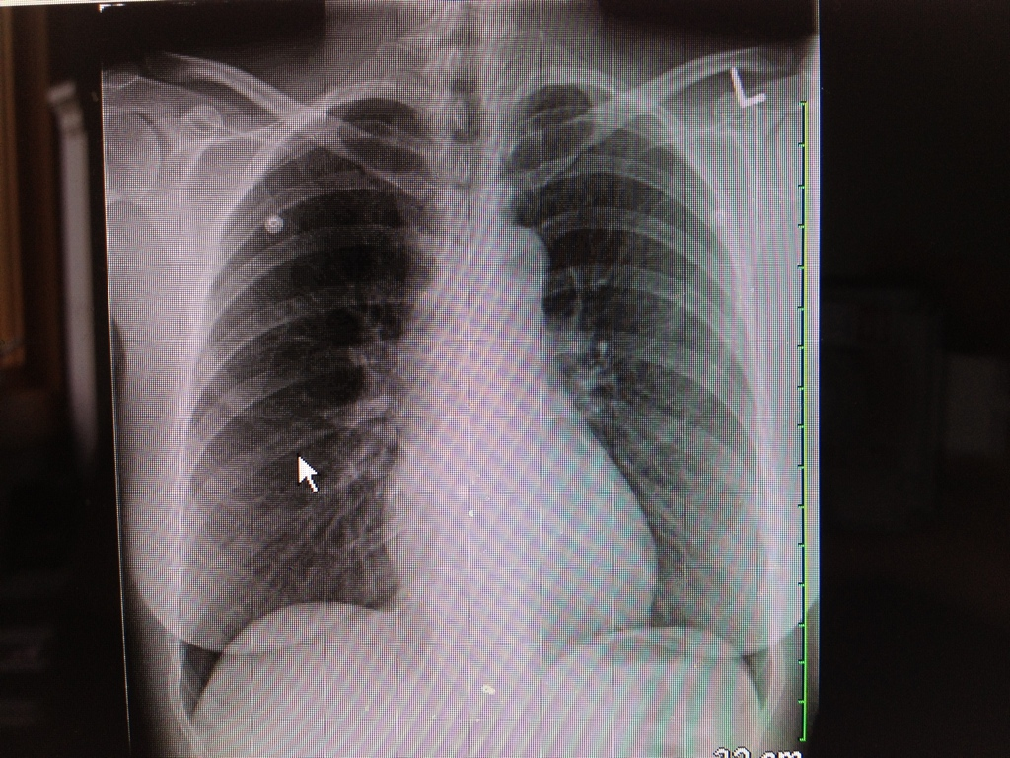

**LABS – click** [here](https://extranet.interiorhealth.ca/IHUBCFaculty/Diagnostics/Forms/AllItems.aspx?RootFolder=%25252FIHUBCFaculty%25252FDiagnostics%25252FLabs&View=%25257bFD97E2FE-FD01-433F-B9CB-D75A4195924E%25257d) **OR fill out below**

|  |  |  |  |
| --- | --- | --- | --- |
| **Test** | **DATE/TIME here** | **Flag** (H or L) | **Reference** |
| **CBC** | | | |
| WBC | 6.9 |  | 3.5 – 10.8 10^9/L |
| RBC |  |  | 4.3 – 5.7 10^12/L |
| Hgb | 167 |  | 130 – 170 g/L |
| HCT | 0.5 | **H** | 0.37 – 0.47 L/L |
| Platelets | 157 |  | 150 – 400 10^9/L |
| D-Dimer | <300 | **H** | <250 mcg/L |
| **Chemistry** | | | |
| Na | 133 | **L** | 137 – 145 mmol/L |
| K | 4.1 |  | 3.5 – 5.0 mmol/L |
| Cl | 94 | **L** | 98 – 107 mmol/L |
| CO2 | 23 |  | 22-30 mmol/L |
| Urea | 5.5 |  | 2.5 – 6.1 mmol/L |
| Creat | 61 | **L** | 62 – 106 umol/L |
| GFR Est |  |  | > 60 ml/min |
| Glucose - Random | 8.3 |  | 3.0 – 11.0 mmol/L |
| Lactate | 1.7 |  | 0.9 – 1.8 mmol/L |
| CK |  |  | 5 – 130 U/L |
| Troponin | 1.14 | **H** | <0.03 mcg/L |
| **Coags** |  |  |  |
| INR |  |  | 0.9 – 1.2 |
| PTT |  |  | 28 – 38 s |
| **ABGs** | | | |
| **Arterial** | | | |
| pH |  |  | 7.35- 7.45 |
| pCO2 |  |  | 35 – 45 mmHg |
| PO2 |  |  | 80-100 mmHg |
| BE |  |  | -2.0 to +2.0 mmol/L |
| HCO3 |  |  | 22 – 26 mmol/L |
| O2 Sat |  |  | 95 – 100% |

**EKGs – click** [here](https://extranet.interiorhealth.ca/IHUBCFaculty/Diagnostics/Forms/AllItems.aspx?RootFolder=%25252FIHUBCFaculty%25252FDiagnostics%25252FECGs&View=%25257bFD97E2FE-FD01-433F-B9CB-D75A4195924E%25257d) **or paste**

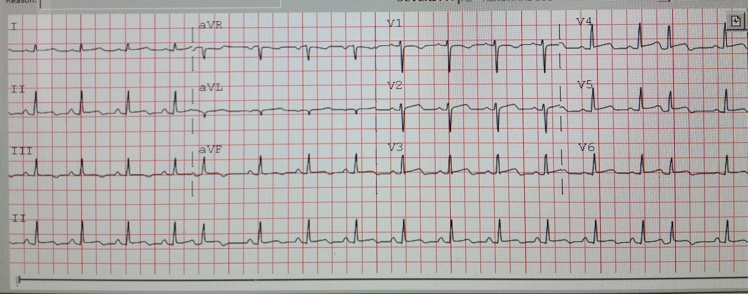

**ULTRASOUNDS – click** [**here**](https://extranet.interiorhealth.ca/IHUBCFaculty/Diagnostics/Forms/AllItems.aspx?RootFolder=%2FIHUBCFaculty%2FDiagnostics%2FUltrasound&View=%7bFD97E2FE-FD01-433F-B9CB-D75A4195924E%7d)

Ultrasound Video – ipad \june 18th pericardial effusion



TEACHING MATERIAL

* Does this patient with Pericardial Effusion Have Pericardial Tamponade? The Rational Clinical Exam JAMA April 25 2007-Vol 297 No 16
* Acute Cardiac Tamponade Spodick NEJM 2003;349:648-90
* Emergency Pericardiocentesis Fitch et al NEJM 2012:366:e17
* Bedside Ultrasound in Resuscitation and the Rapid Ultrasound in Shock Protocol Review Article Critical Care Research and Practice Vol 2012

<http://emcrit.org/rush-exam/>

http://thesonocave.com/2013/[04/tamponade-and-the-many-shades-of-grey/](http://thesonocave.com/2013/04/tamponade-and-the-many-shades-of-grey/)

[http://www.ultrasoundpodca](http://thesonocave.com/2013/04/tamponade-and-the-many-shades-of-grey/)st.com/2013/03/ultrasound-guided-pericardiocentesis-microcast-foamed-ed[ucation-mainlined/](http://www.ultrasoundpodcast.com/2013/03/ultrasound-guided-pericardiocentesis-microcast-foamed-education-mainlined/)

