Case Title | Mediastinal Mass
Scenario Name | Mediastinal Mass

Learning Objectives - Use action words
Knowledge:
- Identify respiratory distress as a presentation of mediastinal mass
- Identify other possible clinical findings of mediastinal mass (eg: Superior Vena Cava Syndrome) and tumor (blood counts, fever, rashes, etc.)
Skills:
- Demonstrate appropriate management of respiratory distress due to mediastinal mass
  - Early oncology intervention – steroids and radiotherapy
  - Cautious intubation – with backup, extreme caution with sedatives and paralytics
- Predict and solve complications of therapy – eg: TLS with steroids
Attitude/Behaviours:
- Demonstrate Team skills
- Demonstrate Situational awareness
- Demonstrate Graded Assertiveness
Scenario Environment
Location | ED
Monitors | Bedside  Cardiac
Props/Equipment | Intubation equipment
Make-up/Moulage
Potential Distractors

Case Introduction:
6 year old boy who has been feeling unwell for 3 weeks. Coughing for 3 weeks, worsening. No cold at start. Now febrile. Over the last week mom has noticed his breathing is noisier especially when lying down.

Patient Parameters | Effective Management | Notes
Phase 1: Presentation  Condition: moderate respiratory distress  Initial Assessment  - Heart Rhythm:  - HR:  - BP:  - RR:  - SP02:  - T:  - Glucose:  - CNS:  - Chest:  - CVS:  - GI:  - GU:  - Integ:  - Weight: 20kg  - Height: | - Take a focused history (see Notes column)  - Patient Assessment  Airway  - Patent – acute risk for deterioration  Breathing  - Moderate distress  Circulation  - Normal  - Medical Management  - Notes importance of ABCs and realizes airway is a major concern  - Institutes appropriate therapy (oxygen, reposition, considers bronchodilators, IV x2)  - Apply monitors  - Orders CXR stat  - Orders stat bloodwork: CBC, Diff, Group and Screen, BC, CRP, Lytes, Ca, Mg, PO4, Urea, Creatinine, Liver Enzymes and Bili’s, PTT, INR, Fibrinogen, D-Dimer, Uric Acid, LDH, Venous Gas and Lactate.  - Calls for senior help as appropriate (Sr ER, Sr Peds, Sr Onc) | - Focused history  - Sick contacts (no), recent illness (no), recent travel (no), TB contacts (no)  - Personal or FHx asthma (no)  - Fevers (x 2/7), night sweats (mom isn’t sure), weight loss (possible, definitely decreased appetite), energy (low)  PMHx  - Healthy  - Fully immunized  Meds  - Nil  Allergies  - NKDA  Other  - If orders steroids, confirm if they truly want it.  - Identifies possible concerns in this patient (airway obstruction, oncologic etiology vs other).  - Consider hyperhydration, alkalinizing urine, allopurinol or raspuricase
Phase 2: Progressive Deterioration  Condition: Stridorous  Physical Examination  - Heart Rhythm:  - HR: 140  - BP: 126/77  - RR: 40  - SP02: 100% on facemask O2  - T: 39  - Glucose:  - CNS: tiring, but otherwise alert  - Chest: loud biphasics stridor  - CVS:  - GI:  - GU:  - Integ: | - Patient Reassessment (see Notes column)  - Medical Management  - Recognize mediastinal mass on CXR  - Support airway (reposition, BVM, oral airway) & call RT  - Prepare for intubation  - Hyperhydrating  - Starts antibiotics empirically (pip/tazo + gent) – has neutrophils, but are they working  - Orders type and x-match pRBCs  - Orders CMV-, irradiated platelets on standby  - Considers cardiac assessment EKG, Echo (esp given mediastinal mass) | - Patient Reassessment  Airway  - Compromised  Breathing  - Stridorous, labored  - Tachypneic  Circulation  - Mildy hypertensive  - Tachycardic  Other  - Won’t tolerate oral airway  - Prompt – sure of sedatives/paralytics, ?noninvasive ventilation, call PICU/Anesthesia
Phase 3: Oncology Fellow Arrives  Condition: Deteriorating  Physical Examination  - Heart Rhythm:  - HR:  - BP:  - RR:  - SP02:  - T:  - Glucose:  - CNS:  - Chest:  - CVS:  - GI:  - GU:  - Integ: | - Patient Reassessment (see Notes column)  - Medical Management  - Ongoing management – airway, monitor for TLS, treat infection  - Central Line  - Oncology may start systemic steroids (methylprednisolone 1mg/kg q6h)  - Consider radiation (50-100cGY)  - Start chemotherapy | - Patient Reassessment  Airway  Breathing  Circulation  Other  - Does NOT perform LP unless intubated and stabilized

Insert more lines if more phases required.

Expected Patient Management | Debriefing Points
- Student

- R1

- Senior IM resident

References:

X-RAYS – Click here

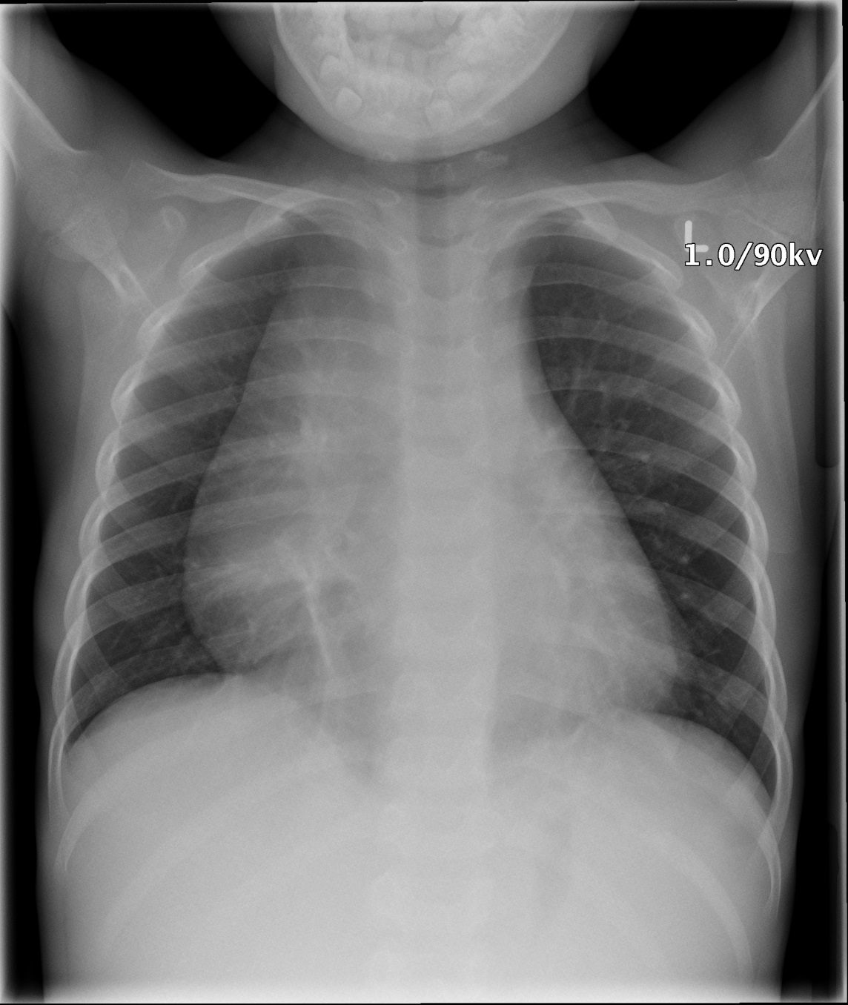

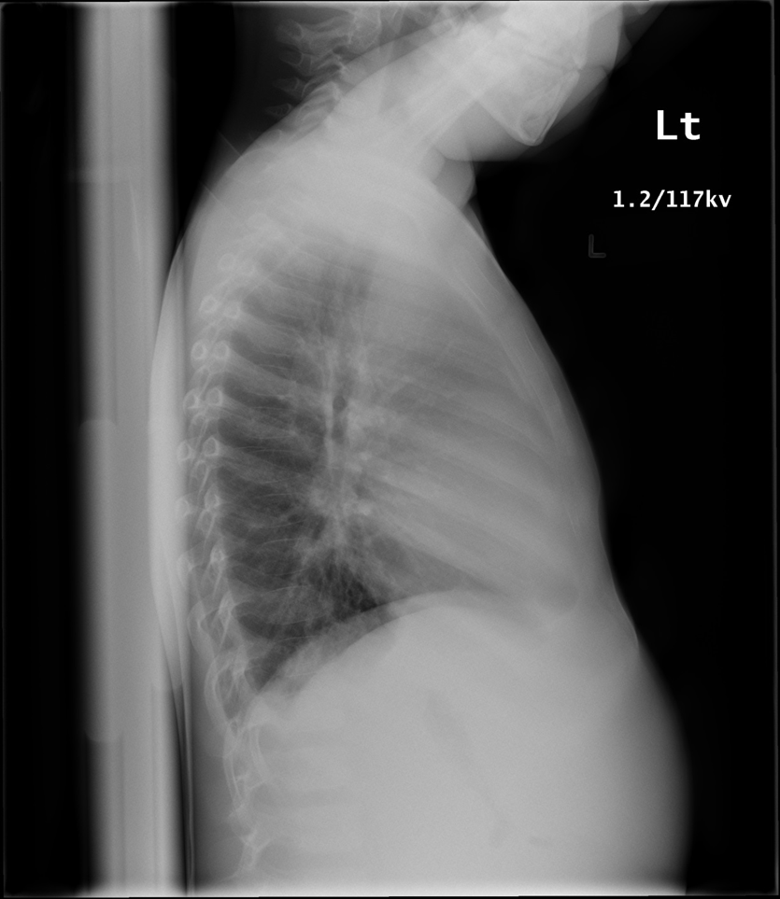
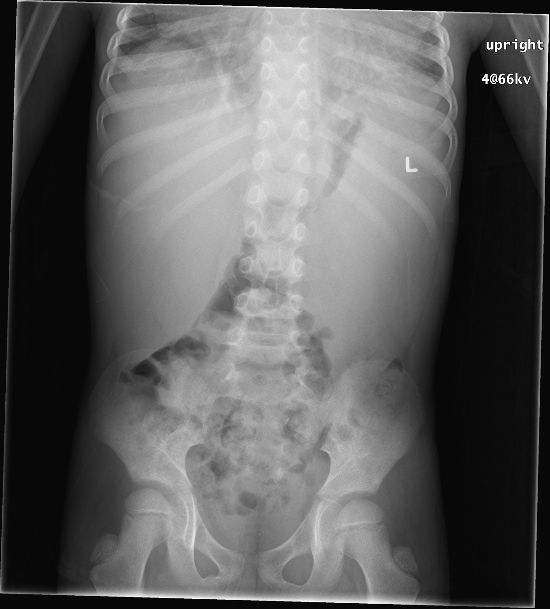

LABS – click here OR fill out below

LABORATORY *LIVE* Lab Summary Report

Test | DATE/TIME here | Flag (H or L) | Reference
CBC
WBC | 236 | H | 3.5 – 10.8 10^9/L
Neutrophils | 7.09
Lymphocytes | 4.72
ESR | 59
Reticulocytes | 43
Hgb | 68 | L | 130 – 170 g/L
Platelets | 28 | L | 150 – 400 10^9/L
Chemistry
Na | 138 |  | 137 – 145 mmol/L
K | 4.5 |  | 3.5 – 5.0 mmol/L
Cl | 106 |  | 98 – 107 mmol/L
Ca | 2.18
PO4 | 1.45
Mg | 0.89
Urea | 3.8 |  | 2.5 – 6.1 mmol/L
Creat | 36 |  | 62 – 106 umol/L
CSF
Appearance | Clear and colourless
Nucleated cells | 2 x 10⁶/L
RBC | <1 x 10⁶/L
Lymphocytes | 77%
Macrophages | 23%
 | No blasts seen

