|  |  |
| --- | --- |
| **Case Title** | High Voltage Electrical Injury |
| **Scenario Name** | Resistance is Futile! |

|  |  |
| --- | --- |
| **Learning Objectives -** [**Use action words**](http://ubccpd.ca/sites/ubccpd.ca/files/Accreditation_Learning%20Objectives_%20Verbs.pdf) | |
| **Knowledge:**   1. ACLS Algorithm for 3rd degree AV block and Vfib arrest 2. Assessment of burn injury to mouth and airway with appropriate management of anticipated difficult airway. | |
| **Skills:**   1. Intubate swollen and flash burned airway 2. Pace patient in heart block 3. Defibrillate patient in cardiac arrest. | |
| **Attitude/Behaviours:**   1. Demonstrate Team skills 2. Demonstrate Situational awareness 3. Demonstrate Graded Assertiveness | |
| **Scenario Environment** | |
| **Location** | Emergency Department Resuscitation Room |
| **Monitors** | NiBP, Telemetry, Saturation |
| **Props/Equipment** | Standard ACLS and Airway resuscitation equipment |
| **Make-up/Moulage** | Airway burns and hand burns |
| **Potential Distractors** | None |

|  |
| --- |
| **Case Introduction:** |
| 28 year old male electrician working at construction site of new Interior Health building. Involved in set up of electrical room. Explosion heard by coworkers. Patient found down near live wires. Small fire in area cleared by coworkers with extinguishers. Patient was unconscious briefly and then waking up put dazed and confused. Obvious burn injuries to hands and face. |

| **Patient Parameters** | **Effective Management** | **Notes** |
| --- | --- | --- |
| **Phase 1: Confused and in 3rd degree block**  **Condition:** Unstable  Confused, GCS M5, V3, E3 = 11  Burns to palms and face  Swelling of lips and tongue  **Initial Assessment**   * **Heart Rhythm:** 3rd Degree block triplets of ventricular beats * **HR:** 35 * **BP:** 90/60 * **RR:** 8 * **SP02:** 93% * **T:**  37 * **Glucose:** 5.6 * **CNS:** Confused, GCS M5, V3, E3 = 11 * **Chest:** Clear air entry to lungs but airway edema * **CVS:** HS normal * **Integ:** Burns to face/lips and palms | 1. **Take a focused history** (see Notes column) 2. **Medical Management**  * IV, Monitor, Oxygen * Assess CVS stability – ECG/rhythm strip * Apply pacer pads * Assess airway issues – burn, swelling * Fluid bolus * Prepare airway equipment – Cmac/glidescope * Consider anesthesia consult- (not available)   **Consequences of ineffective management**   * Airway swells and obstructs * Bradycardia arrest | 1. **Focused history**  * Obtain information from EHS   **PMHx**  None  **Meds**   * None   **Allergies**   * None |
| **Phase 2: Deterioration with Airway Compromise**  **Condition:** Deterioration.  Airway swells further. Decreased LOC.  **Physical Examination**   * **Heart Rhythm:** 3rd Degree block with frequent runs of V.tach and cardiac irritability * **HR:** 30 * **BP:** 80/50 * **RR:** 8 * **SP02:** 88% * **T:**  37 * **Glucose:** 5.6 * **CNS:** Decreased LOC * **Chest:** Wheezing. Airway swells further. * **CVS:** More bradycardia and hypotension * **Integ:** Burns to face/lips and palms | 1. **Patient Reassessment** (see Notes column) 2. **Medical Management**  * Intubate patient * Ketamine/CMAC * Can consider awake look, can consider RSI * More IV fluids * Pacing   **Consequences of ineffective management**   * Hypoxia and arrest. | **Patient Reassessment**  **Airway**   * Airway swells further   **Breathing**   * Wheezing   **Circulation**   * More bradycardic and hypotensive |
| **Phase 3: V. Fib Arrest**  **Condition:** Coding.  **Physical Examination**   * **Heart Rhythm:** Ventricular Fibrillation * **BP:** -/- * **RR:** apneic * **SP02:** unable to detect * **CNS:** GCS 3. Eyes closed. | 1. **Patient Reassessment** (see Notes column) 2. **Medical Management**  * Standard ACLS Algorithm for Vfib arrest * EPI Q 3 minutes * CPR with pulse checks…… * Defibrillation…   **Consequences of ineffective management**   * PEA arrest. | **Patient Reassessment**  **Airway**   * Not patent. Must intubate.   **Breathing**   * Apneic. Must bag.   **Circulation**   * Pulseless. Must do CPR. |
| **Phase 4: ROSC**  **Condition:** Patient stabilizes with 3rd Degree block with pacing.  **Physical Examination**   * **Heart Rhythm:** 3rd Degree block with capture attained with pacing * **HR:** 60 with pacing * **BP:** 88/58 * **RR:** 10 * **SP02:** 94% * **CVS:** ROSC | 1. **Patient Reassessment** (see Notes column) 2. **Medical Management**  * Ventilate * Sedate * Pace * Call cardiology/ICU | **Patient Reassessment**  **Airway**   * Intubated   **Breathing**   * Ventilated   **Circulation**   * ROSC. Continue pacing. |

**Insert more lines if more phases required.**

|  |  |
| --- | --- |
| **Expected Patient Management** | **Debriefing Points** |
| 1. **Student** 2. **R1** 3. **Senior IM resident** |  |

**References:**

**X-RAYS – Click** [here](https://extranet.interiorhealth.ca/IHUBCFaculty/Diagnostics/Forms/AllItems.aspx?RootFolder=%25252FIHUBCFaculty%25252FDiagnostics%25252FX%25252Drays&View=%25257bFD97E2FE-FD01-433F-B9CB-D75A4195924E%25257d)

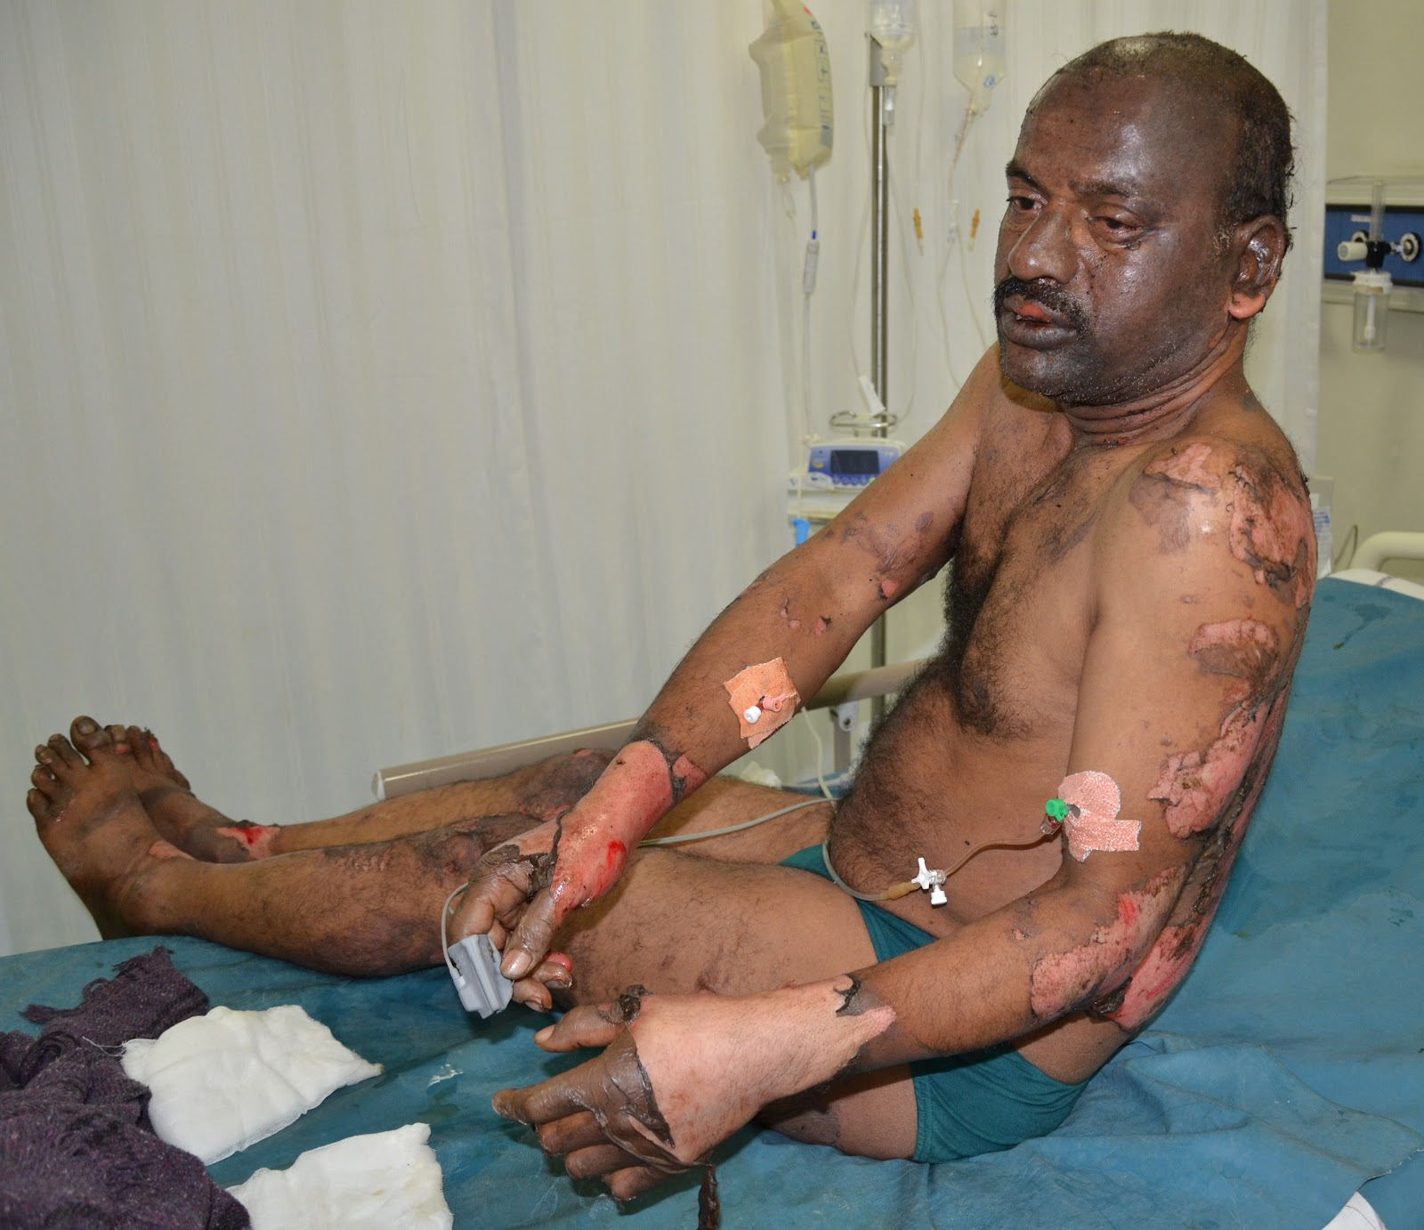[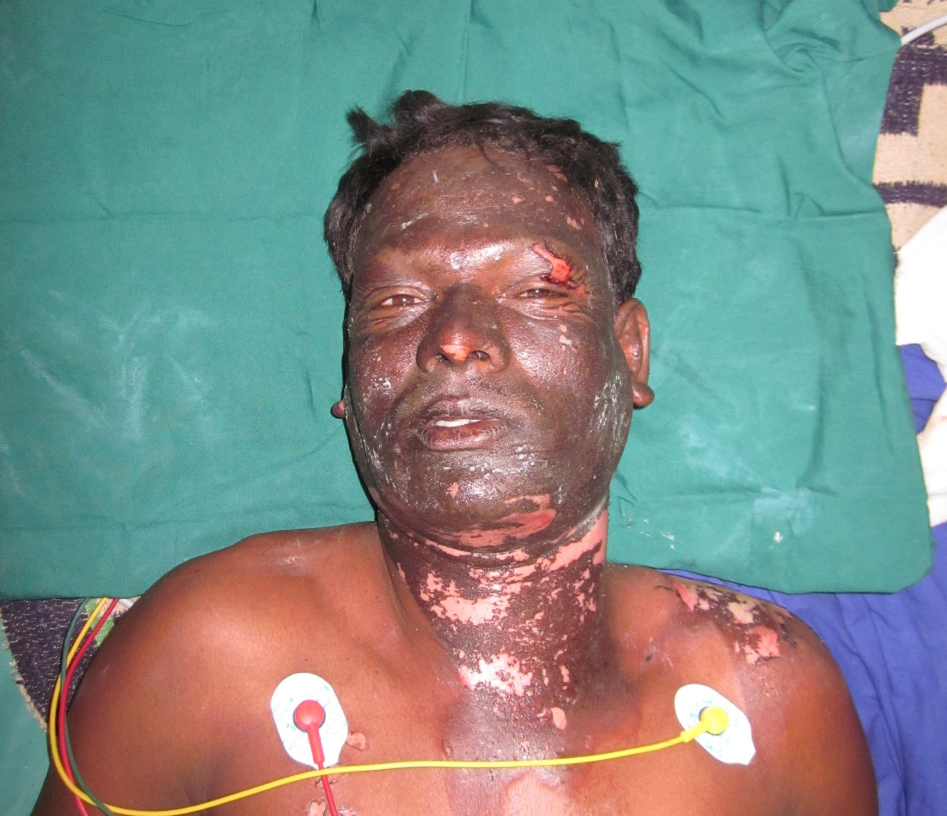](http://www.google.ca/url?sa=i&rct=j&q=&esrc=s&frm=1&source=images&cd=&cad=rja&uact=8&ved=0ahUKEwjCvN_99_zKAhVKkYMKHQYOCJkQjRwIBw&url=http://burnssurgery.blogspot.com/2012/05/electrical-contact-and-flash-burns-face.html&bvm=bv.114195076,d.amc&psig=AFQjCNFct6ohaKmtaFSSxtrDEaBXTFFsqQ&ust=1455733043315012)

**LABS – click** [here](https://extranet.interiorhealth.ca/IHUBCFaculty/Diagnostics/Forms/AllItems.aspx?RootFolder=%25252FIHUBCFaculty%25252FDiagnostics%25252FLabs&View=%25257bFD97E2FE-FD01-433F-B9CB-D75A4195924E%25257d) **OR fill out below**

LABORATORY *LIVE* Lab Summary Report

|  |  |  |  |
| --- | --- | --- | --- |
| **Test** | **DATE/TIME here** | **Flag** (H or L) | **Reference** |
| **CBC** | | | |
| WBC |  |  | 3.5 – 10.8 10^9/L |
| RBC |  |  | 4.3 – 5.7 10^12/L |
| Hgb |  |  | 130 – 170 g/L |
| HCT |  |  | 0.37 – 0.47 L/L |
| Platelets |  |  | 150 – 400 10^9/L |
| D-Dimer |  |  | <250 mcg/L |
| **Chemistry** | | | |
| Na |  |  | 137 – 145 mmol/L |
| K |  |  | 3.5 – 5.0 mmol/L |
| Cl |  |  | 98 – 107 mmol/L |
| HCO3 |  |  | 22-26 mmol/L |
| Urea |  |  | 2.5 – 6.1 mmol/L |
| Creat |  |  | 62 – 106 umol/L |
| GFR Est |  |  | > 60 ml/min |
| Glucose - Random |  |  | 3.0 – 11.0 mmol/L |
| Lactate |  |  | 0.9 – 1.8 mmol/L |
| CK |  |  | 5 – 130 U/L |
| Troponin |  |  | <0.03 mcg/L |
| **Coags** |  |  |  |
| INR |  |  | 0.9 – 1.2 |
| PTT |  |  | 28 – 38 s |
| **ABGs** | | | |
| **Arterial** | | | |
| pH |  |  | 7.35- 7.45 |
| pCO2 |  |  | 35 – 45 mmHg |
| PO2 |  |  | 80-100 mmHg |
| BE |  |  | -2.0 to +2.0 mmol/L |
| HCO3 |  |  | 22 – 26 mmol/L |
| O2 Sat |  |  | 95 – 100% |

**EKGs** 