|  |  |
| --- | --- |
| **Case Title** | A sinking ship |
| **Scenario Name** | Calcium Channel Blocker Overdose |

|  |  |
| --- | --- |
| **Learning Objectives -** [**Use action words**](http://ubccpd.ca/sites/ubccpd.ca/files/Accreditation_Learning%20Objectives_%20Verbs.pdf) | |
| **Knowledge:**   1. Recognize a life-threatening overdose 2. Understand the indications for high dose insulin/euglycemic therapy in CCB/BB overdose 3. Understand the indications for lipid rescue therapy | |
| **Skills:**   1. Basic and advanced life support 2. Airway management in a critically ill patient 3. Initiation of HIET and LRT | |
| **Attitude/Behaviours**   1. Demonstrate Team skills 2. Demonstrate Situational awareness 3. Demonstrate Graded Assertiveness | |
| **Scenario Environment** | |
| **Location** | ED Resuscitation Room |
| **Monitors** | Standard ED Monitors |
| **Props/Equipment** | IV, intubation equipment, Intralipid with monograph, Pharmanet |
| **Make-up/Moulage** | None |
| **Potential Distractors** | None |

|  |
| --- |
| **Case Introduction:** |
| 50 y.o. male with long-standing depression presents to the ED ~5 hours after taking all his blood pressure medications. He cannot remember the name of the medication. |

| **Patient Parameters** | **Effective Management** | **Notes** |
| --- | --- | --- |
| **Phase 1: Bradycardia**  **Condition:** Unstable  Feels lightheaded, nauseated, mild chest tightness  **Initial Assessment**   * **Heart Rhythm:** Sinus Bradycardia * **HR:** 40 * **BP:** 90/60 * **RR:** 18 * **SP02:** 96% on RA * **T:** 36. 0 C * **Glucose:** 15 * **Chest:** Clear * **CNS:** GCS 15, PERRL * **CVS:**  S1,S2 * **GI:** Abd soft, nontender * **Weight:** 70 kg * **Height:** 180 cm | 1. **Take a focused history** (see Notes column) 2. **Medical Management**  * 2 large bore IVs * Cardiac monitors, BP <q5min * IV NS 2L bolus * Labs including CBC/lytes/extended lytes/coma/serum osm/vbg/coag * ECG, PCXR * Requests PCC * Gives atropine 0.5mg IV  1. Recognize potential CCB vs BB OD (bonus if knows more likely CCB because of hyperglycemia) 2. Requests EMS bring all pill bottles from pts home/checks pharmanet 🡺 given pt on verapamil 3. Considers (then does not give) MDAC, WBI 4. Considers need for central line placement for potential infusions | 1. **Focused history**  * Pt admits to suicidal ideation, followed by regret when he began feeling unwell and called EMS * Denies co-ingestion * Feels lightheaded, nauseated, mild chest tightness   **PMHx**   * HTN * Depression   **Meds**   * BP Med * Not taking anti-depressants   **Allergies**   * NKDA |
| **Phase 2: Deterioration**  **Condition:** Unstable  Worsening bradycardia/hypotension with decreased LOC  **Physical Examination**   * **Heart Rhythm:** 1st degree AV block/brady * **HR:** 30s * **BP:** 70/40 * **RR:** 22 * **SP02:** 88% on RA * **T:** 36.0 * **Glucose:** 15 * **Chest:** clear, mild increased WOB * **CNS:** GCS 14 (confused), PERRL, moving x 4 * **CVS:** S1, S2 * **GI:** Abd soft, nontender | 1. **Patient Reassessment** (see Notes column) 2. **Medical Management**  * Initiates Calcium boluses (Ca gluconate unless has initiated central line) * 2nd physician to assist with procedures (central line, intubation) * Calls PCC (if not already done) and ICU * Continues to give atropine to max 3mg IV * Continues to give Ca boluses * Initiates vasopressor (epi or norepi) * Initiates HIET (can say would look up dosing) (1 amp D50W bolus then 1U/kg regular insulin followed by infusion 0.5U/kg/h with glucose 25g/h infusion for euglycemia)   **Consequences of ineffective management**   * Pt goes into PEA Arrest (phase 3) after initiating HIET | 1. **Patient Reassessment**   **Airway**   * Patent   **Breathing**   * AE = AE, increased WOB   **Circulation**   * HR 30s, BP 70/40 and trending down   **NOTES:**   * If resident does not initiate HIET or LRT it can be suggested by PCC or ICU |
| **Phase 3: PEA Arrest**  **Condition:** Coding  **Physcial Examination**   * **Heart Rhythm:** PEA Arrest * **HR:** 30s * **BP:** -/- * **RR:** apneic * **SP02:** unable to detect * **CNS:** GCS 3 | 1. **Patient Reassessment** (see Notes column) 2. **Medical Management**  * Starts CPR/intubates when pt arrests * Initiates intralipid rescue therapy when pt arrests (1.5cc/kg bolus over 1min then infusion 0.25cc/kg/min) * Once bolus of intralipid given pt has ROSC | 1. **Patient Reassessment**   **Airway**   * Not patent   **Breathing**   * Apneic, must use BVM   **Circulation**   * PEA arrest, must do CPR   **NOTES:**   * Resident may use lipidrescue.org or ask pharmacist for dosing (pharmacist available during resuscitation) |

|  |  |
| --- | --- |
| **Expected Patient Management** | **Debriefing Points** |
| 1. **Student** 2. **Junior EM Resident**    1. Recognizes life-threatening “low and slow” overdose and considers DDx (CCB/BB/dig/clonidine)    2. Requests appropriate help – 2nd MD, PCC, ICU    3. Initiates appropriate supportive care    4. Considers and rejects activated charcoal/whole bowel irrigation    5. Basic Knowledge of HIET and LRT 3. **Senior EM resident** |  |

**References:**

# Graudins, A. et al (2016). Calcium channel antagonist and beta-blocker overdose: antidotes and adjunct therapies. [Br J Clin Pharmacol.](http://www-ncbi-nlm-nih-gov.login.ezproxy.library.ualberta.ca/pubmed/26344579) Mar;81(3):453-61.

# Kerns, W. (2007). Management of beta-adrenergic blocker and calcium channel antagonist toxicity. [Emerg Med Clin North Am.](http://www.ncbi.nlm.nih.gov/pubmed/17482022) May;25(2):309-31.

# St. Onge, M. (2014). Treatment for calcium channel blocker poisoning: a systematic review. [Clin Toxicol (Phila).](http://www.ncbi.nlm.nih.gov/pubmed/25283255) 52(9):926-44.

# <http://lifeinthefastlane.com/ccc/calcium-channel-blocker-toxicity/>

# <http://www.thepoisonreview.com/2015/02/28/is-lipid-emulsion-therapy-effective-in-calcium-channel-blocker-and-beta-blocker-overdose/>

**X-RAYS**

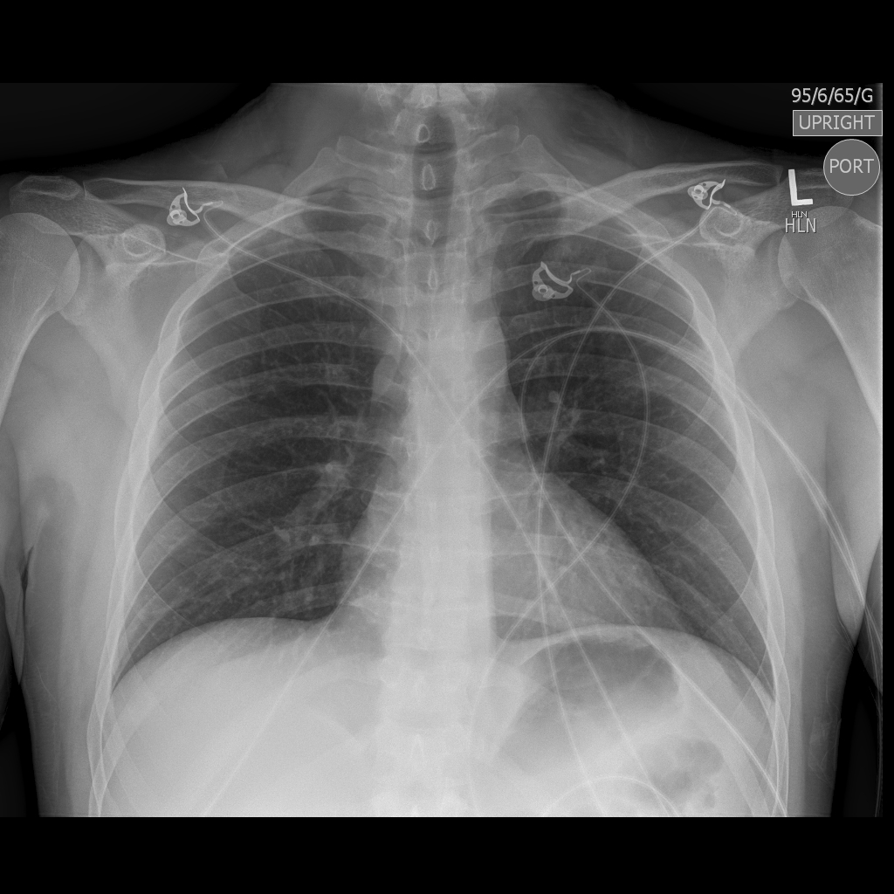

**LABS – click** [here](https://extranet.interiorhealth.ca/IHUBCFaculty/Diagnostics/Forms/AllItems.aspx?RootFolder=%25252FIHUBCFaculty%25252FDiagnostics%25252FLabs&View=%25257bFD97E2FE-FD01-433F-B9CB-D75A4195924E%25257d) **OR fill out below**

LABORATORY *LIVE* Lab Summary Report

|  |  |  |  |
| --- | --- | --- | --- |
| **Test** | **DATE/TIME here** | **Flag** (H or L) | **Reference** |
| **CBC** | | | |
| WBC | 6.0 |  | 3.5 – 10.8 10^9/L |
| RBC |  |  | 4.3 – 5.7 10^12/L |
| Hgb | 135 |  | 130 – 170 g/L |
| HCT |  |  | 0.37 – 0.47 L/L |
| Platelets | 200 |  | 150 – 400 10^9/L |
| D-Dimer |  |  | <250 mcg/L |
| **Chemistry** | | | |
| Glucose - Random | **15.0** | **H** | 3.0 – 11.0 mmol/L |
| Na | 140 |  | 137 – 145 mmol/L |
| K | **3.3** | **L** | 3.5 – 5.0 mmol/L |
| Cl | 102 |  | 98 – 107 mmol/L |
| HCO3 | **16** | **L** | 22-26 mmol/L |
| Urea | **10** | **H** | 2.5 – 6.1 mmol/L |
| Creat | **120** | **H** | 62 – 106 umol/L |
| GFR Est | **55** | **L** | > 60 ml/min |
| Lactate | **5.0** | **H** | 0.9 – 1.8 mmol/L |
| CK |  |  | 5 – 130 U/L |
| Troponin |  |  | <0.03 mcg/L |
| **Coags** |  |  |  |
| INR | 1.1 |  | 0.9 – 1.2 |
| PTT |  |  | 28 – 38 s |
| **ABGs** | | | |
| **Arterial** | | | |
| pH | **7.25** | **L** | 7.35- 7.45 |
| pCO2 | **30** | **L** | 35 – 45 mmHg |
| PO2 |  |  | 80-100 mmHg |
| BE |  |  | -2.0 to +2.0 mmol/L |
| HCO3 | **16** | **L** | 22 – 26 mmol/L |
| O2 Sat |  |  | 95 – 100% |

**EKGs**

