|  |  |
| --- | --- |
| **Case Title** | Near Drowning |
| **Scenario Name** |  |

|  |  |
| --- | --- |
| **Learning Objectives (3 or more) -** [**Use action words**](http://ubccpd.ca/sites/ubccpd.ca/files/Accreditation_Learning%20Objectives_%20Verbs.pdf) | |
| **Knowledge:**   1. Management of drowning 2. Airway management 3. Hypothermic cooling for cerebral protection | |
| **Skills:**   1. Perform airway management 2. Direct hypothermic cooling | |
| **Attitude/Behaviours**   1. Demonstrate Team skills 2. Demonstrate Situational awareness 3. Demonstrate Graded Assertiveness | |
| **Scenario Environment** | |
| **Location** | ER |
| **Monitors** | Standard ER monitor |
| **Props/Equipment** | Airway equipment |
| **Make-up/Moulage** | None |
| **Potential Distractors** | None |

|  |
| --- |
| **Case Introduction:** |
| 20 y.o. male being brought in by EMS. Cardiac arrest following near drowning. BVM ventilation in progress using King tube. Vomiting intermittently. |

| **Patient Parameters** | **Effective Management** | **Notes** |
| --- | --- | --- |
| **Phase 1: Post cardiac arrest, vomiting**  **Condition:** Unstable  King tube in place, vomiting in ED therefore need to intubate patient, pulmonary suctioning  **Initial Assessment**   * **Heart Rhythm:** NSR * **HR:** 95 * **BP:** 155/73 * **RR:** 28 * **SP02:** 94% with King tube * **T:** 35.5 C * **CNS:** GCS 5 (E1, V1, M3) * **Chest:** crackles bilateral * **CVS:** Pulse reg, HS N * **GI:** Abd distended * **Back & Extremities:** Normal | 1. **Take a focused history** (see Notes column) 2. **Medical Management** 3. IV, O2, Monitor 4. BVM with oral airway 5. RSI 6. NG/foley cath 7. Pulmonary suctioning 8. Aware of complications    * Hypothermia    * Cardiac: arrythmias    * Pulmonary: aspiration/noncardiogenic pulmonary edema    * Neuro: anoxic brain injury/seizures 9. PTN 10. ? Hypothermic cooling 11. Investigations     * ECG: NSR     * Labs:     * CXR: bilateral infiltrate/ CHF | 1. **Focused history**  * Attempting to swim across a fast moving river. Swept under the water. In water for approx. 5mins. Immediate bystander CPR. AED no shock, spontaneous ROSC.   **PMHx**   * Healthy   **Meds**   * None   **Allergies**   * None |

|  |  |
| --- | --- |
| **Expected Patient Management** | **Debriefing Points** |
| 1. **Student** 2. **R1** 3. **Senior IM resident** |  |

**References:**

**X-RAYS – Click** [here](https://extranet.interiorhealth.ca/IHUBCFaculty/Diagnostics/Forms/AllItems.aspx?RootFolder=%25252FIHUBCFaculty%25252FDiagnostics%25252FX%25252Drays&View=%25257bFD97E2FE-FD01-433F-B9CB-D75A4195924E%25257d)

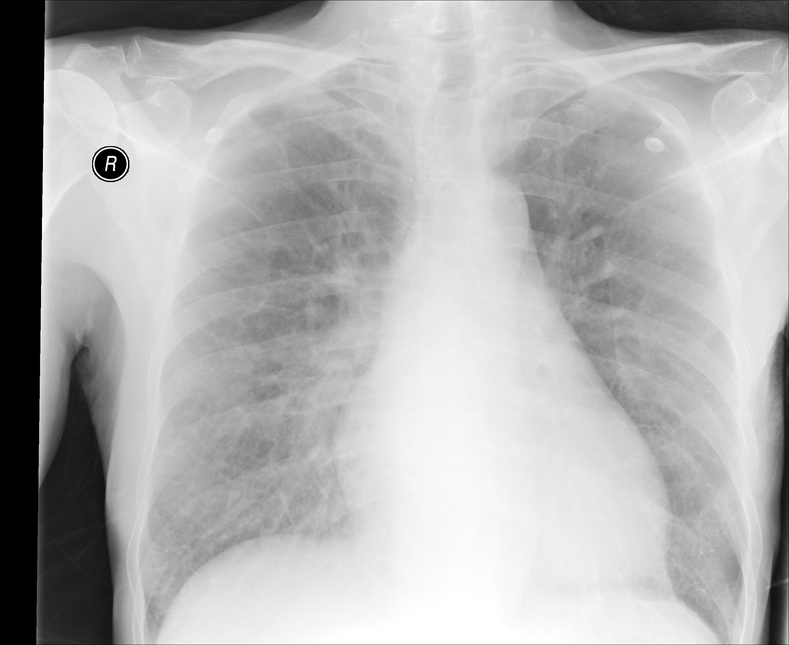

**LABS – click** [here](https://extranet.interiorhealth.ca/IHUBCFaculty/Diagnostics/Forms/AllItems.aspx?RootFolder=%25252FIHUBCFaculty%25252FDiagnostics%25252FLabs&View=%25257bFD97E2FE-FD01-433F-B9CB-D75A4195924E%25257d) **OR paste below**

**EKGs – click** [here](https://extranet.interiorhealth.ca/IHUBCFaculty/Diagnostics/Forms/AllItems.aspx?RootFolder=%25252FIHUBCFaculty%25252FDiagnostics%25252FECGs&View=%25257bFD97E2FE-FD01-433F-B9CB-D75A4195924E%25257d) **or paste**

