**X-RAYS –**

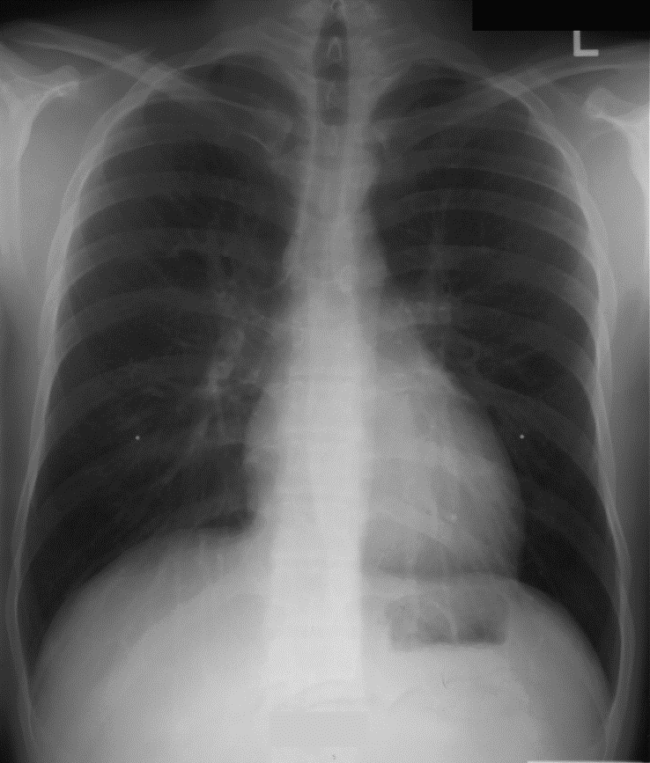

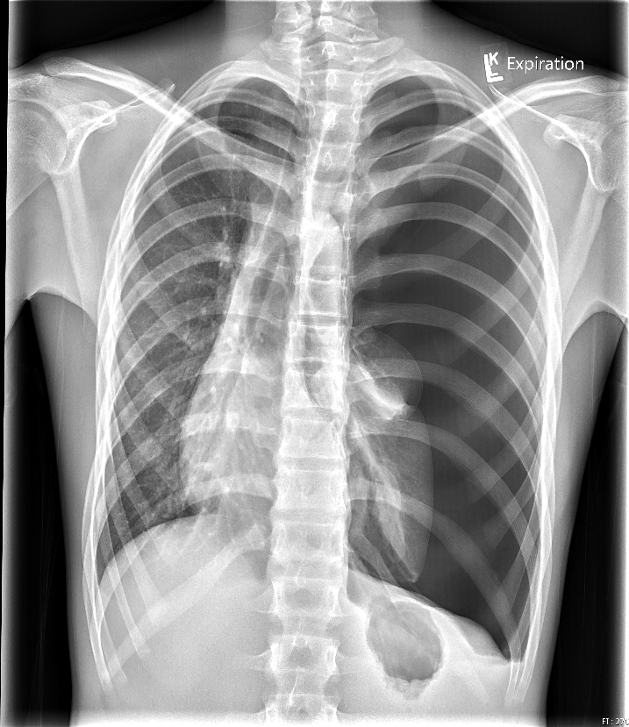

**LABS – click** [here](https://extranet.interiorhealth.ca/IHUBCFaculty/Diagnostics/Forms/AllItems.aspx?RootFolder=%25252FIHUBCFaculty%25252FDiagnostics%25252FLabs&View=%25257bFD97E2FE-FD01-433F-B9CB-D75A4195924E%25257d) **OR fill out below**

LABORATORY *LIVE* Lab Summary Report

|  |  |  |  |
| --- | --- | --- | --- |
| **Test** | **DATE/TIME here** | **Flag** (H or L) | **Reference** |
| **CBC** | | | |
| WBC | **12** | **H** | 3.5 – 10.8 10^9/L |
| RBC | 5.0 |  | 4.3 – 5.7 10^12/L |
| Hgb | 140 |  | 130 – 170 g/L |
| HCT | 0.45 |  | 0.37 – 0.47 L/L |
| Platelets | 300 |  | 150 – 400 10^9/L |
| D-Dimer |  |  | <250 mcg/L |
| **Chemistry** | | | |
| Na | **134** | **L** | 137 – 145 mmol/L |
| K | **3.0** | **L** | 3.5 – 5.0 mmol/L |
| Cl | 100 |  | 98 – 107 mmol/L |
| HCO3 | 24 |  | 22-26 mmol/L |
| Urea | 5.3 |  | 2.5 – 6.1 mmol/L |
| Creat | **60** | **L** | 62 – 106 umol/L |
| GFR Est |  |  | > 60 ml/min |
| Glucose - Random | 4.4 |  | 3.0 – 11.0 mmol/L |
| Lactate | **3.0** | **H** | 0.9 – 1.8 mmol/L |
| CK |  |  | 5 – 130 U/L |
| Troponin |  |  | <0.03 mcg/L |
| **Blood Gases** | | | |
| **Venous** | | | |
| pH | 7.30 |  | 7.30-7.40 |
| pCO2 | 40 |  | 40 – 50 mmHg |
| PO2 | 28 | **L** | 30 - 50 mmHg |
| HCO3 | 24 |  | 22 – 28 mmol/L |
| O2 Sat | 70 |  | 70 – 75% |

**LABS – click** [here](https://extranet.interiorhealth.ca/IHUBCFaculty/Diagnostics/Forms/AllItems.aspx?RootFolder=%25252FIHUBCFaculty%25252FDiagnostics%25252FLabs&View=%25257bFD97E2FE-FD01-433F-B9CB-D75A4195924E%25257d) **OR fill out below**

LABORATORY *LIVE* Lab Summary Report

|  |  |  |  |
| --- | --- | --- | --- |
| **Test** | **DATE/TIME here** | **Flag** (H or L) | **Reference** |
| **CBC** | | | |
| WBC | **12** | **H** | 3.5 – 10.8 10^9/L |
| RBC | 5.0 |  | 4.3 – 5.7 10^12/L |
| Hgb | 140 |  | 130 – 170 g/L |
| HCT | 0.45 |  | 0.37 – 0.47 L/L |
| Platelets | 300 |  | 150 – 400 10^9/L |
| D-Dimer |  |  | <250 mcg/L |
| **Chemistry** | | | |
| Na | **134** | **L** | 137 – 145 mmol/L |
| K | **3.0** | **L** | 3.5 – 5.0 mmol/L |
| Cl | 100 |  | 98 – 107 mmol/L |
| HCO3 | 24 |  | 22-26 mmol/L |
| Urea | 5.3 |  | 2.5 – 6.1 mmol/L |
| Creat | **60** | **L** | 62 – 106 umol/L |
| GFR Est |  |  | > 60 ml/min |
| Glucose - Random | 4.4 |  | 3.0 – 11.0 mmol/L |
| Lactate | **2.0** | **H** | 0.9 – 1.8 mmol/L |
| CK |  |  | 5 – 130 U/L |
| Troponin |  |  | <0.03 mcg/L |
| **Blood Gases** | | | |
| **Venous** | | | |
| pH | **7.29** | **L** | 7.30-7.40 |
| pCO2 | **55** | **H** | 40 – 50 mmHg |
| PO2 | **28** | **L** | 30 - 50 mmHg |
| HCO3 | 24 |  | 22 – 28 mmol/L |
| O2 Sat | **68** | **L** | 70 – 75% |

**EKGs –**

