|  |  |
| --- | --- |
| **Case Title** | Abdominal Trauma |
| **Scenario Name** | MVC with Liver Laceration +/- Tension Pneumo |

|  |  |
| --- | --- |
| **Learning Objectives -** [**Use action words**](http://ubccpd.ca/sites/ubccpd.ca/files/Accreditation_Learning%20Objectives_%20Verbs.pdf) | |
| **Knowledge:**   1. Approach to a trauma patient | |
| **Skills:**   1. Evaluation of a trauma patient using bedside ultrasound 2. Obtaining intraosseous/vascular access | |
| **Attitude/Behaviours**   1. Demonstrate Team skills 2. Demonstrate Situational awareness 3. Demonstrate Graded Assertiveness | |
| **Scenario Environment** | |
| **Location** | Emergency Department |
| **Monitors** | BP, cardiac, oximeter |
| **Props/Equipment** | Bedside ultrasound, IO equipment, simulated units of type O blood, oxygen equipment, large bore angiocath for needle decompression |
| **Make-up/Moulage** | Image of seat belt bruising |
| **Potential Distractors** | None |

|  |
| --- |
| **Case Introduction:** |
| 24 year old male involve in MVC. Restrained driver head-on collision at highway speed. Airbags deployed. No LOC. Spine stabilized. EMS unable to obtain IV access. |

| **Patient Parameters** | **Effective Management** | **Notes** |
| --- | --- | --- |
| **Phase 1: Hypotensive**  **Condition:** Fully alert. Complaining of abdominal pain.  **Initial Assessment**   * **Heart Rhythm:** Sinus tachycardia * **HR:** 120 * **BP:** 86/64 * **RR:** 18 * **SP02:** 95% * **T:** 36.4 C * **Glucose:** 6.5 * **Chest:** Right abrasions, clear lungs * **CNS:** GCS 15, PERL 2 mm. No neuro deficits. No spinal tenderness/deformity * **CVS:**  Normal * **GI:** Abd seatbelt sign with guarding. * **Pelvis:** Stable * **Extremities:** No injuries noted | 1. **Take a focused history** (see Notes column) 2. **Medical Management** 3. Primary Survey    1. Airway       1. Talks to the patient    2. Breathing       1. Obtain SpO2, RR, listens to lungs    3. Circulation       1. Monitor, BP, asks for 2 large bore IVs (unable to obtain IV access)       2. Obtains IO access when IV unsuccessful       3. Fluid bolus. Orders blood.       4. Bedside FAST (positive for free fluid) 4. Disability    * 1. AVPU/GCS, pupils    1. Exposure       1. Exposes patient fully (show image of seat belt bruising when when abd exposed)       2. Temperature       3. Log roll    2. Friends       1. Call for help initially for stabilization       2. Call General Surgeon for free fluid in abdomen 5. Initial Investigations    1. TRAUMA BLOODWORK (Specifics?)    2. ECG? Portable CXR? 6. Complete secondary survey and AMPLE history (see Notes column)   If advanced learners, progress to ***Phase 2 – Respiratory Distress*** | 1. **Focused history**   **A -** None  **M -** None  **P -** Appendectomy  **L-** Breakfast at 8  **E-** Lost control on ice, went into other lane and hit oncoming car going highway speeds. No etoh or illicit drug use. Other driver with minor injuries. |
| **Phase 2: Respiratory Distress**  **Condition:** Increased WOB, complaining that it is becoming more difficult to breath. Sats dropping.  **Physical Examination**   * **Heart Rhythm:** Sinus Tachycardia * **HR:** 130 * **BP**: 80/60 * **RR:** 28 * **SPO2:** 90% and dropping * **CNS:** GCS 15 * **Chest:**  Tension pneumothorax. No A/E left side. * **GI:** Abdomen becoming more distended. | 1. **Patient Reassessment** (see Notes column)-   *Recognizes change in condition*   1. **Medical Management** 2. Airway    1. Talks to patient. Assesses for tracheal deviation. 3. Breathing    1. Needle Decompression    2. Verbalizes need to place chest tube    3. Orders portable CXR 4. Circulation:    1. Transfuse PRBCs once arrrived    2. Consider interventional radiology early 5. Disability:    1. Monitor for deterioration 6. PREPARE FOR TRANSFER TO CT? (Or direct to interventtional radiology/OR for + FF in abd?)   **Further management**   1. Interventional radiology for pelvic vessel embolization 2. Continue blood product resuscitation | 1. **Patient Reassessment**   **Airway**   * Patent. Patient still talking, but anxious and in distress.   **Breathing**   * Sats dropping, tension pneumo   **Circulation**   * Tachycardic, hypotensive |

|  |  |
| --- | --- |
| **Expected Patient Management** | **Debriefing Points** |
| 1. **Student** 2. **Junior Resident** 3. **Senior Resident** |  |

**References**

[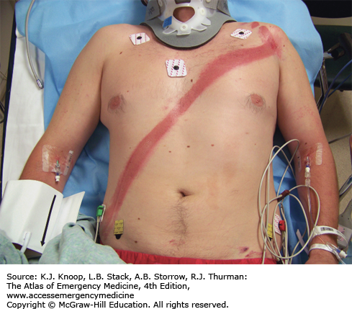](http://www.google.ca/url?sa=i&rct=j&q=&esrc=s&source=images&cd=&cad=rja&uact=8&ved=0ahUKEwi44o2zn6zRAhVCqlQKHWNTBowQjRwIBw&url=http://aneskey.com/chest-and-abdomen/&bvm=bv.142059868,d.cGw&psig=AFQjCNEqJjRwvkXGjOPvqJj5IYb0MJAeTg&ust=1483748274392100)

**X-RAYS**

Phase 1 – Normal CXR

[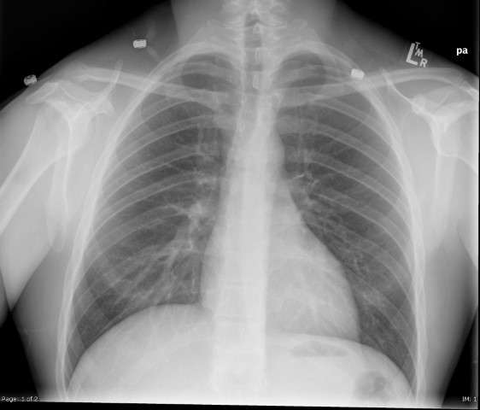](https://extranet.interiorhealth.ca/IHUBCFaculty/Diagnostics/X-rays/Thoracic/Chest%20Xrays/CXR-Normal.bmp)

Phase 2 – Left Tension Pneumo

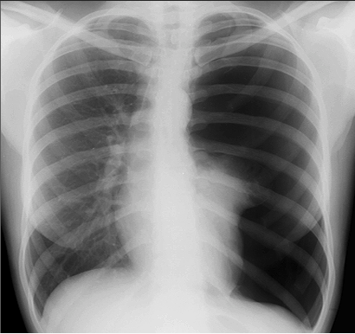

**BEDSIDE ULTRASOUND**

* **Abdomen** – Free fluid RUQ

[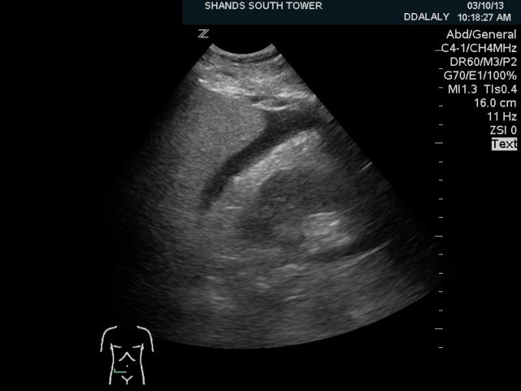](http://anest.ufl.edu/clinical-divisions/critical-care-medicine/critical-care-ultrasonography/ultrasound-training-videos-abdomen/)

**EKGs**

Sinus Tachycardia

[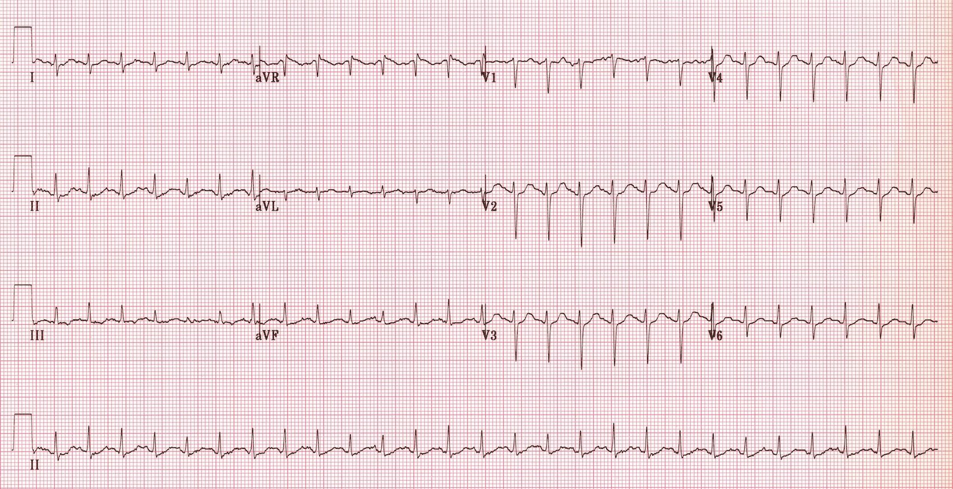](http://www.google.ca/url?sa=i&rct=j&q=&esrc=s&source=images&cd=&cad=rja&uact=8&ved=0ahUKEwje36-poazRAhVK82MKHUR-ARoQjRwIBw&url=http://lifeinthefastlane.com/ecg-library/sinus-tachycardia/&psig=AFQjCNEj_rQvXCSFkgt6_Rp1KEOTcvkIaQ&ust=1483748845359459)