Audience and Participants
Target Learning Group
- All groups
Learning Objectives
Educational Goal
- To enhance resuscitation and team management skills of a major trauma in the rural setting.
*Crisis Resource Management (CRM) Objectives:
- Demonstrate effective communication during scenario: constructing clear messages, closed loop communication, and sharing mental model.
- Mobilizes resources early (calls staff in)
- Recognizes need to transfer early
- Effectively lead a trauma team and delegate roles appropriately.

*Medical Objectives:
- Identify and treat a trauma brain injury (TBI)
  - Demonstrate management of increased ICP
- Identify and treat a unstable pelvic fracture
  - Demonstrate management of hemorrhagic shock
- Effectively resuscitate patient prior to Intubation (address low BP in TBIs) *Key learning objective as recommended by Hazel Park/ Shannon Chestnut
Case Summary:
A 32 year old male presents after being bucked off his horse. EHS gives notification that they are en route, ETA 5 minutes. His GCS is 8, BP is 82/40, head injury.
Physical Props / Equipment
Mannequin:
- High fidelity patient simulator (Adult Mannequin)
- Boggy hematoma to right temporal area
- Abrasions across abdo/pelvis area

Monitors:
- Telemetry
Personnel:
- EHS
- RN (#of staff usually working on shift)
- Observer team (CRM Forms)
- Physician Lead
- Confederate to play paramedic role.
- Rural to call in lab and xray tech
Other:
- Basic airway materials and Advanced Airway materials
- Code blue cart
- Pelvic Binder
- Rapid Infuser or fluid warmer
- Blankets or patient warmer
- Urinary catheter/OG
Room
Set-Up:  - Rural ED Trauma Bay | Medications & Fluids:  - Blood Products and or NS/Plasmalyte for IVF  - Analgesia (e.g. fentanyl, morphine)  - RSI Drugs (ketamine, Roc/Succ)  - TXA | Diagnostics:  - CXR Normal  - CXR post intubation  - XR with Pelvic Fracture  - FAST images showing no free fluid | Documentation Forms:  - Typical RN trauma documentation forms.  - Rural Massive Transfusion Protocol  - Cognitive Aids (Push Dose Pressors)

Scenario
Patient Identification: 32yr old male bucked off his horse and kicked.
Chief Complaint / History: Chest pain
You are working in a rural Emergency Department. You have access to X-ray and lab but there is no CT scanner in the department. The nearest trauma center is a 30 minute flight away via BCAS. The paramedics have just rolled in with a 32 year old male who was bucked off his horse and kicked. He was not wearing a helmet. Witnesses say the horse was given a fright and threw patient off onto his head and kicked him in his lower abdomen area. The patient had a loss of consciousness and remains GCS of 8. He has received 500cc of fluid from the EHS and had a c-spine collar applied. He was unconscious at scene now just moaning with pain stimulus.
Past Medical History:  - Healthy |  |  |  |  | Medications:  - None
Allergies: NKDA
Family History: Non-contributory |  |  |  |  |  | Social History:  - Lives with girlfriend.  - Denies etoh, smoking, or illicit drug use.
Key Management Interventions:
Stage 1: Initial management of poly-trauma patient
A young male brought in by EMS following his trauma. He is on a backboard with cervical collar. IV infusing to left AC.
Vitals:
HR: 120 | BP: 80/40 |  | Temp: 36.0°C |  |  |  | O₂ Sat: 96% RA |  | RR: 22 |  | Glc: 6.5 mmol/L
Physical Exam Findings: |  |  |  |  |  | Review of Systems (ROS)
- CNS: GCS 8 (moaning only), PERL 3mm. Appears Unwell |  |  |  |  |  | Positive ROS:
- CVS: Normal S1S2, cool and pale to peripheries.
- RESP: Normal breath sounds bilaterally
- GI: Soft, non-distended, non-tender.
- GU: No blood at meatus. |  |  |  |  |  | Negative ROS:
- HEENT: Airway patent. Boggy hematoma over right temporal area. Trachea midline. C-spine collar on
- SKIN: Abrasions to hands, pelvis and right flank
- MSK: Pelvis unstable.

Interventions
- Obtains large bore IV access x2 or IO
- Applies continuous cardiorespiratory monitoring
- Applies oxygen
- Orders labs (including Trauma Panel, CXR, ECG)
- Obtains a full set of vitals including NVS, temperature and glucose
- Performs a primary survey
- Airway: Oral Airway and BVM (Would like to consider intubation but not immediately)
- Breathing: O2
- Circulation
  - Comments on hypotension
  - Begins infusion of crystalloid or O-negative blood (Considers initiating MTP) Request blood early if not available
  - Examines abdomen
  - Binds Unstable pelvis

- Disability:
  - Notes GCS 8
  - Examines pupils

- Exposures
  - Performs log roll
- Urinary catheter to measure urine output
- Inserts art line to manage BP monitoring

Successful Intervention:
- Binding Pelvis
- Initiating MTP
- Keeps Patient warm
- Call PTN, Trauma Services, Ortho
- FAST if GP able to perform

Unsuccessful Intervention:
- BP Drops if Pelvis not bound
- BP Drops if Intubated with considering pressors

Stage 2: Herniation
The patient shows signs of increased ICP
Vitals:
HR: 45 BP: 75/45 RR: 6 (If Not intubated) Left pupil blown
Interventions
- Intubate if not done so already (can hyperventilate if advised by PTN)
- HOB @ 30 degrees
- Hypertonic Saline 100ml or,
- Mannitol IV (1-1.5g/kg) IV over 10 minutes via filter
- Call Neurosurgery
- Ensures C-spine collar not too tight

Stage 3: Disposition of trauma patient
The patient is packaged and transport is arranged
Vitals:
HR: 110 |  | BP: 100- 110/65 |  | Temp: 36.9°C |  |  |  | O₂ Sat: 98% O2 |  | RR: 20
Physical Exam Findings:
- CNS:
Interventions
- Asks for adjuncts if not done already (labs, ECG, CXR)
- Performs a FAST
- Takes an AMPLE history
- Begins process to transfer patient
- Intubated for transfer
- Begins secondary survey
Successful Intervention:
- If the patient transfer network is paged for transfer then a confederate playing the trauma surgeon at the referral hospital will answer the learner will handover.
Unsuccessful Intervention:
- If the learner does not attempt to transfer patient the RN or confederate will ask “What is the plan with this patient?”

Notes
Possible Debriefing Points:  - How to perform a primary survey  - How to call for help early – call PTN  - How to bind pelvis  - How to manage ICP  - Rural massive hemorrhage flowchart TXA - PRBCs and FFP (Give Blood w NS) *Avoid Crytalloids, if you need to give Plasmalyte, warm it.  - CRM Principles (teamwork, clear communication)  - How to resuscitate prior to intubation in the management of hypotension with TBI | Debriefer Notes:
References, Resources, Protocols, Algorithms, or Evidence Informed Practice Guidelines:
References:

Adjuncts:
- 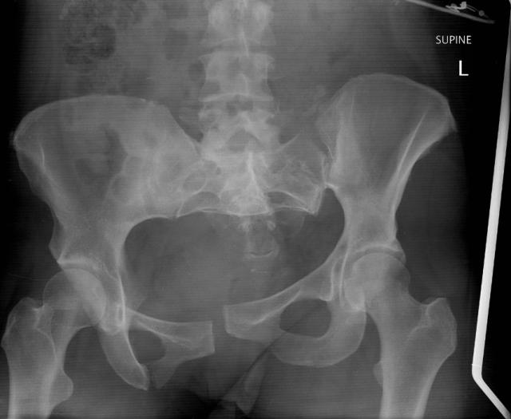

- 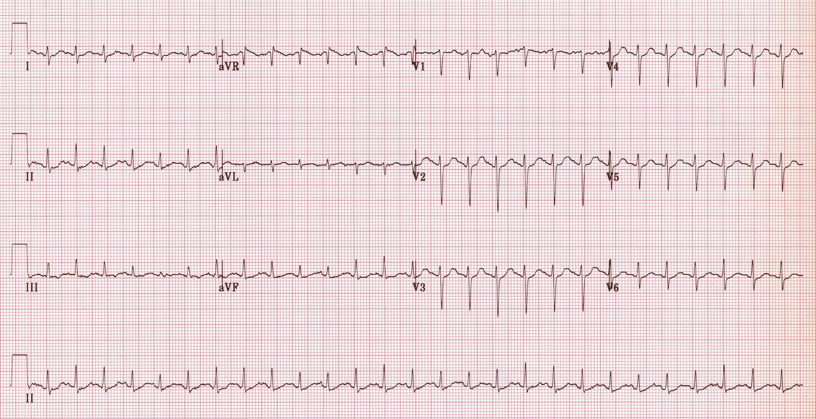
- 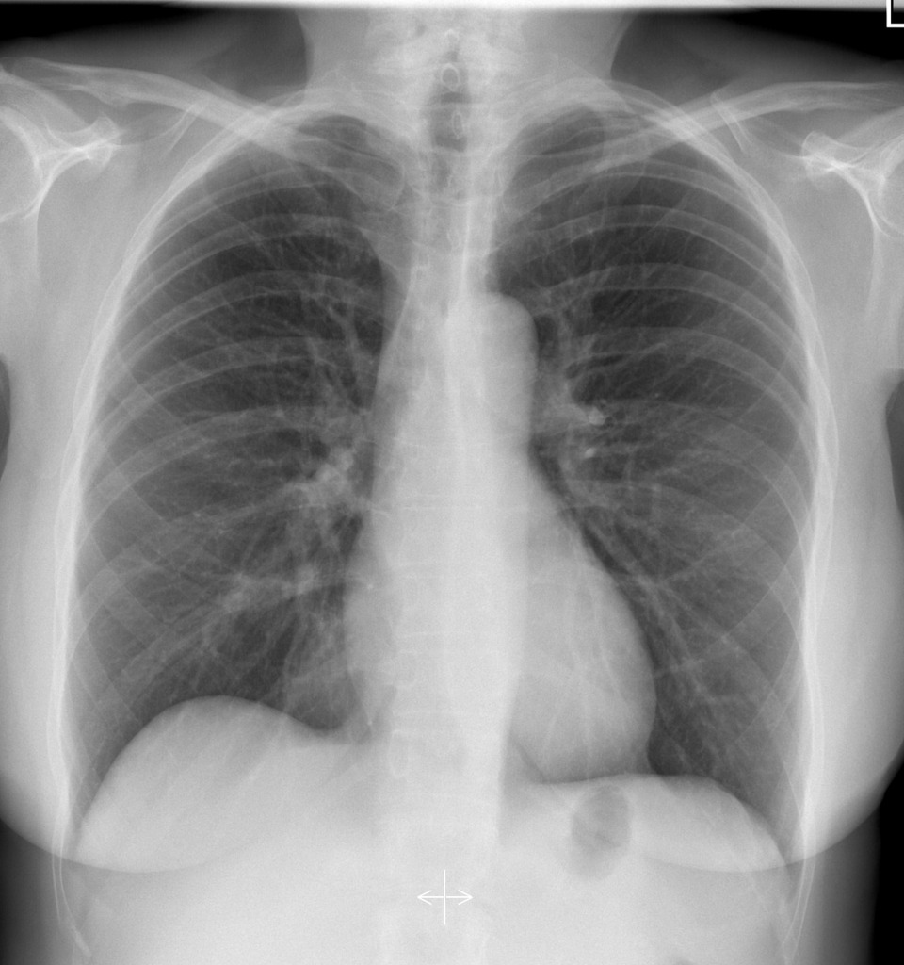
Authors / Contributors:
Case drafted by Kelsey Innes with contributions from Shannon Chestnut, Afshin Khazei and Karen Schafer.
Case Peer reviewed and edited by Michelle Connell and Jaime Gallaher

