|  |  |
| --- | --- |
| **Case Title** | Abdominal Trauma |
| **Scenario Name** | MVC with Liver Laceration +/- Tension Pneumo, +/- Pelvic Binding |

|  |  |
| --- | --- |
| **Learning Objectives -** [**Use action words**](http://ubccpd.ca/sites/ubccpd.ca/files/Accreditation_Learning%20Objectives_%20Verbs.pdf) | |
| **Knowledge:**   1. Approach to a trauma patient | |
| **Skills:**   1. Evaluation of a trauma patient using bedside ultrasound 2. Obtaining intraosseous vascular access | |
| **Attitude/Behaviours**   1. Demonstrate Team skills 2. Demonstrate Situational awareness 3. Demonstrate Graded Assertiveness | |
| **Scenario Environment** | |
| **Location** | Emergency Department |
| **Monitors** | BP, cardiac, oximeter |
| **Props/Equipment** | Bedside ultrasound, IO equipment, simulated units of type O blood, oxygen equipment, large bore angiocath for needle decompression. C-Collar. Clothes to cut off. Trauma sissors (be careful to not cut any of SimMAn’s tubes!!) |
| **Make-up/Moulage** | Image of seat belt bruising |
| **Potential Distractors** | None |

|  |
| --- |
| **Case Introduction:** |
| 24 year old male involve in MVC. Restrained driver, lone occupant, single vehicle collision at highway speed. Crossed centre line and hit a pole, impact to drivers side door. Airbags deployed. No LOC. Spine stabilized. EMS unable to obtain IV access. Vitals HR 120, BP 90palp, SpO2 95% 3L, RR 24. ETA 10mins. |

| **Patient Parameters** | **Effective Management** | **Notes** |
| --- | --- | --- |
| **Phase 1: Hypotensive**  **Condition:** Fully alert. Complaining of abdominal pain.  C-Collar on. Clothes on.  **Initial Assessment**   * **Heart Rhythm:** Sinus tachycardia * **HR:** 120 * **BP:** 86/64 * **RR:** 18 * **SP02:** 95% * **T:** 36.4 C * **Glucose:** 6.5 * **Chest:** Left abrasions, clear lungs * **CNS:** GCS 15, PERL 2 mm. No neuro deficits. No spinal tenderness/deformity * **CVS:**  Normal * **GI:** Abd seatbelt sign with guarding. * **Pelvis:** Stable **OR** Tender to palpation * **Extremities:** No injuries noted | 1. **Take a focused history** (see Notes column) 2. **Medical Management** 3. Primary Survey    1. Airway       1. Asesses airway patency. Talks to the patient.    2. Breathing       1. Obtain SpO2, RR, listens to lungs    3. Circulation       1. Monitor, BP, asks for 2 large bore IVs (unable to obtain IV access)       2. Obtains IO access when IV unsuccessful       3. Fluid bolus. Orders blood. Considers TXA.       4. Bind pelvis 4. Disability    * 1. AVPU/GCS, pupils 5. Exposure    * 1. Exposes patient fully (show image of seat belt bruising when abd exposed)      2. Temperature      3. Log roll 6. Friends    * 1. Call for help initially for stabilization      2. Call General Surgeon for free fluid in abdomen **OR** Call for transfer if RURAL 7. Initial Investigations    1. Bedside FAST (positive for free fluid)    2. Trauma Bloodwork    3. ECG and Portable CXR 8. Complete secondary survey and AMPLE history (see Notes column)   If advanced learners, progress to ***Phase 2 – Respiratory Distress*** | 1. **Focused history**   **A -** None  **M -** None  **P -** Appendectomy  **L-** Breakfast at 8  **E-** Lost control, went into other lane and hit a pole. No etoh or illicit drug use. |
| **Phase 2: Respiratory Distress**  **Condition:** Increased WOB, complaining that it is becoming more difficult to breath. Sats dropping.  **Physical Examination**   * **Heart Rhythm:** Sinus Tachycardia * **HR:** 130 * **BP**: 80/60 * **RR:** 28 * **SPO2:** 90% and dropping * **CNS:** GCS 15 * **Chest:**  Tension pneumothorax. No A/E left side. * **GI:** Abdomen becoming more distended. | 1. **Patient Reassessment** (see Notes column)-   *Recognizes change in condition*   1. **Medical Management** 2. Airway    1. Talks to patient. Assesses for tracheal deviation. 3. Breathing    1. Needle Decompression    2. Verbalizes need to place chest tube    3. Orders portable CXR 4. Circulation:    1. Transfuse PRBCs once arrrived    2. Consider interventional radiology early 5. Disability:    1. Monitor for deterioration 6. Prepare for transfer to OR   **Further management**   1. Surgery **OR** Transfer 2. Continue blood product resuscitation | 1. **Patient Reassessment**   **Airway**   * Patent. Patient still talking, but anxious and in distress.   **Breathing**   * Sats dropping, tension pneumo   **Circulation**   * Tachycardic, hypotensive |

|  |  |
| --- | --- |
| **Expected Patient Management** | **Debriefing Points** |
| 1. **Student** 2. **Junior Resident** 3. **Senior Resident** |  |

**References**

<http://www.teleflex.com/en/usa/ezioeducation/documents/8082_Rev_A_US_FDA_Intraosseous_Infusion_System_IFU.PDF>

<http://www.teleflex.com/en/usa/ezioeducation/documents/VA_IO_Arrow-EZ-IO-Care-Maint_AI_MC-000806.pdf>

[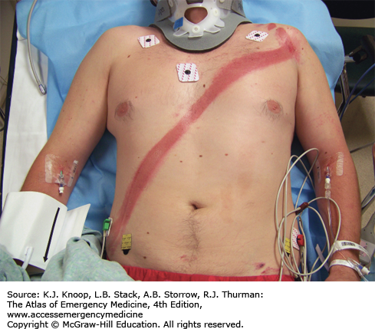](http://www.google.ca/url?sa=i&rct=j&q=&esrc=s&source=images&cd=&cad=rja&uact=8&ved=0ahUKEwi44o2zn6zRAhVCqlQKHWNTBowQjRwIBw&url=http://aneskey.com/chest-and-abdomen/&bvm=bv.142059868,d.cGw&psig=AFQjCNEqJjRwvkXGjOPvqJj5IYb0MJAeTg&ust=1483748274392100)

**X-RAYS**

Phase 1 – Normal CXR

[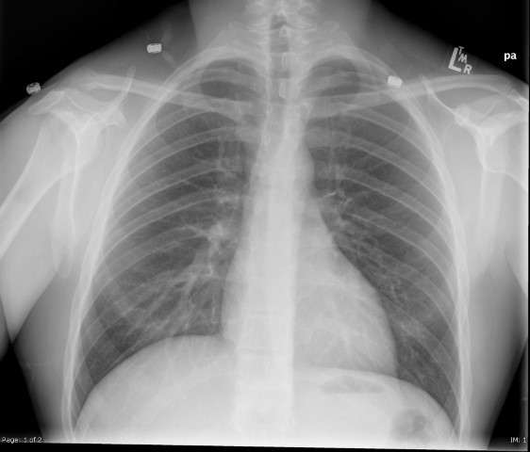](https://extranet.interiorhealth.ca/IHUBCFaculty/Diagnostics/X-rays/Thoracic/Chest%20Xrays/CXR-Normal.bmp)

Phase 2 – Left Tension Pneumo

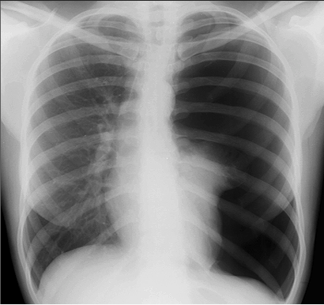

**BEDSIDE ULTRASOUND**

* **Abdomen** – Free fluid RUQ
* U/S video clip: <https://vimeo.com/60616342>

[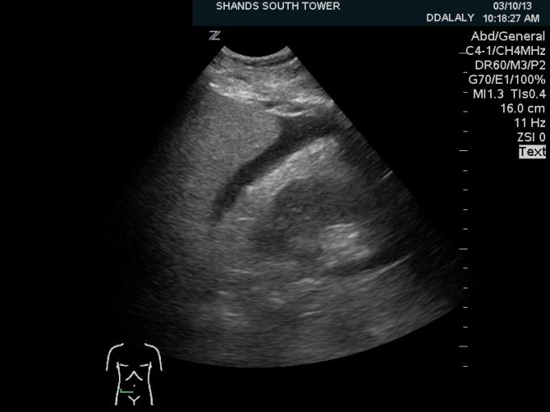](http://anest.ufl.edu/clinical-divisions/critical-care-medicine/critical-care-ultrasonography/ultrasound-training-videos-abdomen/)

**LABS**

RUN DATE: Today LABORATORY *LIVE* Lab Summary Report

LOCATION

|  |  |  |  |
| --- | --- | --- | --- |
| **Test** | **DATE/TIME here** | **Flag** (H or L) | **Reference** |
| **CBC** | | | |
| WBC | **12.5** | **H** | 3.5 – 10.8 10^9/L |
| RBC | 4.4 |  | 4.3 – 5.7 10^12/L |
| Hgb | 135 |  | 130 – 170 g/L |
| HCT | 0.39 |  | 0.37 – 0.47 L/L |
| Platelets | 200 |  | 150 – 400 10^9/L |
| D-Dimer |  |  | <250 mcg/L |
| **Chemistry** | | | |
| Na | 140 |  | 137 – 145 mmol/L |
| K | 4.0 |  | 3.5 – 5.0 mmol/L |
| Cl | 101 |  | 98 – 107 mmol/L |
| HCO3 | 24 |  | 22-26 mmol/L |
| Urea | 4.0 |  | 2.5 – 6.1 mmol/L |
| Creat | 82 |  | 62 – 106 umol/L |
| GFR Est |  |  | > 60 ml/min |
| Glucose - Random | 6.0 |  | 3.0 – 11.0 mmol/L |
| Lactate |  |  | 0.9 – 1.8 mmol/L |
| CK |  |  | 5 – 130 U/L |
| Troponin |  |  | <0.03 mcg/L |
| **Coags** |  |  |  |
| INR | 1.0 |  | 0.9 – 1.2 |
| PTT | 34 |  | 28 – 38 s |
| **ABGs** | | | |
| **Arterial** | | | |
| pH |  |  | 7.35- 7.45 |
| pCO2 |  |  | 35 – 45 mmHg |
| PO2 |  |  | 80-100 mmHg |
| BE |  |  | -2.0 to +2.0 mmol/L |
| HCO3 |  |  | 22 – 26 mmol/L |

**EKGs**

Sinus Tachycardia

[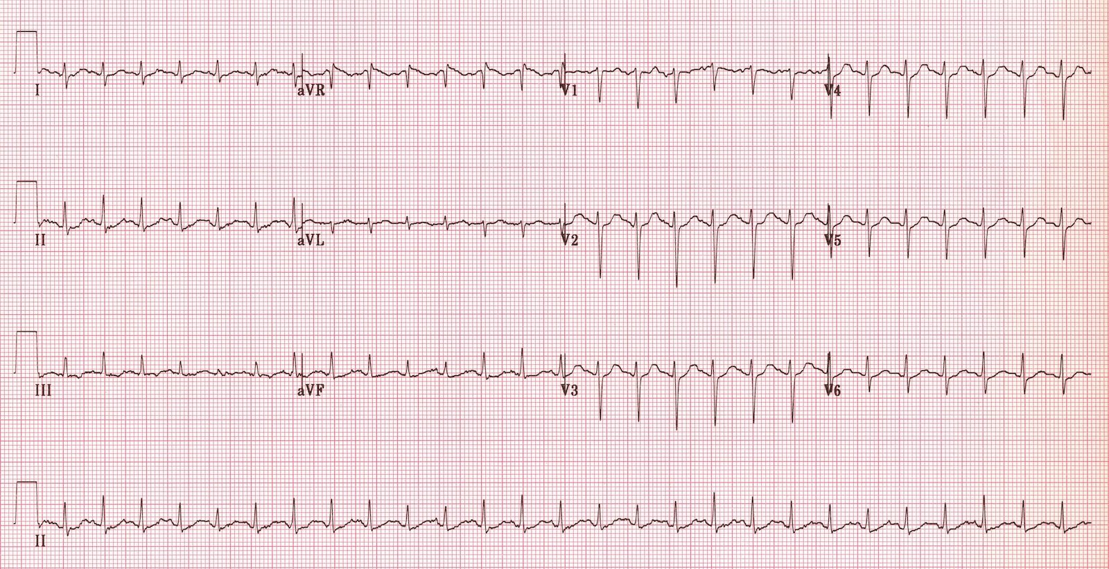](http://www.google.ca/url?sa=i&rct=j&q=&esrc=s&source=images&cd=&cad=rja&uact=8&ved=0ahUKEwje36-poazRAhVK82MKHUR-ARoQjRwIBw&url=http://lifeinthefastlane.com/ecg-library/sinus-tachycardia/&psig=AFQjCNEj_rQvXCSFkgt6_Rp1KEOTcvkIaQ&ust=1483748845359459)