|  |  |
| --- | --- |
| **Case Title** | Full Thickness Burns: Adult |
| **Scenario Name** | Chemical fire |

|  |  |
| --- | --- |
| **Learning Objectives** | |
| **Knowledge:**   1. Initial management of a serious burns patient, including recognition of airway compromise due to inhalation injury | |
| **Skills:**   1. Accurate calculation of total burn surface area (TBSA) using Lund-Browder chart 2. Accurate calculation of fluid resuscitation | |
| **Attitude/Behaviours:**   1. Demonstrate Team skills 2. Demonstrate Situational awareness 3. Demonstrate Graded Assertiveness | |
| **Scenario Environment** | |
| **Location** | Trauma room |
| **Monitors** | Standard ER monitor |
| **Props/Equipment** | IV/IO supplies Burn packs/sterile gauze Portable ventilator/tubing  Intubation equipment Normal saline Bair Hugger  Bags of Lactated Ringers Burns resources/documentation Ranger warmer  Burn packs of sterile gauze Wet flannels |
| **Make-up/Moulage** | Burns: (school glue, red washable markers, charcoal)  Burned clothing |
| **Potential Distractors** | None |

|  |
| --- |
| **Case Introduction:** |
| 38 year old male, working in home garage (door closed), sustained serious burns when a nearby container of flammable liquid caught alight. He tried to put out the fire using a Class A fire extinguisher which caused a massive fireball. Initial appearance: singed nose hairs and soot around his mouth/lips; patient is grimacing and yelling in pain with a hoarse voice; patient is pale with pink mucous membranes. Patient has sustained burns to face, neck, chest, abdomen, arms, hands and thighs. |

| **Patient Parameters** | **Effective Management** | **Notes** |
| --- | --- | --- |
| **Phase 1: Title of Phase**  **Condition:** Unstable**.** Moaning, audible stridor  **Initial Assessment**   * Heart Rhythm: ST * HR: 128 * BP: 132/90 * RR: 28 * SP02: 92% * T: 36.1 * Glucose: 7.3 * CNS: AVPU ; eyes partially open; grimacing; moaning in pain; no clear words audible. * Chest: lungs clear all fields, occasional cough of carbonaceous sputum * CVS: Unable to palpate peripheral pulses (Doppler only); strong carotid/femoral pulses * GI: No bowel sounds * GU: No urine output at this stage, normal * Integ:   - Full thickness burns to face, chest, lower arms, upper abdomen;  - Deep, partial-thickness burns to neck, upper arms and lower abdomen   * Weight: 82 kg * Height: 5’10 (177.8 cm) | 1. **Take a focused history** (see Notes column) 2. **Medical Management**  * Assess airway * Apply oxygen via NRB * Prepare for intubation → intubate → ventilate using portable ventilator * Cool and decontaminate (cold, wet blankets, sterile water, remove clothing/jewelry) * IV/IO access x 2 * Fluid bolus: LR 1L: use fluid warmer * Calculate TBSA based on Lund-Browder chart (30%) * Calculate min & max fluid resuscitation requirements * Give appropriate analgesia/sedation * Check neurovascular compromise of burned limbs * Assess other injuries * Prevent hypothermia   **Consequences of ineffective management**   * Increased tachycardia with delayed fluid resuscitation * Hypotension with delayed fluid resuscitation * Respiratory failure: airway obstruction due to laryngeoedema; decreased SpO2; increased EtCO2 * Difficulty using BVM due to airway obstruction * Hypothermia | 1. **Focused history**  * (see above)   **PMHx**   * Inguinal hernia repair 2 years ago   **Meds**   * None   **Allergies**   * Penicillin |
| **Phase 2: Intubation**  Condition: Airway stable. Patient hypothermic and hypotensive after sedation.  Physical Examination   * Heart Rhythm: ST * HR: 118 * BP: 86/62 (58) * RR: 22 * SP02: 98% * T: 35.3; patient shivering * Glucose: 8.1 * CNS: Sedated * Chest: lungs clear all fields, suctioning carbonaceous sputum via ETT * CVS: Weak central pulses; * GI: Absent bowel sounds * GU: 20ml since admission * Integ: as above | 1. **Patient Reassessment** (see Notes column) 2. **Medical Management**  * Maintain ventilated patient * Give 1L LR * Recalculated fluid requirement * Consider Norepinephrine infusion * Wound dressings: wet saline or sterile water soaked gauze, wrapped in seran wrap or blue pads. * Bair hugger * Ranger warmer   **Consequences of ineffective management**   * Hypotension * Hypothermia | 1. **Patient Reassessment**   **Airway**   * Patient with ETT   **Breathing**   * Adequate if placed on ventilator   **Circulation**   * BP improves with fluid bolus, may remain soft if using fentanyl or propofol for sedation. |

**Insert more lines if more phases required.**

|  |  |
| --- | --- |
| **Expected Patient Management** | **Debriefing Points** |
| 1. **Student** 2. **Junior Resident** 3. **Senior Resident** | * **Airway management of burns patient → risk factors, delay of signs and symptoms, difficult airway** * **Calculating TBSA** * **Fluid calculations** * **LR vs NS** * **Maintaining normothermia** * **Treatment of wounds** |

**References:**

Haywood-Farmer, E. (February 9, 2017). Burns [IH Video presentation].

Shanmuha, P. (2015). *Adult burns patient*. Oxford, UK:Health Education Thames Valley. Retrieved July 13, 2018:

http://www.oxforddeanery.nhs.uk/pdf/EM_Clinical_8.pdf

White, A.H. (2004). Burns. In S.D. Melander (ed) *Case Studies in Critical Care Nursing: A guide for application and review* (3rd edition). Philadelphia, PA:

Elsevier.

**X-RAYS – Click** [here](https://extranet.interiorhealth.ca/IHUBCFaculty/Diagnostics/Forms/AllItems.aspx?RootFolder=%25252FIHUBCFaculty%25252FDiagnostics%25252FX%25252Drays&View=%25257bFD97E2FE-FD01-433F-B9CB-D75A4195924E%25257d)

[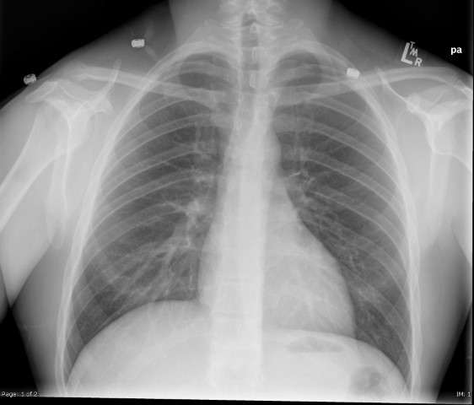](https://extranet.interiorhealth.ca/IHUBCFaculty/Diagnostics/X-rays/Normal/CXR%20Normal.bmp)

**LABS – click** [here](https://extranet.interiorhealth.ca/IHUBCFaculty/Diagnostics/Forms/AllItems.aspx?RootFolder=%25252FIHUBCFaculty%25252FDiagnostics%25252FLabs&View=%25257bFD97E2FE-FD01-433F-B9CB-D75A4195924E%25257d) **OR fill out below**

LABORATORY *LIVE* Lab Summary Report

|  |  |  |  |
| --- | --- | --- | --- |
| **Test** | **DATE/TIME here** | **Flag** (H or L) | **Reference** |
| **CBC** | | | |
| WBC | 11.9 |  | 3.5 – 10.8 10^9/L |
| RBC | 6.3 |  | 4.3 – 5.7 10^12/L |
| Hgb | 170 |  | 130 – 170 g/L |
| HCT | 0.53 |  | 0.37 – 0.47 L/L |
| Platelets |  |  | 150 – 400 10^9/L |
| **Chemistry** | | | |
| Na | 137 |  | 137 – 145 mmol/L |
| K | 3.7 |  | 3.5 – 5.0 mmol/L |
| Cl | 103 |  | 98 – 107 mmol/L |
| HCO3 | 25 |  | 22-26 mmol/L |
| Urea |  |  | 2.5 – 6.1 mmol/L |
| Creat |  |  | 62 – 106 umol/L |
| GFR Est |  |  | > 60 ml/min |
| Glucose - Random | 9.3 |  | 3.0 – 11.0 mmol/L |
| Lactate | 4.6 |  | 0.9 – 1.8 mmol/L |
| CK |  |  | 5 – 130 U/L |
| Troponin |  |  | <0.03 mcg/L |
| **Coags** |  |  |  |
| INR | 0.9 |  | 0.9 – 1.2 |
| PTT | 18 |  | 28 – 38 s |
| **ABGs** | | | |
| **Arterial** | | | |
| pH | 7.30 |  | 7.35- 7.45 |
| pCO2 | 51 |  | 35 – 45 mmHg |
| PO2 | 64 |  | 80-100 mmHg |
| BE | -2.0 |  | -2.0 to +2.0 mmol/L |
| HCO3 | 25 |  | 22 – 26 mmol/L |
| O2 Sat | 97 |  | 95 – 100% |
| Carboxyhemoglobin | 4.8 |  | < 3.0 |

**EKGs – click** [here](https://extranet.interiorhealth.ca/IHUBCFaculty/Diagnostics/Forms/AllItems.aspx?RootFolder=%25252FIHUBCFaculty%25252FDiagnostics%25252FECGs&View=%25257bFD97E2FE-FD01-433F-B9CB-D75A4195924E%25257d) **or paste**

[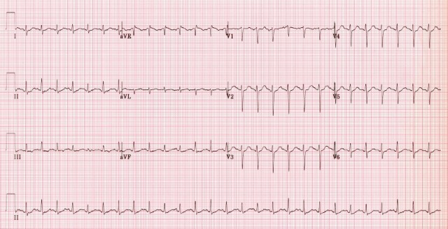](https://extranet.interiorhealth.ca/IHUBCFaculty/Diagnostics/ECGs/Normal/Sinus+Tachycardia.jpg)