Section 1: Case Summary

Scenario Title: | Torsades 2° Long QT
Keywords: | Torsades, Torsade de Pointes, QT, Overdose, ACLS
Brief Description of Case: | Recently admitted patient to High Acuity Unit post-suicide attempt from Seroquel, Clonazepam, and Zopiclone overdose. Patient will quickly deteriorate into Torsade de Pointes, whereby participants will have to run ACLS algorithm, identify Torsades, and treat with Magnesium prior to return of spontaneous circulation (ROSC).

Goals and Objectives
Educational Goal: | Identify and treat Torsade de Pointes
Objectives:  (Medical and CRM) | - Identify and treat Torsades de Points  - Practice ACLS algorithm for Ventricular Tachycardia/Fibrillation  - Establish role clarity and distribute the workload  - Communicate effectively, including closed-loop communication, clear commands and requests, sharing mental model/plan of care, and fostering input of information  - Mobilize resources early and use cognitive aids as needed

Learners, Setting and Personnel
Target Learners: | ☒ Junior Learners |  | ☒ Senior Learners |  |  | ☒ Staff
 | ☒ Physicians | ☒ Nurses |  | ☒ RTs | ☒ Inter-professional
 | ☐ Other Learners:
Location: | ☒ Sim Lab |  | ☒ In Situ |  |  | ☐ Other:
Recommended Number of Facilitators: | Instructors: 1
 | Confederates: 1 (can be instructor; to play part of any extra disciplines asked for – Lab, Xray, etc.)
 | Sim Techs: 1

Scenario Development
Date of Development: | 2017
Scenario Developer(s): | Simmie Kalan
Affiliations/Institutions(s): | Vancouver General Hospital ICU, Vancouver Coastal Health
Contact E-mail: | Simmie.kalan@vch.ca
Last Revision Date: | 2019.11
Revised By: | Christina Choung, Fraser Health
Version Number: | 2

Section 2A: Initial Patient Information

- Patient Chart
Patient Name: Susan Kahn |  |  |  | Age: 52 | Gender: F | Weight: 70kg
Admitting diagnosis: Decreased LOC secondary to overdose
Temp: 36.6 °C | HR: 115 STach | BP: 96/55 |  | RR: 16 | O₂Sat: 96% | FiO₂: FM 8 LPM
Cap glucose: 7.6 |  |  |  | GCS: E2 V4 M5
Handover:
Susan is a 52-year-old female admitted from ER 3 hours ago. She was found unresponsive in bed by her husband, he last saw her about an hour before. A suicide note was found next to her. EMS was called and they took her to ER where she was initially intubated for an hour prior to rousing enough to be extubated and maintain her airway.
Due to her recent suicide attempt, continued decrease in LOC, high O2 needs secondary to aspiration pneumonia, and a new finding of repolarization changes with long QT on ECG, Susan was admitted to the HAU for treatment and cardiac monitoring.

Allergies: NKDA
Past Medical History:  - Depression  - Anxiety  - ETOH (sober 2 years)  - Smoker – 2 packs per week |  |  | Current Medications:  - On hold: Seroquel  - On hold: Zopiclone  - On hold: Clonazepam  - Piptazo 3.375g IV q8h

Section 2B: Extra Patient Information

A. Further History
n/a
B. Physical Exam
Cardio: Sinus tach with repolarization changes and long QT (0.56). Otherwise normal. | Neuro: Opens eyes to pain, confused, localizes to pain. Pupils equal and reactive.
Resp: On FM 8LPM. Coarse crackles throughout | Head & Neck: Normal
Abdo: Normal | MSK/skin: Normal
Other: Access: 2 PIVs in-situ. NG Tube in-situ.

Section 3: Technical Requirements/Room Vision

A. Patient
☒ Mannequin: SimMan3G
☐ Standardized Patient
☐ Task Trainer
☐ Hybrid
B. Special Equipment Required
- 2 PIVs with drainage bags attached to manikin
- Face Mask on manikin
- NG tube in manikin
- Access to crash cart and defibrillator
- ECG (see appendix)

C. Required Medications
- Magnesium IV
- Epinephrine (Cardiac) IV
- Amiodarone IV

D. Moulage
n/a
E. Monitors at Case Onset
☒ Patient on monitor with vitals displayed
☐ Patient not yet on monitor
F. Patient Reactions and Exam
n/a

Section 5: Scenario Progression

Scenario States, Modifiers and Triggers
Patient State/Vitals | Patient Status | Learner Actions, Modifiers & Triggers to Move to Next State |  | Facilitator Notes
1. Baseline State  Rhythm: Sinus Tach w/ long QT  HR: 115  BP: 91/62  RR: 16  O₂SAT: %96  T: 36.6 ºC  GCS: E2 V4 M5 | Eyes closed, opens eyes to pain and mumbles; confused | Expected Learner Actions  Assess patient | Modifiers  - n/a  Triggers  -Move to Phase 2 in 15 seconds  -
2. Torsades  Rhythm: Torsade de Points  HR: 180 (if possible to set)  BP: n/a  RR: 0  O₂SAT: %56 over 40 seconds  T: unchanged  GCS: E1 V1 M1 | Non-responsive | Expected Learner Actions  Notice change in patient status  Determine loss of pulse  Call for help  Effective CPR  -compressions 100-120/min, depth 2 inches  -ventilations successfully delivered  -30:2  Identification of roles and responsibilities, including team lead  Mental model shared; input invited  VT/VFib ACLS algorithm followed  Interruptions in CPR minimized; rotation of CPR providers  Identification of Torasades/polymorphic VT  Magnesium administered  Documentation occurs | Modifiers  -if intubated increase RR to 12 (or if able, match what person delivering manual ventilations is doing) AND set EtCO2:  -EtCO2: high-quality CPR = 15-20 mmHg  -EtCO2: medium-quality CPR = 10-15 mmHg  -EtCO2: poor-quality CPR = <10 mmHg  -If Epinepherine delivered no change  -If Amiodarone delivered no change  -If shock delivered (without Magnesium- see “Triggers”) no change  Triggers  -After Magnesium administered, at least 2 shocks delivered, one of which is post-Magnesium infusion, proceed to phase 3 | -if after 3 cycles of CPR and shocks/Epi/Amio, no mention of Torsades or Magnesium, walk by as attending or consulting cardiologist and point out Torsades on monitor
3. ROSC  Rhythm: Sinus Tach w/ long QT and T-wave inversion  HR: 105  BP: 81/46  RR: 12  O₂SAT: %92 over 40 seconds  T: 36.6 ºC  GCS: E2 V3 M5 | Patient moans (if not intubated), eyes remain closed | Expected Learner Actions  Notice change in patient status  Patient update and plan of care verbalized to all team members  Input invited  Clear delegation of tasks | Modifiers  -n/a  Triggers  -Case ends after time-out/summary completed and plan of care verbalized OR after total case time of 15 minutes – whichever comes first

Appendix A: Laboratory Results

CBC
WBC 9.3
Hgb 117
Plt 265

Lytes
Na 140
K 4.2
Cl 102
HCO₃ 24

Urea 7
Cr 92
Glucose

Extended Lytes
Ca 6.9
Mg 0.7
PO₄ 4.0
Albumin 42

Appendix B: ECGs, X-rays, Ultrasounds and Pictures

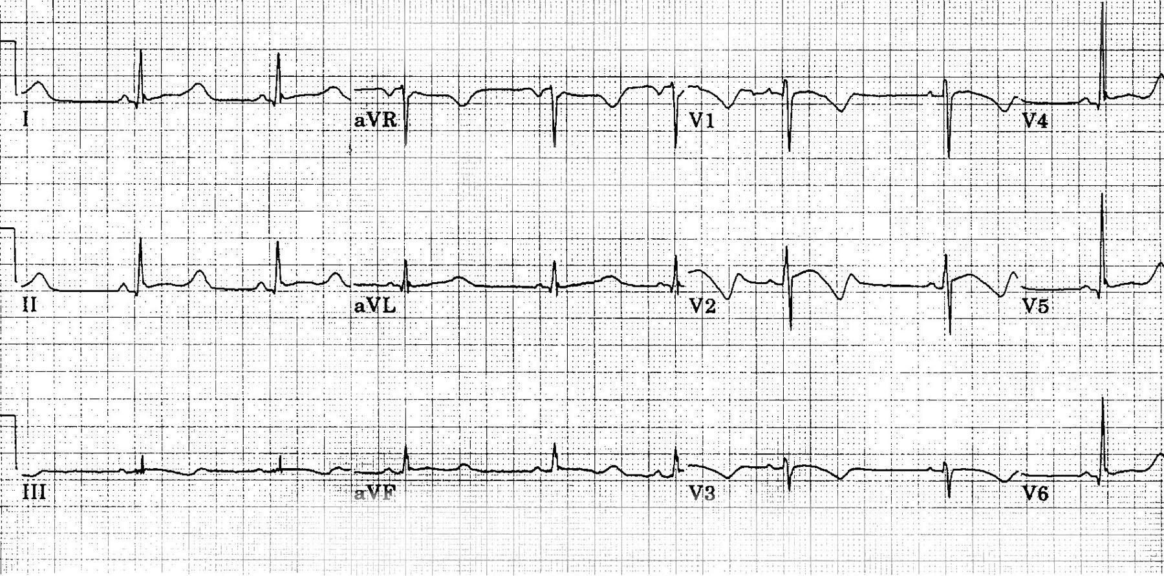
https://img.medscapestatic.com/pi/meds/ckb/06/35006.jpg

Appendix C: Facilitator Cheat Sheet & Debriefing Tips

Include key errors to watch for and common challenges with the case. List issues expected to be part of the debriefing discussion. Supplemental information regarding any relevant pathophysiology, guidelines, or management information that may be reviewed during debriefing should be provided for facilitators to have as a reference.

References

1. Hasnain M, Vieweg WV, Howland RH, et al. Quetiapine, QTc interval prolongation, and torsade de pointes: a review of case reports. Ther Adv Psychopharmacol. 2014;4(3):130–138. doi:10.1177/2045125313510194
2. Berul, C. (Oct 2019). UpToDate, Acquired long QT syndrome: Definitions, causes, and pathophysiology. Retrieved November 2019.
3.

