|  |  |
| --- | --- |
| **Case Title** | Bariatric Arrest |
| **Scenario Name** | Bariatric Arrest |

|  |  |
| --- | --- |
| **Learning Objectives -** [**Use action words**](http://ubccpd.ca/sites/ubccpd.ca/files/Accreditation_Learning%20Objectives_%20Verbs.pdf) | |
| **Knowledge:**   1. Review standard ACLS protocols | |
| **Skills:**   1. Management of a bariatric airway in respiratory arrest 2. Lead ACLS – PEA Arrest 3. Manage difficult team member situation – multiple MDs | |
| **Attitude/Behaviours**   1. Demonstrate Team skills 2. Demonstrate Situational awareness 3. Demonstrate Graded Assertiveness | |
| **Scenario Environment** | |
| **Location** | KGH ED T1 |
| **Monitors** | Standard ED Monitors |
| **Props/Equipment** | ? Obesity/Bariatric  Standard Airway equipment |
| **Make-up/Moulage** | Nil |
| **Potential Distractors** | Multiple MDs |

|  |
| --- |
| **Case Introduction:** |
| 55 year old Obese woman – 400-500lbs  Presents to Triage with SOB, low grade fever, cough x 3 days.  Wheeled to trauma, respiratory arrest in hallway, cyanotic, unresponsive.  Moved to stretcher, PEA arrest, pale and hypoxic.  Code blue called.  Multiple MDs show up all giving orders.  Patient requires appropriate set up and planning for airway. |

| **Patient Parameters** | **Effective Management** | **Notes** |
| --- | --- | --- |
| **Phase 1: PEA Arrest**  **Condition:** Pulseless, cyanotic  **Initial Assessment**   * **Heart Rhythm:** Sinus Tach PEA * **HR**: 140 * **BP:** -/- * **RR:** apneic * **SP02:** unobtainable * **Temp:** 38 * **Glucose:** 9 * **CNS:** GCS 3 * **Chest:** Crackles to Left side * **Weight:** 400-500 lbs | 1. **Take a focused history** (see Notes column) 2. **Medical Management**  * CPR * BVM and oxygen * Call for RT and RN team * Primary survey of patient * Establish vascular access – IO as IV difficult * Run ACLS protocol   + Epinephrine   + Give fluids * Airway set up   + Call for help to intubate pt   + Position and prep pt   + Back-up airway maneuvers on hand * **Need to manage team effectively and identify who is in charge and who is on airway.**   *Multiple MDs enter.*  **Need to control room and who is giving orders.**  *Pt achieve ROSC with Epi, BVM, and CPR – proceed to next phase* | 1. **Focused history**   History only from Triage RN. As above – recent RTI, SOB, Coughing. Increased WOB at triage with saturations of 75% so wheeled to Trauma bay.  **PMHx**   * “Asthma” * Ex-smoker * HTN * High cholesterol   **Meds**   * Ventolin * HCTZ * Ramipril * Statin   **Allergies**   * None |
| **Phase 2: ROSC**  **Condition:** ROSC but hypoxic. Patient reaches for BVM.  **Physical Examination**   * **Heart Rhythm:** Sinus Tach * **HR:** 140 * **BP:** 90/40 * **RR:** 10 * **SpO2:** 75% * **Temp:** 38 * **CNS:** GCS 7 (E1, M5, V1) * **Chest:** Left crackles, poor air entry | 1. **Patient Reassessment** (see Notes column)-*Recognizes change in condition* 2. **Medical Management:**  * Airway:   + Prepare for intubation   + Glidescope, laryngoscope, bougie, etc…   + Use Ketamine   + Consider issues with Roc/Succ   + Propofol or Etomidate can also be considered   + Position pt appropriately – head up, shoulders supported * Circulation:   + Fluid bolus   + Antibiotics   + Norepinephrine if BP does not increase * Diagnostics   + Sepsis panel including lactate and cultures   + CXR   + ECG   + ABG * Disposition   + Consult ICU | **Airway**   * Reaching for BVM   **Breathing**   * Cyanotic and hypoxic   **Circulation**   * ROSC, pressure soft |

|  |  |
| --- | --- |
| **Expected Patient Management** | **Debriefing Points** |
| 1. **Student** 2. **Junior Resident** 3. **Senior Resident** |  |

**References:**

**EKGs**

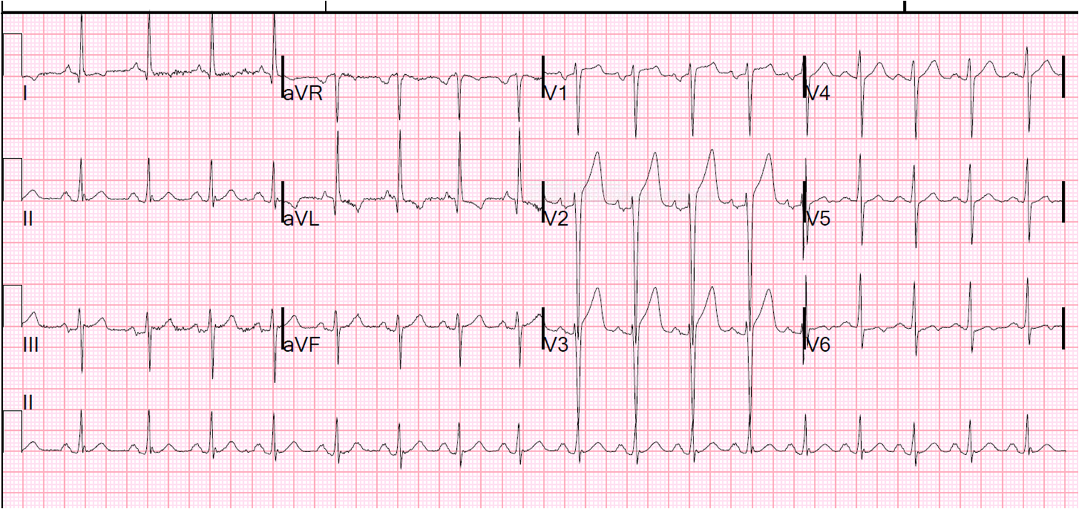

**X-Ray**

