|  |  |
| --- | --- |
| **Case Title** | Ecstasy Overdose |
| **Scenario Name** | Ecstasy and Etoh Overdose with Seizure |

|  |  |
| --- | --- |
| **Learning Objectives -** [**Use action words**](http://ubccpd.ca/sites/ubccpd.ca/files/Accreditation_Learning%20Objectives_%20Verbs.pdf) | |
| **Knowledge:**   1. Identifying principles of toxicology 2. Reviewing etiology of seizures in toxicology and management | |
| **Skills:**   1. Management of NMDA overdose including hyperthermia/hypertension 2. Demonstrate appropriate supportive & therapeutic interventions | |
| **Attitude/Behaviours:**   1. Demonstrate Team skills 2. Demonstrate Situational awareness 3. Demonstrate Graded Assertiveness | |
| **Scenario Environment** | |
| **Location** | ED |
| **Monitors** | Bedside monitor |
| **Props/Equipment** | IV, O2, monitor  Intubation equipment  Medications |
| **Make-up/Moulage** | None |
| **Potential Distractors** | None |

|  |
| --- |
| **Case Introduction:** |
| 16 y.o. male partying with friends. Drinking EtOH and using ecstasy. Complains of feeling unwell and hot prior to coming to ER. Starts talking to wall seeing Mickey Mouse. Acting bizarre according to friends who called ambulance. Picked up outside large gathering.  **Course in ED:**  - initially staring straight ahead lip smacking  - progress to seize in the ER🡪status epilepticus🡪intubation and paralysis  - needs transfer for EEG monitoring  - hyperthermia and hypertension persist🡪recognition of mixed amphetamine (HTN, hyperthermia, tachycardia) overdose plus serotonin syndrome (cognitive and behavioral changes; autonomic dysfunction; neuromuscular dysfunction) |

| **Patient Parameters** | **Effective Management** | **Notes** |
| --- | --- | --- |
| **Phase 1: Hallucinating**  **Condition:** Initially staring straight ahead, lips smacking, talking to wall seeing Mickey Mouse, acting bizarre. Diaphoretic and flushed.  **Initial Assessment**   * **Heart Rhythm:** Sinus Tachycardia * **HR:** 130 * **BP:** 190/115 * **RR:** 30 * **SP02:** 97% * **T:** 38.1 * **Glucose:** 5.0 * **CNS:** GCS 13 (E-4, V-4, M-5). Dilated pupils. * **Chest:** normal * **CVS:** Diaphoretic, flushed. HTN, tachycardia | 1. **Take a focused history** (see Notes column) 2. **Medical Management** 3. IV, O2, Monitor 4. Toxicology management    1. A: Intubation prn    2. B: prn    3. C: Hypertension management       1. No BB       2. benzos       3. nitroprusside/phentolamine/?labetalol    4. D decontamination: charcoal < 1h    5. E: supportive 5. **Investigations:**  * ECG: sinus tachy * Labs: Emerg, COMA (hyponatremia), CK, INR, LFT | 1. **Focused history**  * Limited history available—friends with patient state that he was acting “weird” after using Ecstasy and having a couple of drinks. No one else seems to be affected.   **PMHx**   * Healthy * No seizure history   **Meds**   * Nil   **Allergies**   * NKA |
| **Phase 2: Seizing**  **Condition:** Progresses to seize in ER- status epilepticus.  **Physical Examination**   * **Heart Rhythm:** Sinus Tachycardia * **HR:** 150 * **BP:** 200/120 * **RR:** apneic (actively seizing) * **SP02:** 88% RA * **CNS:** Actively seizing (status epilepticus) | 1. **Patient Reassessment** (see Notes column) 2. **Medical Management** 3. Toxicology management    1. Airway: Suction, set up for intubation with RSI    2. B: high flow O2    3. C: Hypertension management       1. No BB       2. benzos       3. nitroprusside/phentolamine/?labetalol    4. D: Seizure management (as below) 4. Seizure management in toxicology    1. Benzo    2. Limited role of Dilantin    3. Paralysis and intubation with propofol/phenobarb | 1. **Patient Reassessment**   **Airway**   * Not patent, needs suctioning and intubation   **Breathing**   * Needs intubation   **Circulation**   * Remains hypertensive |
| **Phase 3: Intubated & Sedated, Hyperthermia & Hypertension persist**  **Condition:** Intubated and sedated. No more seizure activity. Remains febrile and hypertensive.  **Physical Examination**   * **Heart Rhythm:** Sinus Tachycardia * **HR:** 128 * **BP:** 180/110 * **RR:** 10 on ventilator * **SP02:** 97% * **T:** 38.3 * **CNS:** GCS 3T * **CVS:** Tachycardic, hypertensive | 1. **Patient Reassessment** (see Notes column) 2. **Medical Management**    1. Hyponatremia in Ecstasy (neuro symptoms develop when Na < 120 meq/L)       1. Volume depletion—correct with N saline       2. Hypertonic saline—100 cc 3% saline; may repeat q10 min 2 – 3 x’s ( each dose will raise by 2 – 3 mmol/L); correct    2. Hyperthermia       1. Cooling blanket/ice packs/***cold water immersion)***       2. Consider cyproheptadine (Serotonin syndrome—anti-serotonergic agent)—4 – 8 mg po q 2h       3. Consider dantrolene (.5 – 2.5mg/kg IV q6h)—malignant hyperthermia       4. No role for DA agonist (i.e. bromcriptine)    3. Serotonin syndrome       1. Cognition and behavioral changes          1. Rx: benzo       2. Autonomic dysfunction       3. Neuromuscular activity (rigidity, hyperthermia)    4. Complications       1. Renal failure       2. Rhabdo    5. Transfer       1. Needs transfer for EEG monitoring | 1. **Patient Reassessment**   **Airway**   * Intubated   **Breathing**   * On ventilator   **Circulation**   * Remains tachycardic and hypertensive   **Notes**: Need to recognize mixed amphetamine (HTN, hyperthermia, tachycardia) overdose plus serotonin syndrome (cognitive and behavioral changes; autonomic dysfunction; neuromuscular dysfunction) |

**Insert more lines if more phases required.**

|  |  |
| --- | --- |
| **Expected Patient Management** | **Debriefing Points** |
| 1. **Student** 2. **R1** 3. **Senior IM resident** |  |

**References:**

* UptoDate
* Tintanelli

**EKGs – click** [here](https://extranet.interiorhealth.ca/IHUBCFaculty/Diagnostics/Forms/AllItems.aspx?RootFolder=%25252FIHUBCFaculty%25252FDiagnostics%25252FECGs&View=%25257bFD97E2FE-FD01-433F-B9CB-D75A4195924E%25257d) **or paste**

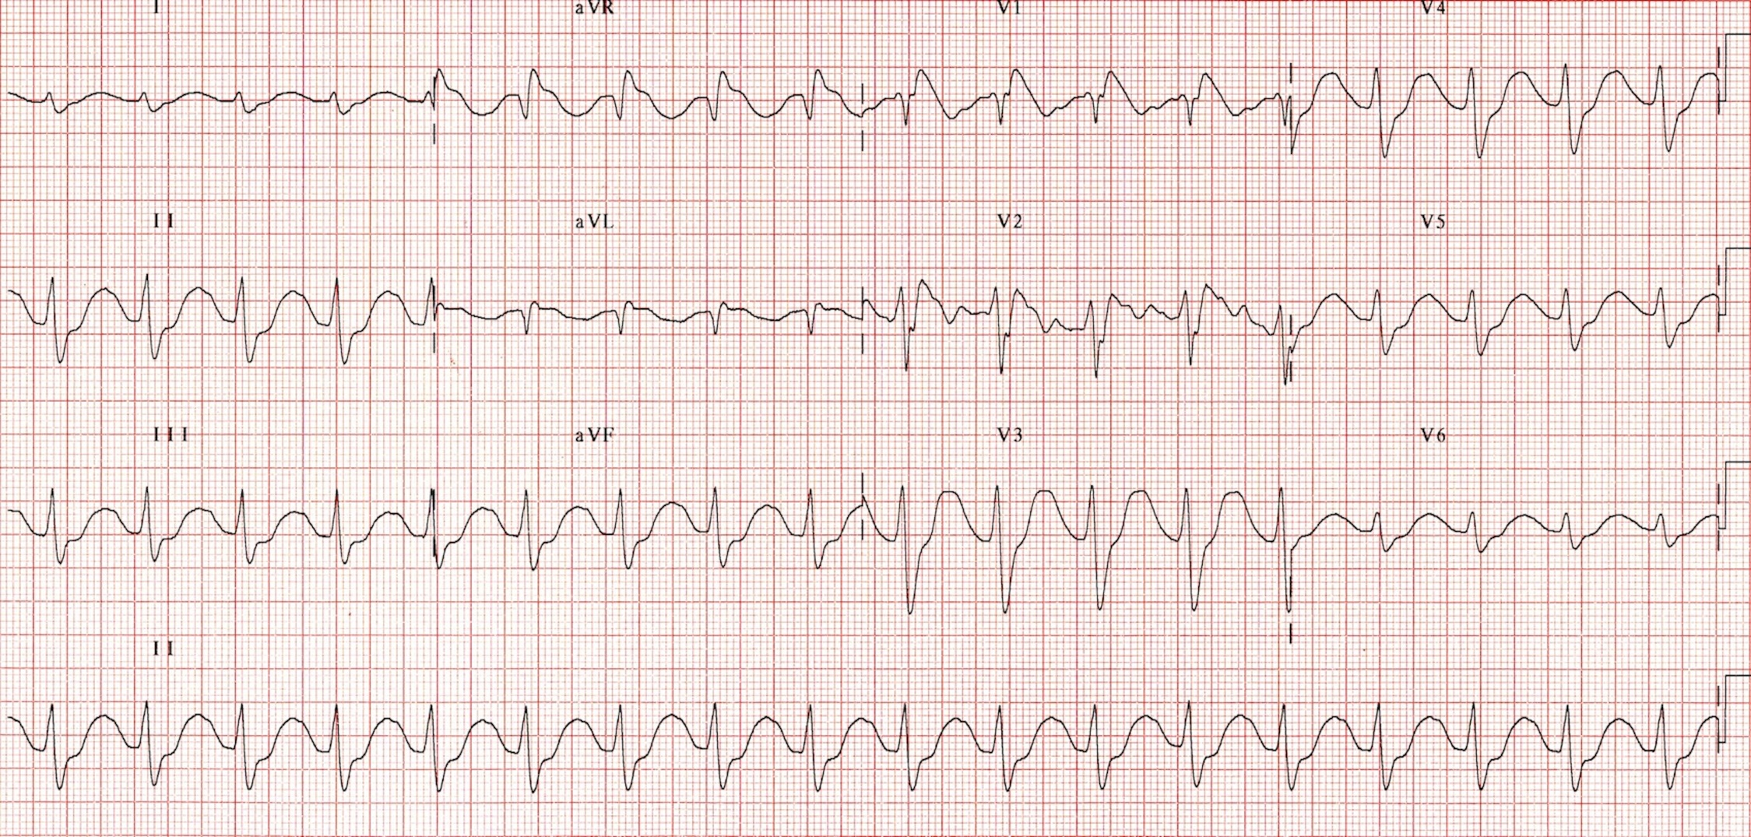

**RSR' pattern and wide QRS typical of sodium channel blockade.**

Seen in cocaine and other toxicities like tricyclic anti-depressants