|  |  |
| --- | --- |
| **Case Title** | Organophosphates Poisoning |
| **Scenario Name** | Organophosphates Poisoning |

|  |  |
| --- | --- |
| **Learning Objectives -** [**Use action words**](http://ubccpd.ca/sites/ubccpd.ca/files/Accreditation_Learning%20Objectives_%20Verbs.pdf) | |
| **Knowledge:**   1. Identify signs of organophosphate intoxication 2. Identify Muscarinic and nicotinic symptoms of organophosphates | |
| **Skills:**   1. Manage organophosphates intoxication with appropriate supportive and therapeutic interventions | |
| **Attitude/Behaviours:**   1. Demonstrate Team skills 2. Demonstrate Situational awareness 3. Demonstrate Graded Assertiveness | |
| **Scenario Environment** | |
| **Location** | Emergency Department |
| **Monitors** | Cardiac, BP, pulse oximeter |
| **Props/Equipment** | * ECG: with sinus tachycardia * CXR: post intubation |
| **Make-up/Moulage** | None |
| **Potential Distractors** | Healthcare worker who begins to fill sick during scenario |

|  |
| --- |
| **Case Introduction:** |
| 5 year old boy, brought by EMS from his home. He has been unwell just this morning with restlessness, nausea, emesis and abdominal pain, had one episode of diarrhea. His parents report that he has been more restless and difficult to settle earlier this morning but has been quieter and less with it since.  Upon arrival: you are asked to see the child immediately. |

| **Patient Parameters** | **Effective Management** | **Notes** |
| --- | --- | --- |
| **Phase 1: Lethargic and Clammy**  **Condition:** Clammy skin, diaphoretic. Slow to respond to commands. Eyes closed.  **Initial Assessment**   * **Heart Rhythm:** Sinus Tachycardia * **HR:** 130 * **BP:** 90/60 * **RR:** 20 * **SP02:** 98% RA * **T:** 36.0 C (Ax) * **CNS:** eyes are closed, responds briefly to questions, slowly responds to commands (does not speak or move otherwise), pupils 5 mm with sluggish reaction symmetrically * **Chest:** spontaneous respirations, no abnormal air entry with wheezes * **CVS:** palpable pulses, slightly cool extremities, with heart murmur, tachycardia, and no loss of pulse. Clammy skin. * **GI:**  hyperactive bowel sound * **Integ:** No rash, no petechiae * **Extremities:** has occasional brief visible fasciculations of proximal musculature of both upper and lower extremities * **Weight:** 20 kg | 1. **Take a focused history** (see Notes column) 2. **Medical Management**   **Airway**   * Talk to the patient: he responds briefly to questions * Has noisy respiration * Optimize airway position * Suction the airway: moderate frothy secretions in the oropharynx   **Breathing**   * Check oxygen saturation * Apply monitors – “sinus tachycardia” * Provide oxygen delivery – no change in clinical appearance * Auscultate chest - noisy transmitted sounds & faint wheezing   **Circulation**   * Monitors (if not done yet) * Check pulse, cap refill, BP – HR 130 (tachycardia identified) * Start IV   **Other**   * Contact poison center * Order bloodwork | 1. **Focused history**  * His family lives on a farm * He & his older sister were outside and around this house, playing unsupervised earlier this morning * No history of trauma or falls * His sister is not present but otherwise well * There are numerous fertilizers, engine fuels, machinery lubricants, coolants & pesticides in the garage at home   **PMHx**   * Previously well * Not immunized   **Meds**   * None   **Allergies**   * NKDA |
| **Phase 2: Condition Worsens**  **Condition:** worsening; tachypnea worsens  **Physical Examination**   * **Heart Rhythm:** Sinus Tachycardia * **HR:** 130 * **BP:** 95/50 * **RR:** 40 * **SP02:** 98% RA * **T:** 36.0 (Ax) * **Glucose:** 4.0 mmol/L * **CNS:** Declining LOC | 1. **Patient Reassessment** (see Notes column) 2. **Medical Management**   Airway   * Prepare equipment for intubation   **Breathing**   * Reassessment breathing, auscultation – more wheezes * Apply 100% oxygen – no change in clinical appearance   **Circulation**   * Reassess HR, pulse, BP * Consider giving fluid bolus 20 cc/kg NS – no change in vital signs   **Further Interventions**   * No response to Flumazenil, naloxone, or glucose * Salbutamol, wheezing is better with no change in broncorrhea * Atropine 0.02/kg ,improves muscarinics symptoms, could be repeated every 5-10 min * Pralidoxmie 10-20mg /kg, improves * Nicotinic symptoms * Glucometer: 4.0 mmol * CBC, differential * Electrolytes, BUN, Cr * PH: 704,pco2 40,HCO3 22 * Need arterial line for monitor * Continuous ECG monitoring * Call for ICU | 1. **Patient Reassessment**   **Airway**   * Drowsy with gradual decrease in LOC   **Breathing**   * Maintaining sats with O2   **Circulation**   * Tachycardic |
| **Phase 3: Improved Condition**  **Condition:** Patient’s condition evolves – improved condition but one of the healthcare members start to feel sick  **Physical Examination**   * **Heart Rhythm:** Sinus Tachycardia * **HR:** 115 * **BP:** 95/50 * **RR:** 24 * **SP02:** 98% * **CNS:** pupil size improves * **MSK:** Muscle fasciculations improved | 1. **Patient Reassessment** (see Notes column) 2. **Medical Management**   **Airway**   * Position airway * OP airway - still in place     **Breathing**   * Reassess auscultation, breathing, RR – no change   **Circulation**   * Reassess HR, pulse, BP, Cap refill * Repeat bolus NS 20 cc/kg – no change * ECG – sinus tachycardia   **Further Interventions**   * Treat everybody in the room * Atropine& Palidoxime * Take precautions * After stabilization admit to the Hospital | 1. **Patient Reassessment**   **Airway**   * OPA in place * Decrease bronchorrhea & salivation   **Breathing**   * Sats maintaining   **Circulation**   * Tachycardic improving |

**Insert more lines if more phases required.**

|  |  |
| --- | --- |
| **Expected Patient Management** | **Debriefing Points** |
| 1. **Student** 2. **R1** 3. **Senior IM resident** |  |

**References:**

**X-RAYS - click** [here](https://extranet.interiorhealth.ca/IHUBCFaculty/Diagnostics/Forms/AllItems.aspx?RootFolder=%25252FIHUBCFaculty%25252FDiagnostics%25252FLabs&View=%25257bFD97E2FE-FD01-433F-B9CB-D75A4195924E%25257d) **OR fill out below**

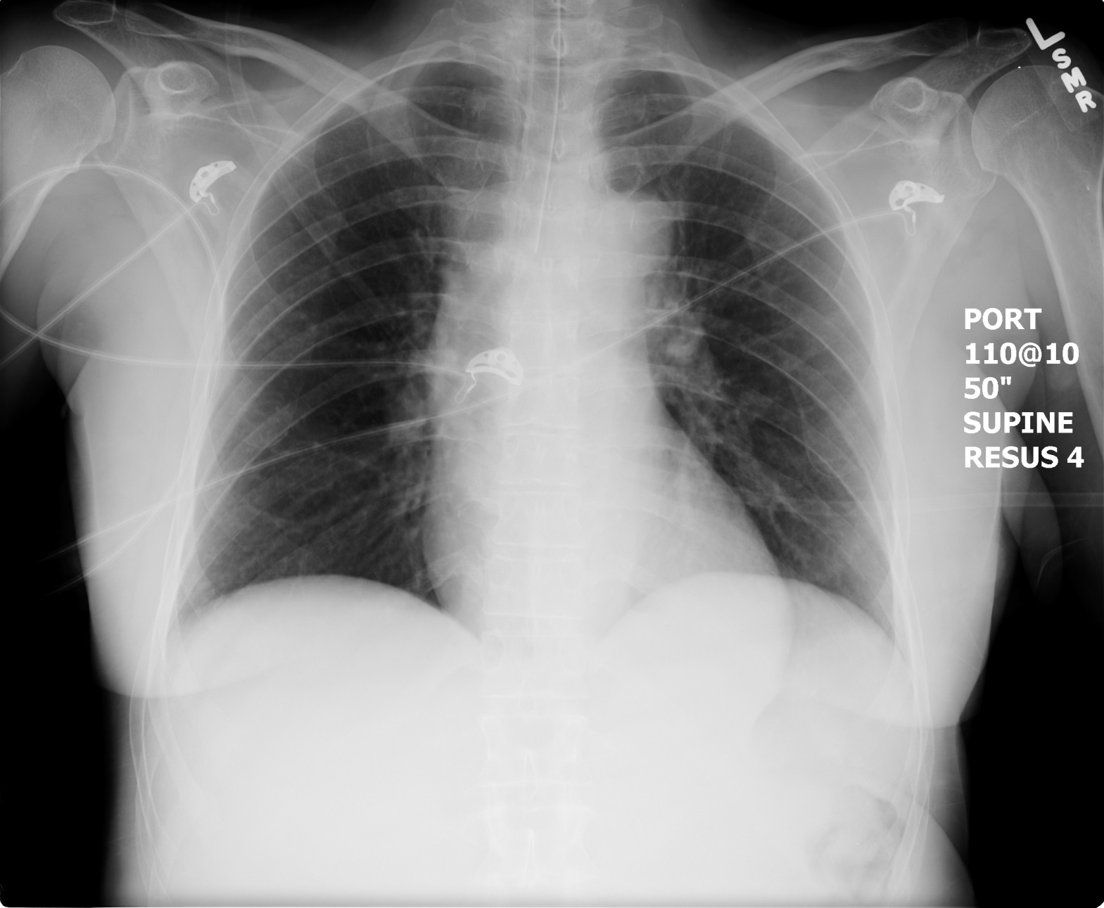

**LABS – click** [here](https://extranet.interiorhealth.ca/IHUBCFaculty/Diagnostics/Forms/AllItems.aspx?RootFolder=%25252FIHUBCFaculty%25252FDiagnostics%25252FLabs&View=%25257bFD97E2FE-FD01-433F-B9CB-D75A4195924E%25257d) **OR fill out below**

LABORATORY *LIVE* Lab Summary Report

|  |  |  |  |
| --- | --- | --- | --- |
| **Test** | **DATE/TIME here** | **Flag** (H or L) | **Reference** |
| **CBC** | | | |
| WBC |  |  | 3.5 – 10.8 10^9/L |
| RBC |  |  | 4.3 – 5.7 10^12/L |
| Hgb |  |  | 130 – 170 g/L |
| HCT |  |  | 0.37 – 0.47 L/L |
| Platelets |  |  | 150 – 400 10^9/L |
| **Chemistry** | | | |
| Na |  |  | 137 – 145 mmol/L |
| K |  |  | 3.5 – 5.0 mmol/L |
| Cl |  |  | 98 – 107 mmol/L |
| HCO3 |  |  | 22-26 mmol/L |
| Urea |  |  | 2.5 – 6.1 mmol/L |
| Creat |  |  | 62 – 106 umol/L |
| GFR Est |  |  | > 60 ml/min |
| Glucose - Random |  |  | 3.0 – 11.0 mmol/L |
| Lactate |  |  | 0.9 – 1.8 mmol/L |
| Serum Osmo |  |  |  |
| Osmo Gap |  |  |  |
| **Coags** |  |  |  |
| INR |  |  | 0.9 – 1.2 |
| PTT |  |  | 28 – 38 s |
| **ABGs** | | | |
| **Arterial** | | | |
| pH | **7.04** | **L** | 7.35- 7.45 |
| pCO2 | 40 |  | 35 – 45 mmHg |
| PO2 |  |  | 80-100 mmHg |
| BE |  |  | -2.0 to +2.0 mmol/L |
| HCO3 | **22** |  | 22 – 26 mmol/L |
| O2 Sat |  |  | 95 – 100% |

**EKGs – click** [here](https://extranet.interiorhealth.ca/IHUBCFaculty/Diagnostics/Forms/AllItems.aspx?RootFolder=%25252FIHUBCFaculty%25252FDiagnostics%25252FECGs&View=%25257bFD97E2FE-FD01-433F-B9CB-D75A4195924E%25257d) **or paste**

